



**PROGRESS REPORT**

**( 1st January - 31st December 2019)**

**KRISHI VIGYAN KENDRA, KHAGARIA**

**(Bihar Agricultural University, Sabour, Bhagalpur)**

**List of Contents**

|  |  |  |
| --- | --- | --- |
| **Sl. No.** | **Title of Topic** | **Page No.** |
| 1 | General Information | 03 |
| 1.8A | Details of 8th SAC Meeting | 07 |
| 2 | District Level Data on Agriculture, Live Stock And Farming Situation | 10 |
| 3 | Technical Achievements | 12 |
| 3.1 | Achievements of Technologies Assessed And Refined | 14 |
| 3.2 | Achievements of Frontline Demonstration | 22 |
| 3.3 | Achievements on Training | 37 |
| 3.4 A | Extension Activities | 59 |
| 4 | Impact of KVK | 74 |
| 5 | Linkages | 79 |
| 6 | Performance of Infrastructure in KVK | 80 |
| 7 | Financial Performance | 82 |
| 8 | Other Information | 84 |
| 9.1 | NYK Training | 84 |
| 9.2 | PPV&FRA Trainings Programme | 84 |
| 9.3 | mKisan Portal | 84 |
| 9.4 | KVK Portal | 85 |
| 9.5 | Swachh Bharat Programme | 85 |
| 9.6 | National Science Day | 85 |
| 9.7 | Programme with BSF | 85 |
| 9.8 | Agriculture knowledge in rural school | 85 |
| 9.9 | Detail of Pre-Rabi Compaining Abhiyan | 86 |
| 9.10 | Swachhata Hi Seva | 86 |
| 9.11 | Mahila Kisan Dewas | 86 |
| 9.14 | Revenue generation | 87 |
| 10 | Report of CSISA | 88 |
| 11 | Details of TSP | 88 |
| 12 | Report of NICRA | 89 |
| 13 | Awards | 90 |
| 14 | Any other Significant Achievements | 91 |
| 15 | Information on visit of Minister | 92 |
| 16 | ASCI Skill Development Training | 92 |
| 17 | NARI Project | 93 |
| 18 | Krishi Kalyan Abhiyan (Phase 1 &2) | 93 |
| 19 | Gramin Krishi Musam Seva, Khagaria | 95 |
| 20 | Any Other Programme Organized by kvk not covered above | 95 |
| 21 | Bio-tech Kisan Hub | 96 |
| 22 | Kisan Choupal | 96 |
| 23 | Video Conferencing | 97 |
| 24 | Celebration of Important Day | 97 |

**PROFORMA FOR ANNUAL REPORT 2019 ( 1st January- 31st December 2019)**

1. GENERAL INFORMATION ABOUT THE KVK

**ANNUAL REPORT**

**(January, 2019 to December, 2019)**

**1. GENERAL INFORMATION ABOUT THE KVK KHAGARIA**

1.1. Name and address of KVK with phone, fax and e-mail

|  |  |  |  |
| --- | --- | --- | --- |
| Address | Telephone | | E mail |
|  | Office | FAX |  |
| Krishi Vigyan Kendra, Khagaria | 0641-2452611 |  | kvkkhagaria@gmail.com |

**1.2 .Name and address of host organization with phone, fax and e-mail**

|  |  |  |  |
| --- | --- | --- | --- |
| Address | Telephone | | E mail |
| Office | FAX |  |
| Bihar Agricultural University, Sabour, Bhagalpur, Bihar | 0641-2452611 |  | deebausabour@gmail.com |

**1.3. Name of the Senior Scientist and Head with phone & mobile No.**

|  |  |  |  |
| --- | --- | --- | --- |
| Name | Telephone / Contact | | |
|  | Residence | Mobile | Email |
| Dr. Anita Kumari | KVK, Khagaria | 9472410438 | kvkkhagaria@gmail.com |

1.4. Year of sanction of KVK : F.No. 602/2010 – AE - I

**1.5. Staff Position (as on 31st December, 2019)**

|  |  |  |  |  |  |  |  |
| --- | --- | --- | --- | --- | --- | --- | --- |
| **Sl. No.** | **Name of the incumbent** | **Designation** | **Discipline** | **Pay Scale with present basic** | **Date of joining** | **Permanent**  **/Temporary** | **Category (SC/ST/**  **OBC/**  **Others)** |
|  | Dr. Anita Kumari | Senior Scientist and Head | Home Science | 37400-67000 | 06.07.2019 | Permanent | SC |
|  | Sri Nanda Kishore Singh | Subject Matter  Specialist | Plant Protection | 15600-39100 | 11.06.2009 | Permanent | GEN |
|  | Sri Jitendra Kumar | Subject Matter  Specialist | Agronomy | 15600-39100 | 13.06.2009 | Permanent | GEN |
|  | Vacant |  |  |  |  |  |  |
|  | Vacant |  |  |  |  |  |  |
|  | Vacant |  |  |  |  |  |  |
|  | Sri Pawan Kumar | Farm Manager | **-** | 9300 - 34800 | 29.10.2012 | Permanent | OBC |
|  | Vacant |  |  |  |  |  |  |
|  | Smt Soni Kumari Singh | Programme Assistant (Computer) | **-** | 9300 - 34800 | 13.05.2013 | Permanent | OBC |
|  | Sri Rhul Kumar | Accountant / Superintendent | **-** | 9300 - 34800 |  | Permanent | Others |
|  | Sri Chandan Kumar | Stenographer | **-** | 5200-20200 |  | Permanent | OBC |
|  | Sri Pankaj Kumar | Driver | **-** | 5200-20200 | 09.05.2015 | Permanent | SC |
|  | Sri Sunil Choudahry | Driver | **-** | 5200-20200 | 18.05.2015 | Permanent | SC |
|  | Sri Deepak Paswan | Supporting staff | **-** | 10000 | 01.09.2013 | Contractual | SC |
|  | Sri Surendra Kumar | Supporting staff | **-** | 10000 | 01.09.2013 | Contractual | SC |

**1.6. Total land with KVK (in ha) : 12.5 ha**

|  |  |  |
| --- | --- | --- |
| **S. No.** | **Item** | **Area (ha)** |
| 1 | Under Buildings | 02.50 |
| 2. | Under Demonstration Units | 01.40 |
| 3. | Under Crops | 05.60 |
| 4. | Orchard/Agro-forestry | 01.00 |
| 5. | Approach Road and others | 02.00 |
|  | **Total** | **12.50** |

*Total area should be matched with breakup*

**1.7. Infrastructure Development:**

A) Buildings and others

|  |  |  |  |  |  |  |  |  |  |
| --- | --- | --- | --- | --- | --- | --- | --- | --- | --- |
| **SL. No.** | **Name of building** | **Not yet started** | **Completed up to plinth level** | **Completed up to lintel level** | **Completed up to roof level** | **Totally completed** | **Plinth area (sq.m)** | **Under use or not\*** | **Source of funding** |
| 1 | Administrative  Building | - | - | - | - | Totally completed | 550 m2 | Under use | ICAR |
| 2 | Farmers Hostel | - | - | - | - | Totally completed | 309.73 m2 | Under use | ICAR |
| 3 | Staff Quarters (6) | - | - | - | - | Totally completed | 334 m2 | Under use | ICAR |
| 4 | Piggery unit | - | - | - | - | - | - | - | - |
| 5 | Fencing | - | - | - | - | - | - | - | - |
| 6 | Rain Water harvesting structure | - | - | - | - | - | - | - | - |
| 7 | Threshing floor | - | - | - | - | Under Constraction | 1200 m2 | - | ICAR |
| 8 | Farm godown | - | - | - | - | Under Constraction | 200 m2 | - | ICAR |
| 9 | Dairy unit | - | - | - | - | - | - | - | - |
| 10 | Poultry unit | - | - | - | - | - | - | - | - |
| 11 | Goatary unit | - | - | - | - | - | - | - | - |
| 12 | Mushroom Lab | - | - | - | - | - | - | Under use | ICAR |
| 13 | Mushroom production unit | - | - | - | - | completed | 150 m2 | Under use | ICAR |
| 14 | Shade house | - | - | - | - | - | - |  |  |
| 15 | Soil test Lab | - | - | - | - | Mini Kit | 60 m2 | Under use | ICAR |
| 16 | Others, Please Specify | - | - | - | - | - | - | - | - |

* If not in use then since when and reason for non-use

**B) Vehicles**

|  |  |  |  |  |
| --- | --- | --- | --- | --- |
| **Type of vehicle** | **Year of purchase** | **Cost (Rs.)** | **Total km. Run** | **Present status** |
| Bolero Jeep | 2012 | 512300 | 140365 | Poor |
| Tractor Mahindra | 2012 | 434000 | 1134 Hr. | Good |
| Motorcycle 1 | 2015 | 60000 | 17388 | Good |
| Motorcycle 2 | 2015 | 60000 | 16291 | Good |

**C) Equipment & AV aids**

|  |  |  |  |  |
| --- | --- | --- | --- | --- |
| **Name of equipment** | **Year of purchase** | **Cost (Rs.)** | **Present status** | **Source of fund** |
| **a. Lab equipment** | | | | |
| GPS Navigator | 2016 | 17593.00 | Good | ICAR |
| Compound Microscope | 2016 | 34780.00 | Good | ICAR |
| Mini Soil Test Kit | 2017 | 170016.00 | Good | ICAR |
| **b. Farm machinery** | | | | |
| Pump Set | 2012 | 39,000.00 | Good | ICAR |
| Tractor | 2012 | 434000.00 | Good | ICAR |
| Pumpset | 2012 | 37000.00 | Good | ICAR |
| **c. AV Aids** | | | | |
| Computer (HP), printer & scanner | 2013 | 47,067.00 | Good | ICAR |
| Xerox Machine (RICOH) | 2013 | 61,286.00 | Good | ICAR |
| Digital Camera (Sony) | 2013 | 14,700.00 | Good | ICAR |
| Digital Camera (Sony) | 2016 | 7990.00 | Good | ICAR |
| Projector | 2013 | 82,968.00 | Good | ICAR |
| Public Address System | 2014 | 45,000.00 | Good | ICAR |
| HP Laptop | 2014 | 45000.00 | Good | ICAR |
| HP Laptop | 2016 | 82583.00 | Good | RKVY |
| Computer (Dell) | 2016 |  |  |
| Xerox Machine (Xerox 5022) with Accessories | 2016 | 90679.00 | Good | RKVY |
| Digital Camera (Cannon) | 2016 | 29600.00 | Good | RKVY |
| Video Camera Handy Cam (Sony) | 2016 | 82871.00 | Good | RKVY |
| Projector with Accessories | 2016 | 52000.00 | Good | RKVY |
| CCTV | 2016 |  |  |  |
| LED Flood Light | 2016 | 6500 | Good | RKVY |
| HP Laptop with Accessories | 2019 | 58400 | Good | GKMS |
| Mobile Phone (Redmi Note 5 Pro) 02 Nos. | 2019 | 29000 | Good | GKMS |

D) Farm implements

|  |  |  |  |  |
| --- | --- | --- | --- | --- |
| **Name of equipment** | **Year of purchase** | **Cost (Rs.)** | **Present status** | **Source of fund** |
| 9 Tine Cultivator | 2012 | 22000.00 | Not working | ICAR |
| Disc harrow | 2013 | 44000.00 | Good | ICAR |
| Zero Till Drill Machine (9 Tyne) | 2014 | 38,500.00 | Good | ATMA |
| 9 Tine Cultivator | 2017 | 17000.00 | Good | ICAR |
| Happy Seeder (02) | 2019 |  | Transfer from BAU, Sabour | Bihar Govt. |

**1.8. Details 8th SAC meeting* conducted in the year**

|  |  |  |  |
| --- | --- | --- | --- |
| Date | Number of Participants | Salient Recommendations | Action Taken |
| 27.07.2019 | 44 | Kishan Chaupal should be on the basis of GPS | Kishan Choupal is going on the basis of GPS |
| Documentation and analysis of crop management system of maize growing farmers of Khagaria district whose productivity is highest and lowest has been done. | Documentation and analysis of crop management system of maize growing farmers of Khagaria district whose productivity is highest and lowest has been done.Various factors affecting production were also analyzed. |
| The database of soybean producer farmers should be prepared and the method of production of soybean should be prepared along with its economy the survey of farmers the factors affecting soybean production should be analysed. | Database of Soybean Producer farmers is being prepared and leaflets is being distributed to the farmers on the method of production of Soybean. The factors affecting soybean production have been analyzed on the basis of survey of farmers. |
| Kadaknath species should be brought under backyard poultry. | In the Budhwa Parri Village of Alauli block,400 and in Gogari block 200 Nos. Of Kadaknath species have been brought to the backyard poultry. |
| The technique of preparing the seedlings of vegetables in low-cost polytunnel should be disseminated and an on-farm trial should be prepared on this subject. | In Telaunch village of Chautham block, 25000 seedlings of vegetables were prepared in low cost polytunnel and on the subject, on farm trial was prepared. |
| Enhancement in the knowledge & skill to the Mushroom producing farmers should be done with the coordination of the ATMA | Continuous monitoring through training and WhatsApp is being done to increase the knowledge and skill of mushroom producing farmers by establishing a coordination with the ATMA. In the year 2018-19, under ICAR and BSDM, two training on long-duration mushroom production was done. The mushroom bags were distributed to the farmers by the Horticulture Department. With the coordination of the ATMA knowledge and skill improvement training was conducted in various blocks. |
| Database should be prepared at the outbreak of new insect (fall armyworm) of maize production. On farm-trial should be prepared for control of this new insects. | After the survey of maize growers, outbreak of new type of worm (fall armiworm) was found in maize. A training program was organized for extension workers for control of armyworm in Maize. |
| The production of Soyabean variety i.e. J.S.-335 should be monitored regularly. | Continuous monitoring is being done. |
| The design of OFT should be on the basis of right survey and data. | OFT is being designed only after regular survey. |
| OFT should be discontinued on the use of hydrogel | on this subject, OFT has been closed. |
| Production of button mushroom should be promoted in Khagaria. | In Khagaria district, 6 farmers have started production of Button mushroom and more number of farmers are going to start production of Button mushroom in 2020-21. |
| Participation of female candidates should be increase in different training program. | Effort is being made on the this topic. |
| Two input dealers should be called to the meeting of the Scientific Advisory Committee | Two input dealers have been called in the meeting |
| Training of extension workers should be done before Rabi and Kharif with the support of DAO and P D ATMA. | The said training program is being organized with coordination of DAO. |
| OFT made by Krishi Vigyan Kendra in the last 5 years should be compiled and given to the line department. | OFT made in the last 5 years was compiled and sent to the District Agricultural Office. |
| Drumstick should be promoted in nutri on garden. | Under the Krishi Kalyan Abhiyan, the importance of drumstick was emphasized during training on the nutri on garden in 50 villages. |

*\* Salient recommendation of SAC in bullet form*

*Attach a copy of SAC proceedings along with list of participants*

**List of Participants of 8th SAC Meeting**

|  |  |  |
| --- | --- | --- |
| **Sl. No.** | **Name** | **Designation** |
|  | Dr. R.K. Sohane | Director Extension Education, BAU, Sabou |
|  | Dr. Brajendu Kumar | Senior Scientist & Head |
|  | Dr. Anita Kumari | Senior Scientist & Head |
|  | Dr. S.B. Singh | Principal Scientist, Maize Research Institute, Begusarai |
|  | Dr. C.K. Panda | Asstt. Professor, BAU |
|  | Dr. Anil Paswan | Asstt. Professor, BAU |
|  | Sri Lal Bahadur Safi | Distt. Fisheries Officer |
|  | Asstt. DAO | Khagaria |
|  | Sri N.K. Singh | SMS ( Plant Pathology) |
|  | Sri Jitendra Kumar | SMS (Agronomy) |
|  | Distt. Horticulture Officer | Khagaria |
|  | ATMA Officer | Khagaria |
|  | Anil Kumar | Gauchhari |
|  | Zafrul Hoda | Bela Simri |
|  | Lal Sahni | Bela Simri |
|  | Sudarshan Singh | Profressive Farmer |
|  | Ramdas Sahu | Profressive Farmer |
|  | Ravindra Roy | Profressive Farmer |
|  | Sanjay Paswan | Profressive Farmer |
|  | Manisha Kumari | Profressive Farmer |
|  | Bipasa Kumari | Profressive Farmer |
|  | Sanju Devi | Profressive Farmer |
|  | Hema Devi | Profressive Farmer |
|  | Rupesh Kumar, NYKS | Khagaria |
|  | Sanjeev Kumar Singh | Profressive Farmer |
|  | Sunita Srivastava | Profressive Farmer |
|  | Mukesh Priyank | Profressive Farmer |
|  | Aashish Kumar | Profressive Farmer |
|  | Manorma Kumari, JIVIKA | NGO, Khagaria |
|  | Ravishankar. | Reporter, Hindustan |
|  | Raushan Kumar | Reporter, Dainik Bhasker |
|  | Davendra Sing | Profressive Farmer |
|  | Dr. Pooja Kumari | SMS (Agromet) |
|  | Priyaranjan | Lab Asstt. |
|  | Pawan Kumar | Farm Manager |
|  | Sajjan Kumar Jha | Asstt |
|  | Smt. Soni Kumari | Prog. Asstt. (Computer) |
|  | Chandan Kumar | Stenographer |
|  | Ritesh Kumar | Observer (GKMS) |
|  | Pankaj Kumar | Driver |
|  | Sunil Kumar | Driver |
|  | Rajesh Paswan | Worker |
|  | Surendra Kumar | Supporting Staff |
|  | Deepak Kumar | Supporting Staff |

**2.a. District level data on agriculture, livestock and farming situation (2019-20)**

|  |  |  |  |  |
| --- | --- | --- | --- | --- |
| **Sl. No.** | **Item** | **Information** | | |
| 1 | Major Farming system/enterprise | Maize/ Wheat and paddy | | |
| Animal Husbandry | | |
| Banana cultivation and orchard development | | |
| Fish Culture | | |
| 2 | Agro-climatic Zone | Zone-II, North – East Alluvial Plain | | |
| 3 | Agro ecological situation | Upland sandy soil  Medium land with Sandy loam soil  Low lying clay soil with flood and water logged condition  Diara Land with sandy to loamy soil | | |
| 4 | Soil type | Sandy loam to clay loam | | |
| 5 | Productivity of major 2-3 crops under cereals, pulses, oilseeds, vegetables, fruits and others | Cereals | | Productivity (q/ha) |
| Paddy | |  |
| Kharif | | 28.00 |
| Maize | | |
| Kharif | | 30.00 |
| Rabi | | 80.11 |
| Summer | | 30.74 |
| Wheat | | 28.05 |
| Pulses | | |
| Lentil | | 7.81 |
| Moong | | 7.20 |
| Oilseed | | |
| Rai | | 8.19 |
| Fruits | | |
| Banana | | 200.00 |
| Mango | | 68.00 |
| 6 | Mean yearly temperature, rainfall, humidity of the district | Temperature – 25o C, Rainfall – 1170 mm, | | |
|  | Production of major livestock products like milk, egg, meat etc. | Cow | 51233197 lit/annum | |
| Buffalo | 3827993 lit/annum | |

**2.b. Details of operational area / villages (2019)**

| **Sl.No.** | **Name of Taluk** | **Name of the block** | **Name of the village** | **Major crops & enterprises** | **Major problem identified** | **Identified Thrust Areas** |
| --- | --- | --- | --- | --- | --- | --- |
| 1 | **KHAGARIA** | Khagaria | Rako | Mango, Wheat, Paddy, Maize, Vegetables, Live Stock, Poultry, Dairy, Bee Keeping | Imbalanced use of fertilizers  Lack of proper package of practices for cereal crops, poor productivity of orchards, Lack of proper management of insect pest and disease | Improved management of existing orchards  Introduction of high yielding varieties of crops, scientific cultivation of cereal crops, IPM and IDM. Scientific management of disease of poultry and feed management |
| 2 | Khagaria | Rani Sakarpura | Mango, Wheat, Paddy, Maize, Vegetables, Sugarcane, Live Stock, Mushrom Spawan Production, Mushroom Cultivation | Imbalanced use of fertilizers  Lack of proper package of practices of cereal crops, poor productivity of orchards, Lack of proper management of insect pest and disease | Improved management of existing orchards  Introduction of high yielding varieties of crops, scientific cultivation of cereal crops, IPM and IDM |
| **3** | Gogri | Chaidha Banni | Paddy, Wheat, Maize, Dairy Mushroom Cultivation | Lack of Integrated nutrient management and Integrated pest management, Lack of proper management of insect pest and disease | Integrated nutrient management and integrated pest management, IPM and IDM |

**2. c. Details of village adoption programme:**

Name of the villages adopted by PC and SMS (2019) for its development and action plan

|  |  |  |
| --- | --- | --- |
| **Name of village** | **Block** | **Action taken for development** |
| Rako | Khagaria | FLDs, OFTs, Training, Kisan choupal and exposure visits of farmers and Farmers Awareness Programme under GKMS |
| Rani Sakarpura | Khagaria | FLDs, OFTs, Training, Kisan choupal and exposure visits of farmers and Farmers Awareness Programme under GKMS |
| Chaidha Banni | Gogri | FLDs, OFTs, Training, Kisan choupal and exposure visits of farmers and Farmers Awareness Programme under GKMS |

**2.1 Priority thrust areas**

|  |  |
| --- | --- |
| **SL. No** | **Thrust area** |
| 1. | Increasing productivity of maize, banana and orchard crops in upland areas. |
| 2. | Increasing productivity of grain and pulse crops in medium land. |
| 3. | Encouraging fish culture and integrated aquaculture in low land areas. |
| 4. | Encouraging cultivation of cucurbits, vegetables, pulse and oilseed crops as well as summer maize in diara areas. |
| 5. | Income generation of rural youth through, Mushroom Cultivation, Goatry, Poultry and Processing of fruits and vegetables. |
| 6. | Enhancing productivity of milch cattle through their scientific management. |
| 7. | Organic cultivation of fruits and vegetables |
| 8. | Bee keeping and production of honey |

**3. TECHNICAL ACHIEVEMENTS**

**3.A. Details of target and achievement of mandatory activities by KVK during the year 2019**

|  |  |  |  |  |  |  |  |  |  |  |  |
| --- | --- | --- | --- | --- | --- | --- | --- | --- | --- | --- | --- |
| **OFT** | | | | | | **FLD** | | | | | |
| **No. of technologies:** | | | | | | **No. of technologies:** | | | | | |
| **Number of OFTs** | | **Number of farmers** | | | | **Number of FLDs** | | **Number of farmers** | | | |
| **Target** | **Achievement** | **Target** | **Achievement** | | | **Target** | **Achievement** | **Target** | **Achievement** | | |
|  |  |  | SC/ ST | Others | Total |  |  |  | SC/ ST | Others | Total |
| 02 | 02 | 14 | 06 | 08 | 14 | 02 | 02 | 20 | 08 | 12 | 20 |
| 02 | 02 | 13 | 02 | 11 | 13 | 02 | 02 | 50 | 10 | 40 | 50 |
| 01 | 01 | 10 | 03 | 07 | 10 | 02 | 02 | 40 | 10 | 30 | 40 |
| **05** | **05** | **37** | **11** | **26** | **37** | **06** | **06** | **110** | **28** | **82** | **110** |

|  |  |  |  |  |  |  |  |  |  |  |  |  |  |  |
| --- | --- | --- | --- | --- | --- | --- | --- | --- | --- | --- | --- | --- | --- | --- |
| **Training** | | | | | | | | **Extension activities** | | | | | | |
| **Number of Courses** | | **Number of Participants** | | | | | | **Number of activities** | | **Number of participants** | | | | |
| **Target** | **Achievement** | **Target** | | **Achievement** | | | | **Target** | **Achievement** | **Target** | | **Achievement** | | |
|  |  |  | | SC/ ST | Others | Total | |  |  |  | | SC/ ST | Others | Total |
| **99** | **170** | **2475** | | **1512** | **2304** | **3816** | | **4150** | **4994** | **9215** | | **2015** | **8435** | **10450** |
|  |  |  | |  |  |  | |  |  |  | |  |  |  |
| **Seed production (q)** | | | | | | | **Planting material (in Lakh)** | | | | | | | |
| **Target** | | | **Achievement** | | | | **Target** | | | | **Achievement** | | | |
| Wheat (5 ha) | | | Crop is standing In the field | | | | - | | | | - | | | |
| Lentil (2 ha) | | | - | | | | - | | | |

|  |  |  |  |
| --- | --- | --- | --- |
| **Livestock strains and fish fingerlings produced (in lakh)\*** | | **Soil, water, plant, manures samples tested (in lakh)** | |
|  | |  | |
| **Target** | **Achievement** | **Target** | **Achievement** |
| - | - | **0.05** | **0.0798** |

* **\* Give no. only in case of fish fingerlings**

|  |  |  |
| --- | --- | --- |
| **Publication by KVKs** | | |
| **Item** | **Number** | **No. circulated** |
| Research paper | - | - |
| Seminar/conference/ symposia papers | **03** | **03** |
| Books | **-** | **-** |
| Bulletins | **-** | **-** |
| News letter | **3000** | **3000** |
| Popular Articles | **07** | **07** |
| Book Chapter | **-** | **-** |
| Extension Pamphlets/ literature | **02** | **02** |
| Technical reports | **01** | **01** |
| Electronic Publication (CD/DVD etc) | - | - |
| **TOTAL** | **3013** | **013** |

**3.1 Achievements on technologies assessed and refined**

**OFT-1 (Agronomy)**

|  |  |  |
| --- | --- | --- |
| 1. | Title of On farm Trial | **Assessment of soybean productivity under different rate of application of seed** |
| 2. | Problem diagnosed | Lower productivity of crop due to higher rate of seed application |
| 3. | Details of technologies selected for assessment/refinement | Farmers Practice : Unspecified high dose  Technology option-I (TO-I) : 75 kg/ha (Recommended practice)  Technology option-I (TO-II) : 65 kg/ha  Technology option-II (TO-III) : 55 kg/ha |
| 4. | Source of Technology | ICAR, Reginal Maize Research and Seed Production Centre, Begusarai, Bihar |
| 5. | Production system and thematic area | Rice-Wheat, Rice- Maize, Maize-Maize Cropping Systems |
| 6. | Performance of the Technology with performance indicators | Grain Yield (q/ha), Gross return, Net return, B:C ratio |
| 7. | Final recommendation for micro level situation | The variety PS 1042 and PS – 1241 of soyabean can be recommended as it has better productivity, is resistant to YMV and also suitable for slight water logged condition. |
| 8. | Constraints identified and feedback for research | The certified seed of improved variety with resistance to YMV is not available in the market. Variety of soybean resistant to water-logged should be developed. |
| 9. | Process of farmers participation and their reaction | Training, Kisan Choupal, Field visit |

***Thematic area:***  *Cropping System*

**Problem definition :** Lower productivity of crop due to higher rate of seed application

**Technology assessed:**

Farmers Practice : Unspecified high dose

Technology option-I (TO-I) : 75 kg/ha (Recommended practice)

Technology option-I (TO-II) : 65 kg/ha

Technology option-II (TO-III) : 55 kg/ha

**Results : Crop was damaged due to heavy rain fall in last week of Sept, 2019**

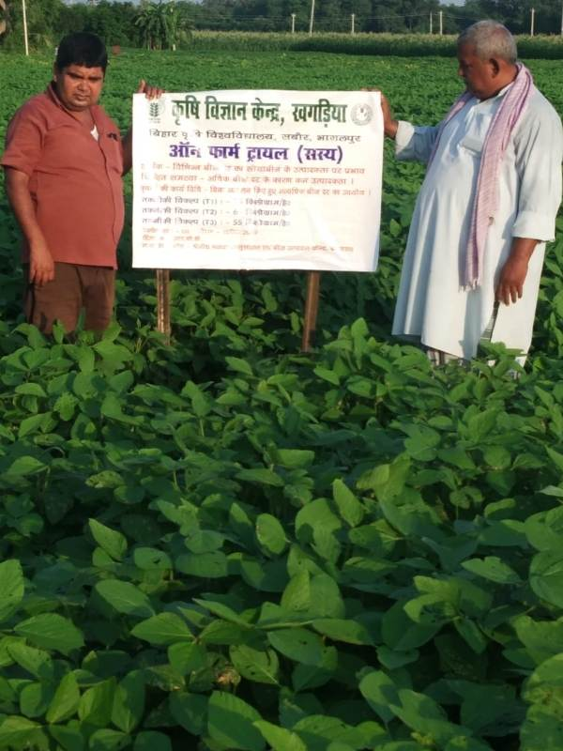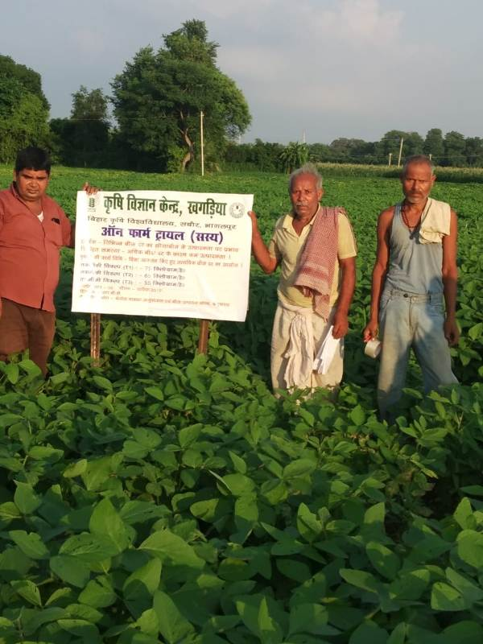

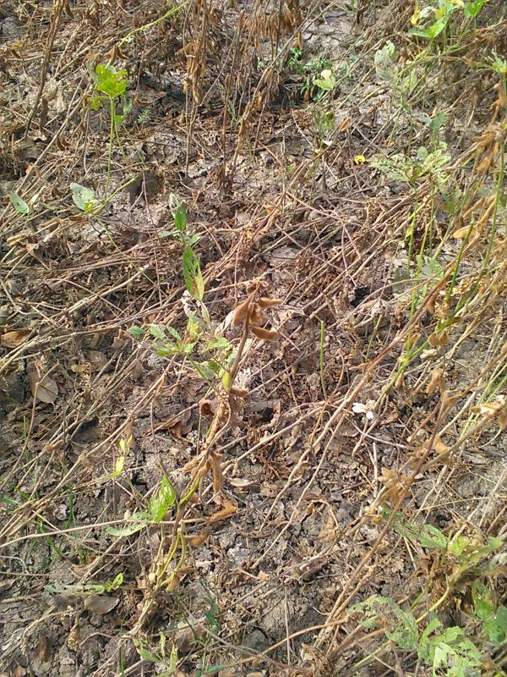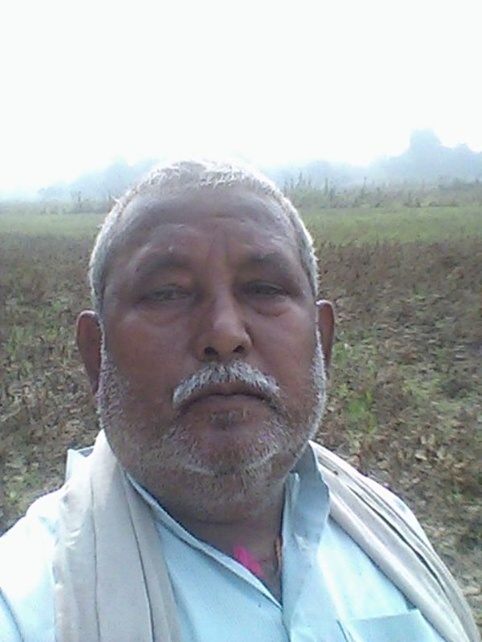

**Crop was damaged due to heavy rain fall and flood in last week of Sept, 2019**

**OFT-2 (Agronomy)**

|  |  |  |
| --- | --- | --- |
| 1. | Title of On farm Trial | **Assessment of Rabi Maize productivity under different fertility level.** |
| 2. | Problem diagnosed | Farmers are using very high dose of fertilizer for getting higher yield. |
| 3. | Details of technologies selected for assessment/refinement | TO1 : Use of high unestimated dose of fertilizers Farmers  practice  TO2 : 120 : 75 : 50 Kg/ha N:P:K (Recommended dose)  TO 3 : 150 : 95 : 65 Kg/ha N:P:K  TO4 : 180 : 115 : 75 Kg/ha N:P:K |
| 4. | Source of Technology | ICAR, Reginal Maize Research and Seed Production Centre,  Begusarai, Bihar |
| 5. | Production system and thematic area | Maize-Maize, Paddy-Wheat, Paddy- Maize and Cropping system |
| 6. | Performance of the Technology with performance indicators | No. of grain/cob, Test wt.(g), Grain yield (q/ha), Cost of cultivation (Rs/ha), Gross return (Rs/ha), Net Return (Rs/ha), B:C ratio. |
| 7. | Final recommendation for micro level situation |  |
| 8. | Constraints identified and feedback for research | To standardize the rate of application of fertilizers in the maize crop of Khagaria district |
| 9. | Process of farmers participation and their reaction | 08 |

**Results: Awaited**

**OFT-3 (Home Science)**

|  |  |  |
| --- | --- | --- |
| 1. | Title of On farm Trial | **Assessment of drudgery reducing weeding tool for farm women in Khagaria district** |
| 2. | Problem diagnosed | Lower working efficiency and productivity of traditional tools |
| 3. | Details of technologies selected for assessment/refinement | Farmers Practice : weeding by local Khurpi  TO 1 : weeding by Saral Khurpi  TO 2 : Weeding by Falcon Khurpi |
| 4. | Source of Technology | College of Rural Home Science, UAS, Dharwad, Karnataka |
| 5. | Production system and thematic area | Vegetable cultivation in backyards and nutri-gardens and |
| 6. | Performance of the Technology with performance indicators | No. of grain/cob, Test wt.(g), Grain yield (q/ha), Cost of cultivation (Rs/ha), Gross return (Rs/ha), Net Return (Rs/ha), B:C ratio. |
| 7. | Final recommendation for micro level situation |  |
| 8. | Constraints identified and feedback for research | To enhance weeding efficiency per hour  To reduce total time required for weeding per unit area |
| 9. | Process of farmers participation and their reaction | 04 |

***Thematic area:***Drudgery Reduction

**Problem definition:** Farm women of Khagaria district generally use traditional Khurpi for weeding in kitchen gardens which is very much labour intensive and time consuming

**Details of technologies selected for assessment**

Technology Option 1 : weeding by local khurpi (Farmers Practice)

Technology Option 2 : weeding by Saral khurpi

Technology Option 3 : Weeding by Falcon Khurpi

**Table 1: Output of respondents performing activities by employing weeding tools in Nutritional garden. (Plot Size- 1000 sq. Feet)**

|  |  |  |
| --- | --- | --- |
| **Technology** | **Working day** | **Works done / hour (Sq. feet)** |
| **Farmers Practice** | 03 | 41.66 |
| **TO 2** | 02 | 62.50 |
| **TO 3** | 2.5 | 50.00 |

**Table 2 : Labour cost**

|  |  |  |
| --- | --- | --- |
| **Technology** | **Labour wages** | **Cost (Rs)** |
| **Farmers Practice** | Rs. 400 x 3 days | 1200.00 |
| **TO 2** | Rs. 400 x 2 days | 800.00 |
| **TO 3** | Rs. 400 x 2.5 days | 1000.00 |

**It was observed that use the of Saral Khurapi (TO2) was more economically viable and superior in terms of reducing drudgery which was following by falcon Khurpi (TO3).**

**OFT-4 (Home Science)**

|  |  |  |
| --- | --- | --- |
| 1. | Title of On farm Trial | **Assessment of different drying methods on quality of dried Oyster Mushroom** |
| 2. | Problem diagnosed | Poor dehydration technique applied by rural mushroom consumers |
| 3. | Details of technologies selected for assessment/refinement | TO 1 : Cutting into pieces and drying in Sun (Farmers Practice)  TO 2 : Washing, cutting into even pieces, blanching, treating with salt solution (0.5 %) and drying in sun  TO 3 : Washing, cutting into even pieces, blanching, treating with citric acid (0.25 %) and drying in Sun.  TO 4 : Washing, cutting into even pieces, blanching, treating with Potassium metabisulphite solution and KMS (0.1 %), drying in Sun. |
| 4. | Source of Technology | NRC, Solan |
| 5. | Production system and thematic area | Value addition |
| 6. | Performance of the Technology with performance indicators | The study of keeping quality of oyster mushroom preserved for three months revealed that blanching with KMS treatment produced best result in terms of colour, texture, flavour and taste. Again general acceptability was also found to be highest in the treatment. This was followed by blanching with sun drying. |
| 7. | Final recommendation for micro level situation | Blanching with KMS treatment can be recommended to the farmers due to best result result produced as described. |
| 8. | Constraints identified and feedback for research | Lack of motivation for marketing of dried mushroom among mushroom growers. |
| 9. | Process of farmers participation and their reaction | Training, Kisan Choupal, Demonstrations |

**Performance Indicator**

**Table: Effect of different drying practices on time of drying and keeping quality as well as recovery of dehydrated mushroom**

|  |  |  |  |  |
| --- | --- | --- | --- | --- |
| **Technology option** | **Drying Time (in days)** | **Recovery of Dehydrated Mushroom (g/kg)** | **Keeping Quality (Month)** | **Unit Cost (Rs)** |
| TO 1 | 4 | 140 | 3.5 | 112.00 |
| TO 2 | 3 | 150 | 4.5 | 120.00 |
| TO 3 | 3 | 140 | 6.0 | 112.00 |
| TO 4 | 3 | 130 | 5.0 | 140.00 |

**Table: Acceptability score of sensory characteristic of dried Oyster Mushroom Products**

|  |  |  |  |  |  |
| --- | --- | --- | --- | --- | --- |
| **Technology option** | **Colour** | **Texture** | **Flavour** | **Taste** | **General Acceptability** |
| TO 1 | 7.2 | 7.0 | 7.0 | 7.2 | 7.0 |
| TO 2 | 7.4 | 7.2 | 7.0 | 7.2 | 7.0 |
| TO 3 | 7.8 | 7.2 | 7.2 | 7.6 | 8.0 |
| TO 4 | 7.6 | 7.0 | 7.0 | 7.4 | 7.6 |

**Result :** Observation of keeping quality of oyster mushroom preserved for three months revealed that blanching with Potassium Meta-bi-sulphate treatment produced best result in terms of colour, texture, flavour and taste. Again general acceptability was also found to be highest in the treatment. This was followed by blanching with sun drying.

**OFT-05 (Home Science)**

|  |  |  |
| --- | --- | --- |
| 1. | Title of On farm Trial | Assessment of effect of different casing materials on the growth and yield of Button mushroom |
| 2. | Problem diagnosed | Farm women’s products have low keeping quality, color and solidness with low economic returns |
| 3. | Details of technologies selected for assessment/refinement | Farmers Practice: Use of only soil  TO1 : 2 years old cow dung and Soil of orchard (1:1)  TO2 : Cocopits and Soil of orchard (1:1) |
| 4. | Source of Technology | NRCM, Solan, HP |
| 5. | Production system and thematic area | Nutritional security |
| 6. | Performance of the Technology with performance indicators | (**a) Technical observation**  (1) Yield (Kg / bag) (2) Self life of Button mushroom (3) Keeping quality  **(b) Economic indicator**  (1) Cost of cultivation (2) Net return (3) BCR |
| 7. | Final recommendation for micro level situation |  |
| 8. | Constraints identified and feedback for research |  |
| 9. | Process of farmers participation and their reaction |  |

**Result : Awaited**

**OFT – 05 (Plant Protection)**

|  |  |  |
| --- | --- | --- |
| 1. | Title of On farm Trial | To test the efficacy of chemical pesticides and biofertilizers against FAW in maize crops |
| 2. | Problem diagnosed | Management of insect in Maize Crops |
| 3. | Details of technologies selected for assessment/refinement | PF :- Propenofose 50 EC @1ml/lit of water  TO 1 :- Azadiractin 1500 ppm @ 4-5 ml/lit  TO – 2 :- Lambda cyhalothrin 5 % EC 1ml/lit of water |
| 4. | Source of Technology | IARI, New Delhi |
| 5. | Production system and thematic area | Soybean - Maize |
| 6. | Performance of the Technology with performance indicators | 1. Increase in yield3 2. Cost of Intervention 3. Cost of Cultivation |
| 7. | Final recommendation for micro level situation | ---- |
| 8. | Constraints identified and feedback for research | Beneficial for natural enmies, environment and low cost input. |
| 9. | Process of farmers participation and their reaction | --- |

**Result : Awaited**

**3.2 Achievements of Frontline Demonstrations**

**A. Details of FLDs conducted during the year**

**Cereals :**

|  |  |  |  |  |  |  |  |  |  |  |  |  |  |  |  |
| --- | --- | --- | --- | --- | --- | --- | --- | --- | --- | --- | --- | --- | --- | --- | --- |
| **Sl.**  **No.** | **Crop** | **Thematic area** | **Technology Demonstrated with detailed treatments** | **Area (ha)** | | **No. of farmers/**  **demonstration** | | | | | | | | | **Reasons for shortfall in achievement** |
| **Proposed** | **Actual** | **SC** | | **ST** | | **Others** | | **Total** | | |  |
|  |  |  |  |  |  | **M** | **F** | **M** | **F** | **M** | **F** | **M** | **F** | **T** |  |
| 1. | Paddy | Cropping System | Var. - Sabour Ardhajal | 04 | 04 | 04 | - | - | - | 06 | - | 10 | - | 10 |  |
| 2. | Wheat | Cropping system | Var – HD – 2967 | 04 | 04 | 04 | - | - | - | 06 | - | 10 | - | 10 |
| 3. | Wheat | Cropping system | Var. – BHU – 25, BHU – 31 and WB - 02 | 0.8 | 0.8 | 01 | - | - | - | 04 | - | 05 | - | 05 |  |

**Details of farming situation**

|  |  |  |  |  |  |  |  |  |  |  |  |
| --- | --- | --- | --- | --- | --- | --- | --- | --- | --- | --- | --- |
| **Crop** | **Season** | **Farming situation (RF/Irrigated)** | **Soil type** | **Status of soil**  **(Kg/ha)** | | | **Previous crop** | **Sowing date** | **Harvest date** | **Seasonal rainfall (mm)** | **No. of rainy days** |
| **N** | **P2O5** | **K2O** |
| Paddy | Kharif 2019 | Irrigated | Clay Loam | 361 | 35 | 235 | Maize and Wheat | 11.07.2019 to 15.07.2019 | 10.11.2019 to 14.11.2019 | NA | NA |
| Wheat | Rabi 2019-20 | Irrigated | Clay Loam | 355 | 37 | 215 | Maize, Paddy and Soybean | 28.11.2019 to 05.12.2019 | Crop is standing in the field | | |
| Wheat | Rabi 2019-20 | Irrigated | Clay Loam | 350 | 33 | 221 | Maize and Paddy | 28.11.2019 to 30.11.2019 | Crop is standing in the field | | |

**Note :-** In both the Tables, information of same crop should be provided. For example, if in Table 3.2A crops are mentioned as a,b,c,d etc., in the table for Details of farming situation, the same crop should be mentioned in the identical sequence.

**Performance of FLD**

**Cereals:**

Frontline demonstrations on Cereals crops

|  |  |  |  |  |  |  |  |  |  |  |  |  |  |  |  |
| --- | --- | --- | --- | --- | --- | --- | --- | --- | --- | --- | --- | --- | --- | --- | --- |
| **Crop** | **Thematic Area** | **Name of the technology demonstrated** | **No. of Farmers** | **Area**  **(ha)** | **Yield (q/ha)** | | **% Increase** | **\*Economics of demonstration (Rs./ha)** | | | | **\*Economics of check**  **(Rs./ha)** | | | |
| **Demo** | **Check** | **Gross**  **Cost** | **Gross**  **Return** | **Net Return** | **\*\***  **BCR** | **Gross**  **Cost** | **Gross**  **Return** | **Net Return** | **\*\***  **BCR** |
| Paddy | Cropping System | ImprovedVariety –Sabour Ardhajal | 10 | 4.00 | 30.65 | 26.50 | 15.66 | 30000 | 52105 | 22105 | 1.74 | 30000 | 45050 | 15050 | 1.50 |
| Wheat | Cropping System | ImprovedVariety – HD – 2967 | 10 | 4.00 | Crop is standing in the field | | | | | | | | | | |
| Wheat | Cropping System | Var. – BHU – 25, BHU – 31 and WB - 02 | 05 | 0.80 | Crop is standing in the field | | | | | | | | | | |

**Oilseeds:**

Frontline demonstrations on oilseed crops

|  |  |  |  |  |  |  |  |  |  |  |  |  |  |  |  |
| --- | --- | --- | --- | --- | --- | --- | --- | --- | --- | --- | --- | --- | --- | --- | --- |
| **Crop** | **Thematic Area** | **Name of the technology demonstrated** | **No. of Farmers** | **Area**  **(ha)** | **Yield (q/ha)** | | **% Increase** | **\*Economics of demonstration (Rs./ha)** | | | | **\*Economics of check**  **(Rs./ha)** | | | |
| **Demo** | **Check** | **Gross**  **Cost** | **Gross**  **Return** | **Net Return** | **\*\***  **BCR** | **Gross**  **Cost** | **Gross**  **Return** | **Net Return** | **\*\***  **BCR** |
|  |  |  |  |  |  |  |  |  |  |  |  |  |  |  |  |

* Economics to be worked out based on total cost of production per unit area and not on critical inputs alone.

** BCR= GROSS RETURN/GROSS COST

**Pulses :**Frontline demonstration on pulse crops

|  |  |  |  |  |  |  |  |  |  |  |  |  |  |  |  |
| --- | --- | --- | --- | --- | --- | --- | --- | --- | --- | --- | --- | --- | --- | --- | --- |
| **Crop** | **Thematic Area** | **Name of the technology demonstrated** | **No. of Farmers** | **Area**  **(ha)** | **Yield (q/ha)** | | **% Increase** | **\*Economics of demonstration (Rs./ha)** | | | | **\*Economics of check**  **(Rs./ha)** | | | |
| **Demo** | **Check** | **Gross**  **Cost** | **Gross**  **Return** | **Net Return** | **\*\***  **BCR** | **Gross**  **Cost** | **Gross**  **Return** | **Net Return** | **\*\***  **BCR** |
|  |  |  |  |  |  |  |  |  |  |  |  |  |  |  |  |

* Economics to be worked out based on total cost of production per unit area and not on critical inputs alone.

** BCR= GROSS RETURN/GROSS COST

**Other crops**

|  |  |  |  |  |  |  |  |  |  |  |  |  |  |  |  |  |  |
| --- | --- | --- | --- | --- | --- | --- | --- | --- | --- | --- | --- | --- | --- | --- | --- | --- | --- |
| **Crop** | **Thematic area** | **Name of the technology demonstrated** | **No. of Farmer** | **Area**  **(ha)** | **Yield (q/ha)** | | **% change in yield** | **Other parameters** | | **\*Economics of demonstration (Rs./ha)** | | | | **\*Economics of check**  **(Rs./ha)** | | | |
| **Demons**  **ration** | **Check** | **Demo** | **Check** | **Gross**  **Cost** | **Gross**  **Return** | **Net Return** | **\*\***  **BCR** | **Gross**  **Cost** | **Gross**  **Return** | **Net Return** | **\*\***  **BCR** |
|  |  |  |  |  |  |  |  |  |  |  |  |  |  |  |  |  |  |

**Livestock**

|  |  |  |  |  |  |  |  |
| --- | --- | --- | --- | --- | --- | --- | --- |
| **Category** | **Thematic**  **area** | **Name of the technology demonstrated** | **No. of Farmer** | **No. of units** | **Major parameters** | | **% change in major parameter** |
| **Demonstration** | **Check** |
| **1** | **2** | **3** | **4** | **5** | **6** | **7** | **8** |
| Dairy |  |  |  |  |  |  |  |
| Buffalo |  |  |  |  |  |  |  |
| Sheep and goat |  |  |  |  |  |  |  |
| Others (pl.specify) |  |  |  |  |  |  |  |
| Total |  |  |  |  |  |  |  |

|  |  |  |  |  |  |  |  |  |  |
| --- | --- | --- | --- | --- | --- | --- | --- | --- | --- |
| **Other parameter** | | **\*Economics of demonstration (Rs.)** | | | | **\*Economics of check (Rs.)** | | | |
| **Demons**  **ration** | **Check** | **Gross**  **Cost** | **Gross**  **Return** | **Net Return** | **\*\***  **BCR** | **Gross**  **Cost** | **Gross**  **Return** | **Net Return** | **\*\***  **BCR** |
| **9** | **10** | **11** | **12** | **13** | **14** | **15** | **16** | **17** | **18** |
|  |  |  |  |  |  |  |  |  |  |

* Economics to be worked out based on total cost of production per unit area and not on critical inputs alone.

** BCR= GROSS RETURN/GROSS COST

**Fisheries**

|  |  |  |  |  |  |  |  |  |  |  |  |  |  |  |  |  |  |  |
| --- | --- | --- | --- | --- | --- | --- | --- | --- | --- | --- | --- | --- | --- | --- | --- | --- | --- | --- |
| **Category** | **Thematic area** | | **Name of the technology demonstrated** | **No. of Farmer** | **No.of units** | **Major parameters** | | **% change in major parameter** | **Other parameter** | | **\*Economics of demonstration (Rs.)** | | | | **\*Economics of check**  **(Rs.)** | | | |
| **Demons**  **ration** | **Check** | **Demons**  **ration** | **Check** | **Gross**  **Cost** | **Gross**  **Return** | **Net Return** | **\*\***  **BCR** | **Gross**  **Cost** | **Gross**  **Return** | **Net Return** | **\*\***  **BCR** |
| **Common carps** |  | |  |  |  |  |  |  |  |  |  |  |  |  |  |  |  |  |
| **Mussels** |  | |  |  |  |  |  |  |  |  |  |  |  |  |  |  |  |  |
| **Ornamental fishes** |  | |  |  |  |  |  |  |  |  |  |  |  |  |  |  |  |  |
| **Others (pl.specify)** |  | |  |  |  |  |  |  |  |  |  |  |  |  |  |  |  |  |
|  |  | |  |  |  |  |  |  |  |  |  |  |  |  |  |  |  |  |
|  | | Total | |  |  |  | | | | | | | | | | | | |

* Economics to be worked out based on total cost of production per unit area and not on critical inputs alone.

** BCR= GROSS RETURN/GROSS COST

**Other enterprises**

|  |  |  |  |  |  |  |  |  |  |  |  |  |  |  |  |  |
| --- | --- | --- | --- | --- | --- | --- | --- | --- | --- | --- | --- | --- | --- | --- | --- | --- |
| **Category** | **Name of the technology demonstrated** | **No. of Farmer** | **No.of units** | **Major parameters** | | **% change in major parameter** | **Other parameter** | | **\*Economics of demonstration (Rs.) or Rs./unit** | | | | **\*Economics of check**  **(Rs.) or Rs./unit** | | | |
| **Demons**  **ration** | **Check** | **Demons**  **ration** | **Check** | **Gross**  **Cost** | **Gross**  **Return** | **Net Return** | **\*\***  **BCR** | **Gross**  **Cost** | **Gross**  **Return** | **Net Return** | **\*\***  **BCR** |
| Oyster mushroom | **Enterprise development** | **50** | **10** | **8.4** | **-** | **-** | **-** | **-** | **441** | **1050** | **609** | **2.38** | **-** | **-** | **-** | **-** |
| Button mushroom | **Enterprise development** | **10** | **10** | **8.2** | **-** | **-** | **-** | **-** | **441** | **1025** | **584** | **2.32** | **-** | **-** | **-** | **-** |
| Vermicompost |  |  |  |  |  |  |  |  |  |  |  |  |  |  |  |  |
| Sericulture |  |  |  |  |  |  |  |  |  |  |  |  |  |  |  |  |
| Apiculture |  |  |  |  |  |  |  |  |  |  |  |  |  |  |  |  |
| Others (pl.specify) |  |  |  |  |  |  |  |  |  |  |  |  |  |  |  |  |
| Total | |  |  |  | | | | | | | | | | | | |

* Economics to be worked out based on total cost of production per unit area and not on critical inputs alone.

** BCR= GROSS RETURN/GROSS COST

**Women empowerment**

|  |  |  |  |  |  |
| --- | --- | --- | --- | --- | --- |
| **Category** | **Name of technology** | **No. of demonstrations** | **Observations** | | **Remarks** |
| **Demonstration** | **Check** |
| Farm Women | Improved Sickel | 20 | Fast Harvesting Rate | Slow Harvesting Rate |  |
| Pregnant women | Nutrition Garden | 40 | Balanced Diet | Unbalanced Diet |  |
| Adolescent Girl |  |  |  |  |  |
| Other women | Tie & Dye Kit | 20 | Improved quality and better beauty | Low quality without beauty |  |
| Children |  |  |  |  |  |
| Neonatal |  |  |  |  |  |
| Infants |  |  |  |  |  |

**Farm implements and machinery**

|  |  |  |  |  |  |  |  |  |  |  |  |  |  |  |  |
| --- | --- | --- | --- | --- | --- | --- | --- | --- | --- | --- | --- | --- | --- | --- | --- |
| **Name of the implement** | **Crop** | **Name of the technology demonstrated** | **No. of Farmer** | **Area (Acre)** | **Filed observation (output/man hour)** | | **% change in major parameter** | **Labor reduction (man days)** | | | | **Cost reduction (Rs./ha or Rs./Unit)** | | | |
| **Demons**  **ration** | **Check** |  |  |  |  |  |  |  |  |
| Happy Seeder | Wheat , Maize | Resource Conservation Technology | 19 | 35.5 |  |  |  |  |  |  |  |  |  |  |  |
| Zero Tillage | Wheat , Maize, Lentil | Resource Conservation Technology | 65 | 67.5 |  |  |  |  |  |  |  |  |  |  |  |

* Economics to be worked out based on total cost of production per unit area and not on critical inputs alone.

** BCR= GROSS RETURN/GROSS COST

**Demonstration details on crop hybrids**

|  |  |  |  |  |  |  |  |  |  |  |
| --- | --- | --- | --- | --- | --- | --- | --- | --- | --- | --- |
| **Crop** | **Name of the Hybrid** | **No. of**  **farmers** | **Area**  **(ha)** | **Yield (kg/ha) / major parameter** | | | **Economics (Rs./ha)** | | | |
| **Cereals** |  |  |  | **Demo** | **Local check** | **% change** | **Gross**  **Cost** | **Gross**  **Return** | **Net**  **Return** | **BCR** |
| Bajra |  |  |  |  |  |  |  |  |  |  |
| Maize |  |  |  |  |  |  |  |  |  |  |
| Paddy |  |  |  |  |  |  |  |  |  |  |
| Sorghum |  |  |  |  |  |  |  |  |  |  |
| Wheat |  |  |  |  |  |  |  |  |  |  |
| Others (Pl. specify) |  |  |  |  |  |  |  |  |  |  |
| Total |  |  |  |  |  |  |  |  |  |  |
| Oilseeds |  |  |  |  |  |  |  |  |  |  |
| Castor |  |  |  |  |  |  |  |  |  |  |
| Mustard |  |  |  |  |  |  |  |  |  |  |
| Safflower |  |  |  |  |  |  |  |  |  |  |
| Sesame |  |  |  |  |  |  |  |  |  |  |
| Sunflower |  |  |  |  |  |  |  |  |  |  |
| Groundnut |  |  |  |  |  |  |  |  |  |  |
| Soybean |  |  |  |  |  |  |  |  |  |  |
| Others (Pl. specify) |  |  |  |  |  |  |  |  |  |  |
| Total |  |  |  |  |  |  |  |  |  |  |
| Pulses |  |  |  |  |  |  |  |  |  |  |
| Greengram |  |  |  |  |  |  |  |  |  |  |
| Blackgram |  |  |  |  |  |  |  |  |  |  |
| Bengalgram |  |  |  |  |  |  |  |  |  |  |
| Redgram |  |  |  |  |  |  |  |  |  |  |
| Others (Pl. specify) |  |  |  |  |  |  |  |  |  |  |
| Total |  |  |  |  |  |  |  |  |  |  |
| Vegetable crops |  |  |  |  |  |  |  |  |  |  |
| Bottle gourd |  |  |  |  |  |  |  |  |  |  |
| Capsicum |  |  |  |  |  |  |  |  |  |  |
| Cucumber |  |  |  |  |  |  |  |  |  |  |
| Tomato |  |  |  |  |  |  |  |  |  |  |
| Brinjal |  |  |  |  |  |  |  |  |  |  |
| Okra |  |  |  |  |  |  |  |  |  |  |
| Onion |  |  |  |  |  |  |  |  |  |  |
| Potato |  |  |  |  |  |  |  |  |  |  |
| Field bean |  |  |  |  |  |  |  |  |  |  |
| Others (Pl. specify) |  |  |  |  |  |  |  |  |  |  |
| Total |  |  |  |  |  |  |  |  |  |  |
| Commercial crops |  |  |  |  |  |  |  |  |  |  |
| Cotton |  |  |  |  |  |  |  |  |  |  |
| Coconut |  |  |  |  |  |  |  |  |  |  |
| Others (Pl. specify) |  |  |  |  |  |  |  |  |  |  |
|  |  |  |  |  |  |  |  |  |  |  |
| Total |  |  |  |  |  |  |  |  |  |  |
| Fodder crops |  |  |  |  |  |  |  |  |  |  |
| Napier (Fodder) |  |  |  |  |  |  |  |  |  |  |
| Maize (Fodder) |  |  |  |  |  |  |  |  |  |  |
| Sorghum (Fodder) |  |  |  |  |  |  |  |  |  |  |
| Others (Pl. specify) |  |  |  |  |  |  |  |  |  |  |
| Total |  |  |  |  |  |  |  |  |  |  |

**Technical Feedback on the demonstrated technologies**

|  |  |  |
| --- | --- | --- |
| Sl. No | Crop | Feed Back |
|  | Paddy (Var. - Sabour Ardhajal) | Good cooking quality, has less stickiness but yield is lower than that of hybrid varieties |
|  | Wheat (Var – HD – 2967) |  |
|  | Wheat (Var. – BHU – 25, BHU – 31 and WB – 02) |  |
|  | Bhindi Plucker | It is a tool which helps on plucking of Bhindi ( Lady’s finger) without causing any itching or discomfort to skin. |
|  | Oyster Mushroom Kit | Good for the nutritional security and income generation particularly for the landless households. The variety which can be cultivated round the year in normal condition should be developed. |
|  | Pheromone Trap |  |
|  |  |  |

**Extension and Training activities under FLD**

|  |  |  |  |  |  |
| --- | --- | --- | --- | --- | --- |
| **Sl.No.** | **Activity** | **Date** | **No. of activities organized** | **Number of participants** | **Remarks** |
| 1. | Field days |  |  |  |  |
| 2. | Farmers Training | 01.06.2019, 08.06.2019, 15.06.2019, 30.06.2019, 06.07.2019, 13.07.2019, 20.07.2019 | 07 | 383 |  |
| 3. | Media coverage |  |  |  |  |
| 4. | Training for extension functionaries | 13.08.2019 | 01 | 30 |  |

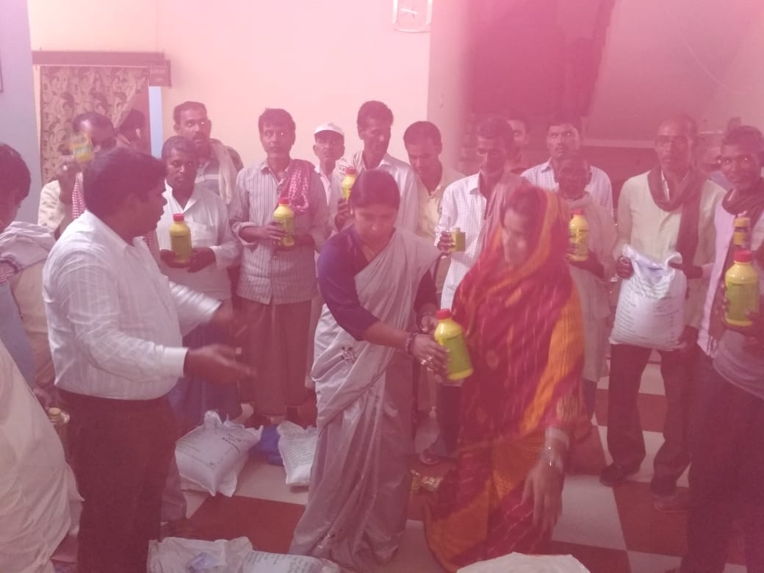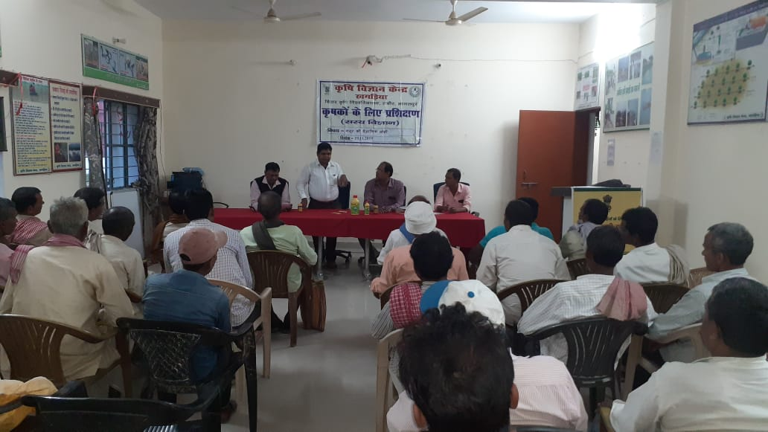

**Performance of the demonstration under CFLD on Pulse and Oilseed Crops during Kharif 2019 and Rabi 2019-20:**

1. **Technical Parameters :**

|  |  |  |  |  |  |  |  |  |  |  |  |  |  |  |  |
| --- | --- | --- | --- | --- | --- | --- | --- | --- | --- | --- | --- | --- | --- | --- | --- |
| **Sl.**  **No.** | **Crop demonstrated** | **Existing (Farmer's) variety name** | **Existing yield**  **(q/ha)** | **Yield gap (Kg/ha)**  **w.r.to** | | | **Name of Variety + Technology**  **demonstrated** | **Number of farmers** | **Area in ha** | **Yield obtained (q/ha)** | | | **Yield gap minimized**  **(%)** | | |
| **District**  **yield (D)** | **State**  **yield (S)** | **Potential**  **yield (P)** |
| **Max.** | **Min.** | **Av.** | **D** | **S** | **P** |
| 1. | Summer Green Gram | Local | 6.60 | 6.24 | 6.24 | 15.00 | Improved variety seed (HUM-16), inoculation of seed with Rhizobium culture Carbendazim and Chloropyriphos. Soil application of Azitibactor with PSB. Pendimethalin for weed control and Monocrotophos for plant protection | 51 | 20 | 9.00 | 7.25 | 8.05 |  |  |  |
| 2 | Soybean | JS-335 |  |  |  |  | Improved variety of seed (PS-1042), inoculation of seed with Carbendazim, Imizathipar for weed control and Rocket for plant protection | 50 | 20.00 | Crop was damaged due to heavy rain fall in last week of Sept., 2019 | | | | | |
| 3 | Lentil | Arun |  | NA | NA | NA | Improved variety seed HUL-57 inocolution of seed with Carbendazim, cholropyriphous and Rhizobium culture, Pendimethelin for weed control. | 55 | 20.00 | Crop is standing in the farmers field | | | | | |

1. **Economic parameters**

|  |  |  |  |  |  |  |  |  |  |
| --- | --- | --- | --- | --- | --- | --- | --- | --- | --- |
| **Sl.**  **No.** | **Variety demonstrated & Technology demonstrated** | **Farmer’s Existing plot** | | | | **Demonstration plot** | | | |
| **Gross Cost**  **(Rs/ha)** | **Gross return**  **(Rs/ha)** | **Net Return**  **(Rs/ha)** | **B:C**  **ratio** | **Gross Cost**  **(Rs/ha)** | **Gross return**  **(Rs/ha)** | **Net Return**  **(Rs/ha)** | **B:C**  **ratio** |
| 1 | Improved variety seed (HUM-16), inoculation of seed with Rhizobium culture Carbendazim and Chloropyriphos. Soil application of Azitibactor with PSB. Pendimethalin for weed control and Monocrotophos for plant protection | 22000 | 33000 | 11000 | 1.50 | 22000 | 40250 | 18250 | 1.83 |
| 2 | Improved variety of seed (PS-1042) inculation of seed with carbendazim, Imizathipar for weed control and Rocket for plant protection | 30000 | NA | NA | NA | 30000 | Crop was damaged due to heavy rain fall in last week of Sept., 2019 | | |
| 3 | Improved variety seed HUL-57 inocolution of seed with Carbendazim, cholropyriphous and Rhizobium culture, Pendimethelin for weed control. | Crop is standing in the farmers field | | | | | | | |

1. **Socio-economic impact parameters**

|  |  |  |  |  |  |  |  |  |
| --- | --- | --- | --- | --- | --- | --- | --- | --- |
| **Sl.**  **No.** | **Crop and variety**  **Demonstrated** | **Total Produce**  **Obtained (kg)** | **Produce sold**  **(Kg/household)** | **Selling**  **Rate**  **(Rs/Kg)** | **Produce used for own sowing (Kg)** | **Produce distributed to other farmers (Kg)** | **Purpose for which income gained was utilized** | **Employment Generated (Mandays/house hold)** |
| 1 | Summer Green Gram  (HUM-16) | 16100 | As per need kept for seed purpose and rest produce sold | 50 | To be sown in summer season | NA | Personal Need | NA |
| 2 | Soybean  (PS-1042) | Crop was damaged due to heavy rain fall in last week of Sept., 2019 | | | | | | |
| 3 | Lentil  (HUL-57) | Crop is standing in the farmers field | | | | | | |

1. **Oilseed Farmers’ perception of the intervention demonstrated**

|  |  |  |  |  |  |  |  |
| --- | --- | --- | --- | --- | --- | --- | --- |
| **Sl.**  **No.** | **Technologies demonstrated**  **(with name)** | **Farmers' Perception parameters** | | | | | |
| **Suitability to their farming system** | **Likings**  **(Preference)** | **Affordability** | **Any negative effect** | **Is Technology acceptable to all in the group/village** | **Suggestions, for change/improvement, if any** |
| 1 | Improved variety seed (HUM-16), inoculation of seed with Rhizobium culture Carbendazim and Chloropyriphos. Soil application of Azitibactor with PSB. Pendimethalin for weed control and Monocrotophos for plant protection | Suitable in irrigated condition | Due to Higher production in medium size of grain hence more marketability | Seed and input cost is very much affordable to farmers | NO | Yes | Late sown variety with sowing time in the last week of April to middle of May should be developed |
| 2 | Improved variety of seed (PS-1042) inculation of seed with carbendazim, Imizathipar for weed control and Rocket for plant protection | Crop was damaged due to heavy rain fall in last week of Sept., 2019 | | | | | |
| 3 | Improved variety seed HUL-57 inocolution of seed with Carbendazim, cholropyriphous and Rhizobium culture, Pendimethelin for weed control. | Crop is standing in the farmers field | | | | | |

1. **Specific Characteristics of Technology and Performance**
2. **Greengram**

|  |  |  |  |
| --- | --- | --- | --- |
| **Specific Characteristic** | **Performance** | **Performance of Technology vis-a vis Local Check** | **Farmers Feedback** |
| Quality seed | Potential Yield 15 q/ha | 21.96 % increase in yield | Most of the farmers preferred the variety due to its higher productivity . |
| Inoculation of seed with Rhizobium culture | Early germination, better root growth and profuse flowering | Early germination better root growth and profuse flowering |

1. **Extension activities under FLD conducted:**

|  |  |  |  |  |
| --- | --- | --- | --- | --- |
| **Sl. No.** | **Extension Activities organized** | **Date and place of activity** | **Number of farmer attended** |  |
| 1 | Field Day | 28/06/2019, Bauchhouta | 88 |  |
| 2 | Field Day | 28/06/2019, Ranko | 115 |  |
| 3 | Training (Mushroom) | 28/06/2019, KVK Campus | 21 |  |
| 4 | Training | 26-27/06/2019, KVK | 26 |  |
| 5 | Training | 05/07/2019, KVK | 30 |  |
| 6 | Training | 05/07/2019, KVK | 35 |  |
| 7 | Training | 08-09/07/2019, KVK | 23 |  |
| 8 | Training | 07-08/08/2019, KVK | 21 |  |
| 9 | Training | 13/08/2019, KVK | 29 |  |
| 10 | Training | 03-04/09/2019, KVK | 24 |  |
| 11 | Training | 13/09/2019, KVK | 21 |  |
| 12 | Training | 08/11/2019, KVK | 25 |  |
| 13 | Training | 19/11/2019, KVK | 30 |  |
| 14 | Training | 30/11/2019, KVK | 18 |  |

**Sequential good quality photographs (as per crop stages i.e. growth & development)**

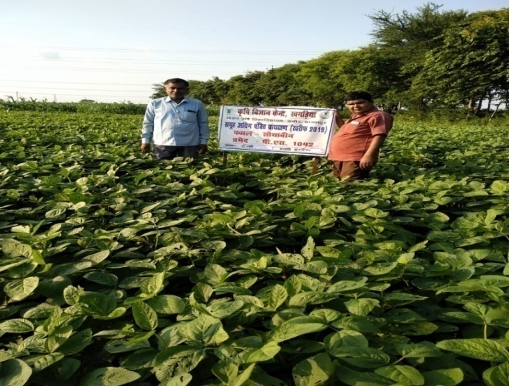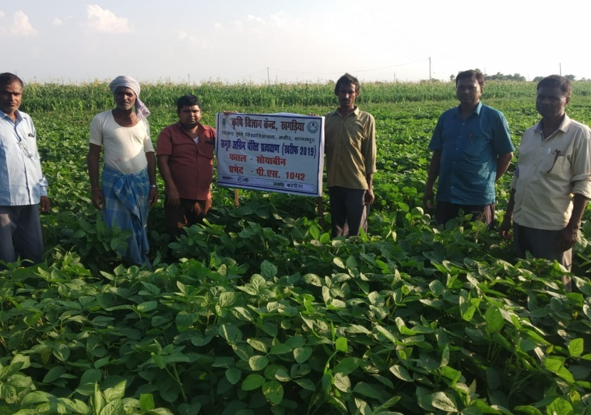

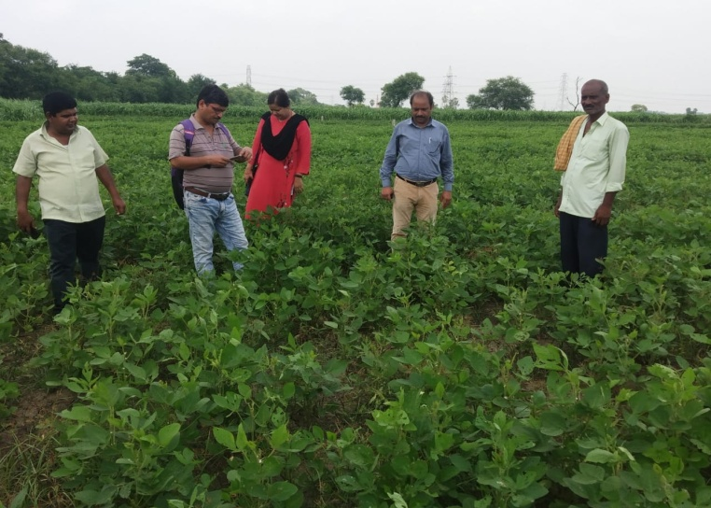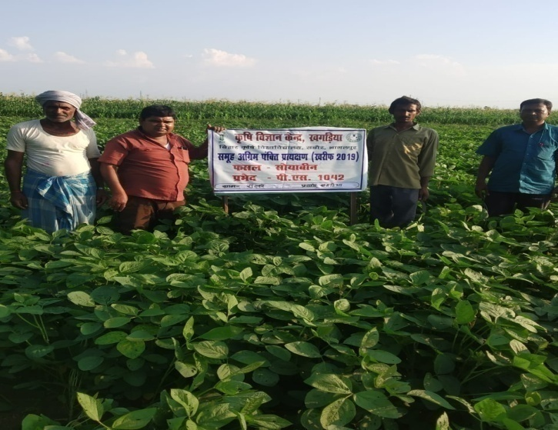

1. **Farmers' training photographs**

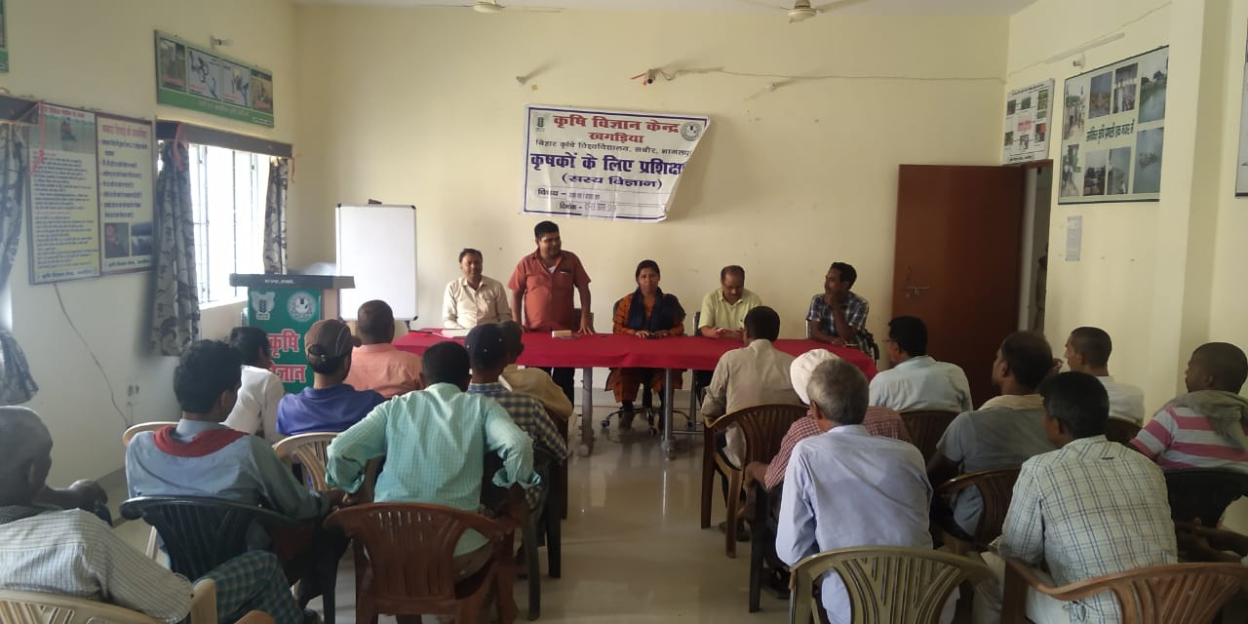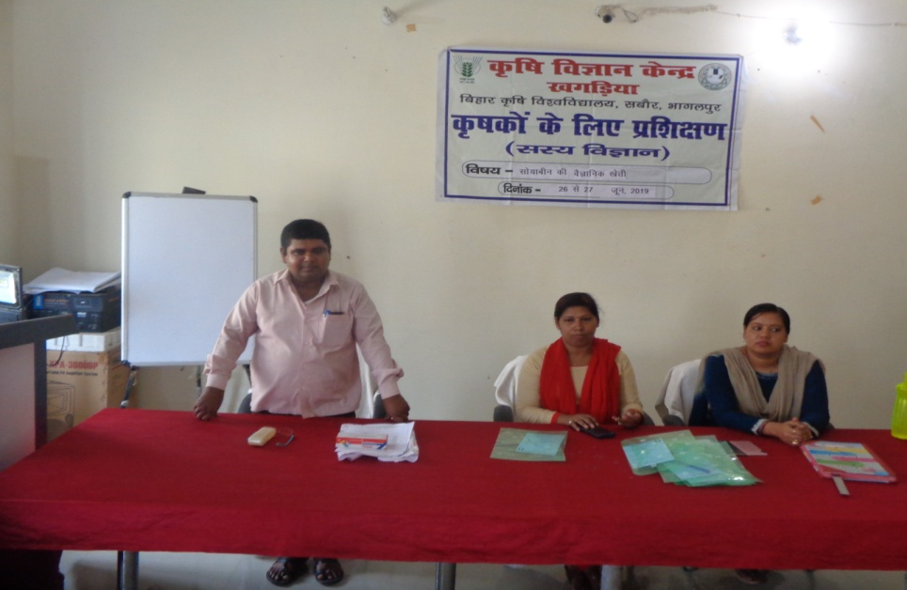

1. **Quality Action Photographs of field visits/field days and technology demonstrated.**

**J. Details of budget utilization**

|  |  |  |  |  |
| --- | --- | --- | --- | --- |
| **Crop**  **(provide crop wise information )** | **Items** | **Budget**  **Received**  **(Rs.)** | **Budget**  **Utilization**  **(Rs.)** | **Balance**  **(Rs.)** |
| Soybean | i) Critical input | 1,50000.00 | 1,50000.00 | NIL |
| ii) TA/DA/POL etc. for monitoring |
| iii) Extension Activities (Field day) |
| iv)Publication of literature |
|  | **Total** | **1,50000.00** | **1,50000.00** | **NIL** |

* 1. **Achievements on Training (Including the sponsored and FLD training programmes):**

1. **Farmers and farm women (on campus)**

| **Thematic Area** | **No. of Courses** | **No. of Participants** | | | | | | | | | | **Grand Total** | | |
| --- | --- | --- | --- | --- | --- | --- | --- | --- | --- | --- | --- | --- | --- | --- |
| **Other** | | | **SC** | | | | **ST** | | |
|  | **M** | **F** | **T** | **M** | **F** | | **T** | **M** | **F** | **T** | **M** | **F** | **T** |
| **I. Crop Production** |  |  |  |  |  |  | |  |  |  |  |  |  |  |
| Weed Management | **02** | **21** | **-** | **21** | - | - | | - | - | - | - | **21** | - | **21** |
| Resource Conservation Technologies |  |  |  |  |  |  | |  |  |  |  |  |  |  |
| Cropping Systems | **05** | **108** | **14** | **122** | **07** | **03** | | **10** | - | - | - | **115** | **17** | **132** |
| Crop Diversification | **06** | **73** | - | **73** | **06** | - | | **06** | - | - | - | **79** | - | **79** |
| Integrated Farming |  |  |  |  |  |  | |  |  |  |  |  |  |  |
| Water management |  |  |  |  |  |  | |  |  |  |  |  |  |  |
| Seed production | **25** | **14** | - | **14** | **06** | - | | **06** | - | - | - | **20** | - | **20** |
| Nursery management |  |  |  |  |  |  | |  |  |  |  |  |  |  |
| Integrated Crop Management |  |  |  |  |  |  | |  |  |  |  |  |  |  |
| Fodder production |  |  |  |  |  |  | |  |  |  |  |  |  |  |
| Production of organic inputs |  |  |  |  |  |  | |  |  |  |  |  |  |  |
| Others, (cultivation of crops ) | **01** | **20** | **02** | **22** | **06** | **01** | | **07** | - | - | - | **26** | **03** | **29** |
| **II. Horticulture** |  |  |  |  |  |  | |  |  |  |  |  |  |  |
| **a) Vegetable Crops** |  |  |  |  |  |  | |  |  |  |  |  |  |  |
| Integrated nutrient management |  |  |  |  |  |  | |  |  |  |  |  |  |  |
| Water management |  |  |  |  |  |  | |  |  |  |  |  |  |  |
| Enterprise development |  |  |  |  |  |  | |  |  |  |  |  |  |  |
| Skill development |  |  |  |  |  |  | |  |  |  |  |  |  |  |
| Yield increment |  |  |  |  |  |  | |  |  |  |  |  |  |  |
| Production of low volume and high value crops |  |  |  |  |  |  | |  |  |  |  |  |  |  |
| Off-season vegetables |  |  |  |  |  |  | |  |  |  |  |  |  |  |
| Nursery raising |  |  |  |  |  |  | |  |  |  |  |  |  |  |
| Export potential vegetables |  |  |  |  |  |  | |  |  |  |  |  |  |  |
| Grading and standardization |  |  |  |  |  |  | |  |  |  |  |  |  |  |
| Protective cultivation (Green Houses, Shade Net etc.) |  |  |  |  |  |  | |  |  |  |  |  |  |  |
| Others, if any (Cultivation of Vegetable) |  |  |  |  |  |  | |  |  |  |  |  |  |  |
| Training and Pruning |  |  |  |  |  |  | |  |  |  |  |  |  |  |
| **b) Fruits** |  |  |  |  |  |  | |  |  |  |  |  |  |  |
| Layout and Management of Orchards |  |  |  |  |  |  | |  |  |  |  |  |  |  |
| Cultivation of Fruit | **01** | **22** | **02** | **24** | **02** | - | | **02** | - | - | - | **24** | **02** | **26** |
| Management of young plants/orchards |  |  |  |  |  |  | |  |  |  |  |  |  |  |
| Rejuvenation of old orchards |  |  |  |  |  |  | |  |  |  |  |  |  |  |
| Export potential fruits |  |  |  |  |  |  | |  |  |  |  |  |  |  |
| Micro irrigation systems of orchards |  |  |  |  |  |  | |  |  |  |  |  |  |  |
| Plant propagation techniques |  |  |  |  |  |  | |  |  |  |  |  |  |  |
| Others, if any(INM) |  |  |  |  |  |  | |  |  |  |  |  |  |  |
| **c) Ornamental Plants** |  |  |  |  |  |  | |  |  |  |  |  |  |  |
| Nursery Management |  |  |  |  |  |  | |  |  |  |  |  |  |  |
| Management of potted plants |  |  |  |  |  |  | |  |  |  |  |  |  |  |
| Export potential of ornamental plants |  |  |  |  |  |  | |  |  |  |  |  |  |  |
| Propagation techniques of Ornamental Plants |  |  |  |  |  |  | |  |  |  |  |  |  |  |
| Others, if any |  |  |  |  |  |  | |  |  |  |  |  |  |  |
| **d) Plantation crops** |  |  |  |  |  |  | |  |  |  |  |  |  |  |
| Production and Management technology |  |  |  |  |  |  | |  |  |  |  |  |  |  |
| Processing and value addition |  |  |  |  |  |  | |  |  |  |  |  |  |  |
| Others, if any |  |  |  |  |  |  | |  |  |  |  |  |  |  |
| **e) Tuber crops** |  |  |  |  |  |  | |  |  |  |  |  |  |  |
| Production and Management technology |  |  |  |  |  |  | |  |  |  |  |  |  |  |
| Processing and value addition |  |  |  |  |  |  | |  |  |  |  |  |  |  |
| Others, if any |  |  |  |  |  |  | |  |  |  |  |  |  |  |
| **f) Spices** |  |  |  |  |  |  | |  |  |  |  |  |  |  |
| Production and Management technology |  |  |  |  |  |  | |  |  |  |  |  |  |  |
| Processing and value addition |  |  |  |  |  |  | |  |  |  |  |  |  |  |
| Others, if any |  |  |  |  |  |  | |  |  |  |  |  |  |  |
| **g) Medicinal and Aromatic Plants** |  |  |  |  |  |  | |  |  |  |  |  |  |  |
| Nursery management |  |  |  |  |  |  | |  |  |  |  |  |  |  |
| Production and management technology |  |  |  |  |  |  | |  |  |  |  |  |  |  |
| Post harvest technology and value addition |  |  |  |  |  |  | |  |  |  |  |  |  |  |
| Others, if any |  |  |  |  |  |  | |  |  |  |  |  |  |  |
| **III. Soil Health and Fertility Management** |  |  |  |  |  |  | |  |  |  |  |  |  |  |
| Soil fertility management |  |  |  |  |  |  | |  |  |  |  |  |  |  |
| Soil and Water Conservation |  |  |  |  |  |  | |  |  |  |  |  |  |  |
| Integrated Nutrient Management |  |  |  |  |  |  | |  |  |  |  |  |  |  |
| Production and use of organic inputs |  |  |  |  |  |  | |  |  |  |  |  |  |  |
| Management of Problematic soils |  |  |  |  |  |  | |  |  |  |  |  |  |  |
| Micro nutrient deficiency in crops |  |  |  |  |  |  | |  |  |  |  |  |  |  |
| Nutrient Use Efficiency |  |  |  |  |  |  | |  |  |  |  |  |  |  |
| Soil and Water Testing |  |  |  |  |  |  | |  |  |  |  |  |  |  |
| Others, if any |  |  |  |  |  |  | |  |  |  |  |  |  |  |
| **IV. Livestock Production and Management** |  |  |  |  |  |  | |  |  |  |  |  |  |  |
| Dairy Management |  |  |  |  |  |  | |  |  |  |  |  |  |  |
| Poultry Management |  |  |  |  |  |  | |  |  |  |  |  |  |  |
| Piggery Management |  |  |  |  |  |  | |  |  |  |  |  |  |  |
| Rabbit Management |  |  |  |  |  |  | |  |  |  |  |  |  |  |
| Disease Management |  |  |  |  |  |  | |  |  |  |  |  |  |  |
| Feed management |  |  |  |  |  |  | |  |  |  |  |  |  |  |
| Production of quality animal products |  |  |  |  |  |  | |  |  |  |  |  |  |  |
| Others, if any Goat farming |  |  |  |  |  |  | |  |  |  |  |  |  |  |
| **V. Home Science/Women empowerment** |  |  |  |  |  |  | |  |  |  |  |  |  |  |
| Household food security by kitchen gardening and nutrition gardening |  |  |  |  |  |  | |  |  |  |  |  |  |  |
| Design and development of low/minimum cost diet |  |  |  |  |  |  | |  |  |  |  |  |  |  |
| Designing and development for high nutrient efficiency diet |  |  |  |  |  |  | |  |  |  |  |  |  |  |
| Minimization of nutrient loss in processing |  |  |  |  |  |  | |  |  |  |  |  |  |  |
| Gender mainstreaming through SHGs |  |  |  |  |  |  | |  |  |  |  |  |  |  |
| Storage loss minimization techniques |  |  |  |  |  |  | |  |  |  |  |  |  |  |
| Enterprise development |  |  |  |  |  |  | |  |  |  |  |  |  |  |
| Value addition |  |  |  |  |  |  | |  |  |  |  |  |  |  |
| Income generation activities for empowerment of rural Women | **01** | **11** | **08** | **19** | **02** | - | | **02** | - | - | - | **13** | **08** | **21** |
| Location specific drudgery reduction technologies |  |  |  |  |  |  | |  |  |  |  |  |  |  |
| Rural Crafts |  |  |  |  |  |  | |  |  |  |  |  |  |  |
| Capacity building | **01** | - | **29** | **29** | **-** | **20** | | **20** | - | - | - | - | **49** | **49** |
| Women and child care |  |  |  |  |  |  | |  |  |  |  |  |  |  |
| Others, if any |  |  |  |  |  |  | |  |  |  |  |  |  |  |
| **VI.Agril. Engineering** |  |  |  |  |  |  | |  |  |  |  |  |  |  |
| Installation and maintenance of micro irrigation systems |  |  |  |  |  |  | |  |  |  |  |  |  |  |
| Use of Plastics in farming practices |  |  |  |  |  |  | |  |  |  |  |  |  |  |
| Production of small tools and implements |  |  |  |  |  |  | |  |  |  |  |  |  |  |
| Repair and maintenance of farm machinery and implements |  |  |  |  |  |  | |  |  |  |  |  |  |  |
| Small scale processing and value addition |  |  |  |  |  |  | |  |  |  |  |  |  |  |
| Post Harvest Technology |  |  |  |  |  |  | |  |  |  |  |  |  |  |
| Others, if any |  |  |  |  |  |  | |  |  |  |  |  |  |  |
| **VII. Plant Protection** |  |  |  |  |  |  | |  |  |  |  |  |  |  |
| Integrated Pest Management | **13** | **238** | **29** | **267** | **22** | **19** | | **41** | - | - | - | **260** | **48** | **308** |
| Integrated Disease Management | **13** | **238** | **19** | **257** | **22** | **20** | | **42** | - | - | - | **260** | **39** | **299** |
| Bio-control of pests and diseases |  |  |  |  |  |  | |  |  |  |  |  |  |  |
| Production of bio control agents and bio pesticides |  |  |  |  |  | |  |  |  |  |  |  |  |  |
| Others, if any |  |  |  |  |  | |  |  |  |  |  |  |  |  |
| **VIII. Fisheries** |  |  |  |  |  | |  |  |  |  |  |  |  |  |
| Integrated fish farming |  |  |  |  |  | |  |  |  |  |  |  |  |  |
| Carp breeding and hatchery management |  |  |  |  |  | |  |  |  |  |  |  |  |  |
| Carp fry and fingerling rearing |  |  |  |  |  | |  |  |  |  |  |  |  |  |
| Composite fish culture & fish disease |  |  |  |  |  | |  |  |  |  |  |  |  |  |
| Fish feed preparation & its application to fish pond, like nursery, rearing & stocking pond |  |  |  |  |  | |  |  |  |  |  |  |  |  |
| Hatchery management and culture of freshwater prawn |  |  |  |  |  | |  |  |  |  |  |  |  |  |
| Breeding and culture of ornamental fishes |  |  |  |  |  | |  |  |  |  |  |  |  |  |
| Portable plastic carp hatchery |  |  |  |  |  | |  |  |  |  |  |  |  |  |
| Pen culture of fish and prawn |  |  |  |  |  | |  |  |  |  |  |  |  |  |
| Shrimp farming |  |  |  |  |  | |  |  |  |  |  |  |  |  |
| Edible oyster farming |  |  |  |  |  | |  |  |  |  |  |  |  |  |
| Pearl culture |  |  |  |  |  | |  |  |  |  |  |  |  |  |
| Fish processing and value addition |  |  |  |  |  | |  |  |  |  |  |  |  |  |
| Others, if any |  |  |  |  |  | |  |  |  |  |  |  |  |  |
| **IX. Production of Inputs at site** |  |  |  |  |  | |  |  |  |  |  |  |  |  |
| Seed Production |  |  |  |  |  | |  |  |  |  |  |  |  |  |
| Planting material production |  |  |  |  |  | |  |  |  |  |  |  |  |  |
| Bio-agents production |  |  |  |  |  | |  |  |  |  |  |  |  |  |
| Bio-pesticides production |  |  |  |  |  | |  |  |  |  |  |  |  |  |
| Bio-fertilizer production |  |  |  |  |  | |  |  |  |  |  |  |  |  |
| Vermi-compost production |  |  |  |  |  | |  |  |  |  |  |  |  |  |
| Organic manures production |  |  |  |  |  | |  |  |  |  |  |  |  |  |
| Production of fry and fingerlings |  |  |  |  |  | |  |  |  |  |  |  |  |  |
| Production of Bee-colonies and wax sheets |  |  |  |  |  | |  |  |  |  |  |  |  |  |
| Small tools and implements |  |  |  |  |  | |  |  |  |  |  |  |  |  |
| Production of livestock feed and fodder |  |  |  |  |  | |  |  |  |  |  |  |  |  |
| Production of Fish feed |  |  |  |  |  | |  |  |  |  |  |  |  |  |
| Others, if any |  |  |  |  |  | |  |  |  |  |  |  |  |  |
| **X. Capacity Building and Group Dynamics** |  |  |  |  |  | |  |  |  |  |  |  |  |  |
| Leadership development |  |  |  |  |  | |  |  |  |  |  |  |  |  |
| Group dynamics |  |  |  |  |  | |  |  |  |  |  |  |  |  |
| Formation and Management of SHGs |  |  |  |  |  | |  |  |  |  |  |  |  |  |
| Mobilization of social capital |  |  |  |  |  | |  |  |  |  |  |  |  |  |
| Entrepreneurial development of farmers/youths |  |  |  |  |  | |  |  |  |  |  |  |  |  |
| WTO and IPR issues |  |  |  |  |  | |  |  |  |  |  |  |  |  |
| Others, if any |  |  |  |  |  | |  |  |  |  |  |  |  |  |
| XI Agro-forestry |  |  |  |  |  | |  |  |  |  |  |  |  |  |
| Production technologies |  |  |  |  |  | |  |  |  |  |  |  |  |  |
| Nursery management |  |  |  |  |  | |  |  |  |  |  |  |  |  |
| Integrated Farming Systems |  |  |  |  |  | |  |  |  |  |  |  |  |  |
| **XII. Others (Pl. Specify)** |  |  |  |  |  | |  |  |  |  |  |  |  |  |
| **TOTAL** | **68** | **745** | **103** | **848** | **73** | | **63** | **136** | - | - | - | **818** | **166** | **984** |

**B) Rural Youth (on campus)**

| **Thematic Area** | **No. of Courses** | **No. of Participants** | | | | | | | | | | **Grand Total** | | |
| --- | --- | --- | --- | --- | --- | --- | --- | --- | --- | --- | --- | --- | --- | --- |
| **Other** | | | **SC** | | | | **ST** | | |
|  | **M** | **F** | **T** | **M** | **F** | | **T** | **M** | **F** | **T** | **M** | **F** | **T** |
| Mushroom Production | **10** | **22** | **12** | **34** | **17** | | **14** | **31** | - | - | - | **39** | **26** | **65** |
| Bee-keeping |  |  |  |  |  | |  |  |  |  |  |  |  |  |
| Integrated farming |  |  |  |  |  | |  |  |  |  |  |  |  |  |
| Seed production | **02** | **14** | **07** | **21** | **02** | | **02** | **04** | - | - | - | **16** | **09** | **25** |
| Production of organic inputs |  |  |  |  |  | |  |  |  |  |  |  |  |  |
| Integrated Farming (INM) | **02** | **79** | **10** | **89** | **14** | | **11** | **25** | - | - | - | **93** | **21** | **114** |
| Planting material production |  |  |  |  |  | |  |  |  |  |  |  |  |  |
| Vermi-culture |  |  |  |  |  | |  |  |  |  |  |  |  |  |
| Sericulture |  |  |  |  |  | |  |  |  |  |  |  |  |  |
| Protected cultivation of vegetable crops |  |  |  |  |  | |  |  |  |  |  |  |  |  |
| Commercial fruit production |  |  |  |  |  | |  |  |  |  |  |  |  |  |
| Repair and maintenance of farm machinery and implements |  |  |  |  |  | |  |  |  |  |  |  |  |  |
| Nursery Management of Horticulture crops |  |  |  |  |  | |  |  |  |  |  |  |  |  |
| Training and pruning of orchards |  |  |  |  |  | |  |  |  |  |  |  |  |  |
| Value addition |  |  |  |  |  | |  |  |  |  |  |  |  |  |
| Production of quality animal products |  |  |  |  |  | |  |  |  |  |  |  |  |  |
| Dairying |  |  |  |  |  | |  |  |  |  |  |  |  |  |
| Sheep and goat rearing |  |  |  |  |  | |  |  |  |  |  |  |  |  |
| Quail farming |  |  |  |  |  | |  |  |  |  |  |  |  |  |
| Piggery |  |  |  |  |  | |  |  |  |  |  |  |  |  |
| Rabbit farming |  |  |  |  |  | |  |  |  |  |  |  |  |  |
| Poultry production |  |  |  |  |  | |  |  |  |  |  |  |  |  |
| Ornamental fisheries |  |  |  |  |  | |  |  |  |  |  |  |  |  |
| Enterprise development | **01** | **06** | **05** | **11** | **05** | | **04** | **09** | - | - | - | **11** | **09** | **20** |
| Para vets |  |  |  |  |  | |  |  |  |  |  |  |  |  |
| Para extension workers |  |  |  |  |  | |  |  |  |  |  |  |  |  |
| Composite fish culture |  |  |  |  |  | |  |  |  |  |  |  |  |  |
| Freshwater prawn culture |  |  |  |  |  | |  |  |  |  |  |  |  |  |
| Shrimp farming |  |  |  |  |  | |  |  |  |  |  |  |  |  |
| Pearl culture |  |  |  |  |  | |  |  |  |  |  |  |  |  |
| Cold water fisheries |  |  |  |  |  | |  |  |  |  |  |  |  |  |
| Fish harvest and processing technology |  |  |  |  |  | |  |  |  |  |  |  |  |  |
| Fry and fingerling rearing |  |  |  |  |  | |  |  |  |  |  |  |  |  |
| Small scale processing |  |  |  |  |  | |  |  |  |  |  |  |  |  |
| Post Harvest Technology |  |  |  |  |  | |  |  |  |  |  |  |  |  |
| Tailoring and Stitching |  |  |  |  |  | |  |  |  |  |  |  |  |  |
| Rural Crafts |  |  |  |  |  | |  |  |  |  |  |  |  |  |
| **TOTAL** | **15** | **121** | **34** | **155** | **38** | | **31** | **69** | - | - | - | **159** | **65** | **224** |

1. **Extension Personnel (on campus)**

| Thematic Area | No. of Courses | No. of Participants | | | | | | | | | | Grand Total | | |
| --- | --- | --- | --- | --- | --- | --- | --- | --- | --- | --- | --- | --- | --- | --- |
| Other | | | SC | | | | ST | | |
|  | M | F | T | M | F | | T | M | F | T | M | F | T |
| Productivity enhancement in field crops | **03** | **75** | **05** | **80** | **19** | | **01** | **20** | - | - | - | **94** | **06** | **100** |
| Value addition |  |  |  |  |  | |  |  |  |  |  |  |  |  |
| Integrated Pest Management | **04** | **263** | **21** | **284** | **18** | | **13** | **31** | - | - | - | **281** | **34** | **315** |
| Integrated Nutrient management |  |  |  |  |  | |  |  |  |  |  |  |  |  |
| Rejuvenation of old orchards |  |  |  |  |  | |  |  |  |  |  |  |  |  |
| Protected cultivation technology |  |  |  |  |  | |  |  |  |  |  |  |  |  |
| Formation and Management of SHGs |  |  |  |  |  | |  |  |  |  |  |  |  |  |
| Group Dynamics and farmers organization |  |  |  |  |  | |  |  |  |  |  |  |  |  |
| Information networking among farmers |  |  |  |  |  | |  |  |  |  |  |  |  |  |
| Capacity building for ICT application |  |  |  |  |  | |  |  |  |  |  |  |  |  |
| Care and maintenance of farm machinery and implements |  |  |  |  |  | |  |  |  |  |  |  |  |  |
| WTO and IPR issues |  |  |  |  |  | |  |  |  |  |  |  |  |  |
| Management in farm animals |  |  |  |  |  | |  |  |  |  |  |  |  |  |
| Livestock feed and fodder production |  |  |  |  |  | |  |  |  |  |  |  |  |  |
| Household food security |  |  |  |  |  | |  |  |  |  |  |  |  |  |
| Women and Child care |  |  |  |  |  | |  |  |  |  |  |  |  |  |
| Low cost and nutrient efficient diet designing |  |  |  |  |  | |  |  |  |  |  |  |  |  |
| Production and use of organic inputs |  |  |  |  |  | |  |  |  |  |  |  |  |  |
| Gender mainstreaming through SHGs |  |  |  |  |  | |  |  |  |  |  |  |  |  |
| **TOTAL** | **07** | **338** | **26** | **364** | **37** | | **14** | **51** | - | - | - | **375** | **40** | **415** |

**D) Farmers and farm women (off campus)**

| **Thematic Area** | **No. of Courses** | **No. of Participants** | | | | | | | | | | **Grand Total** | | |
| --- | --- | --- | --- | --- | --- | --- | --- | --- | --- | --- | --- | --- | --- | --- |
| **Other** | | | **SC** | | | | **ST** | | |
|  | **M** | **F** | **T** | **M** | **F** | | **T** | **M** | **F** | **T** | **M** | **F** | **T** |
| **I. Crop Production** |  |  |  |  |  |  | |  |  |  |  |  |  |  |
| Weed Management | **03** | **61** | **20** | **81** | **03** | - | | **03** | - | - | - | **64** | **20** | **84** |
| Resource Conservation Technologies |  |  |  |  |  |  | |  |  |  |  |  |  |  |
| Cropping Systems | **08** | **101** | **22** | **123** | **31** | **15** | | **46** | - | - | - | **132** | **37** | **169** |
| Crop Diversification |  |  |  |  |  |  | |  |  |  |  |  |  |  |
| Integrated Farming |  |  |  |  |  |  | |  |  |  |  |  |  |  |
| Water management |  |  |  |  |  |  | |  |  |  |  |  |  |  |
| Seed production |  |  |  |  |  |  | |  |  |  |  |  |  |  |
| Nursery management | **02** | **18** | **02** | **20** | **05** | **01** | | **06** | - | - | - | **23** | **03** | **26** |
| Integrated Crop Management | **01** | **21** | **11** | **32** | **18** | **05** | | **22** | - | - | - | **39** | **16** | **55** |
| Fodder production |  |  |  |  |  |  | |  |  |  |  |  |  |  |
| Production of organic inputs |  |  |  |  |  |  | |  |  |  |  |  |  |  |
| Others, (cultivation of crops ) |  |  |  |  |  |  | |  |  |  |  |  |  |  |
| **II. Horticulture** |  |  |  |  |  |  | |  |  |  |  |  |  |  |
| **a) Vegetable Crops** |  |  |  |  |  |  | |  |  |  |  |  |  |  |
| Integrated nutrient management |  |  |  |  |  |  | |  |  |  |  |  |  |  |
| Water management |  |  |  |  |  |  | |  |  |  |  |  |  |  |
| Enterprise development |  |  |  |  |  |  | |  |  |  |  |  |  |  |
| Skill development |  |  |  |  |  |  | |  |  |  |  |  |  |  |
| Yield increment |  |  |  |  |  |  | |  |  |  |  |  |  |  |
| Production of low volume and high value crops |  |  |  |  |  |  | |  |  |  |  |  |  |  |
| Off-season vegetables |  |  |  |  |  |  | |  |  |  |  |  |  |  |
| Nursery raising |  |  |  |  |  |  | |  |  |  |  |  |  |  |
| Export potential vegetables |  |  |  |  |  |  | |  |  |  |  |  |  |  |
| Grading and standardization |  |  |  |  |  |  | |  |  |  |  |  |  |  |
| Protective cultivation (Green Houses, Shade Net etc.) | **01** | **22** | - | **22** | **07** | **01** | | **08** | - | - | - | **29** | **01** | **30** |
| Others, if any (Cultivation of Vegetable) | **01** | **20** | - | **20** | **09** | - | | **09** | - | - | - | **29** | - | **29** |
| Training and Pruning |  |  |  |  |  |  | |  |  |  |  |  |  |  |
| **b) Fruits** |  |  |  |  |  |  | |  |  |  |  |  |  |  |
| Layout and Management of Orchards | **02** | **22** | **02** | **24** | **03** | **01** | | **04** | - | - | - | **25** | **03** | **28** |
| Cultivation of Fruit |  |  |  |  |  |  | |  |  |  |  |  |  |  |
| Management of young plants/orchards | **01** | **21** | **-** | **21** | **08** | - | | **08** | - | - | - | **29** | - | **29** |
| Rejuvenation of old orchards |  |  |  |  |  |  | |  |  |  |  |  |  |  |
| Export potential fruits |  |  |  |  |  |  | |  |  |  |  |  |  |  |
| Micro irrigation systems of orchards |  |  |  |  |  |  | |  |  |  |  |  |  |  |
| Plant propagation techniques |  |  |  |  |  |  | |  |  |  |  |  |  |  |
| Others, if any(INM) |  |  |  |  |  |  | |  |  |  |  |  |  |  |
| **c) Ornamental Plants** |  |  |  |  |  |  | |  |  |  |  |  |  |  |
| Nursery Management |  |  |  |  |  |  | |  |  |  |  |  |  |  |
| Management of potted plants |  |  |  |  |  |  | |  |  |  |  |  |  |  |
| Export potential of ornamental plants |  |  |  |  |  |  | |  |  |  |  |  |  |  |
| Propagation techniques of Ornamental Plants |  |  |  |  |  |  | |  |  |  |  |  |  |  |
| Others, if any |  |  |  |  |  |  | |  |  |  |  |  |  |  |
| **d) Plantation crops** |  |  |  |  |  |  | |  |  |  |  |  |  |  |
| Production and Management technology |  |  |  |  |  |  | |  |  |  |  |  |  |  |
| Processing and value addition |  |  |  |  |  |  | |  |  |  |  |  |  |  |
| Others, if any |  |  |  |  |  |  | |  |  |  |  |  |  |  |
| **e) Tuber crops** |  |  |  |  |  |  | |  |  |  |  |  |  |  |
| Production and Management technology |  |  |  |  |  |  | |  |  |  |  |  |  |  |
| Processing and value addition |  |  |  |  |  |  | |  |  |  |  |  |  |  |
| Others, if any |  |  |  |  |  |  | |  |  |  |  |  |  |  |
| **f) Spices** |  |  |  |  |  |  | |  |  |  |  |  |  |  |
| Production and Management technology |  |  |  |  |  |  | |  |  |  |  |  |  |  |
| Processing and value addition |  |  |  |  |  |  | |  |  |  |  |  |  |  |
| Others, if any |  |  |  |  |  |  | |  |  |  |  |  |  |  |
| **g) Medicinal and Aromatic Plants** |  |  |  |  |  |  | |  |  |  |  |  |  |  |
| Nursery management |  |  |  |  |  |  | |  |  |  |  |  |  |  |
| Production and management technology |  |  |  |  |  |  | |  |  |  |  |  |  |  |
| Post harvest technology and value addition |  |  |  |  |  |  | |  |  |  |  |  |  |  |
| Others, if any |  |  |  |  |  |  | |  |  |  |  |  |  |  |
| **III. Soil Health and Fertility Management** |  |  |  |  |  |  | |  |  |  |  |  |  |  |
| Soil fertility management |  |  |  |  |  |  | |  |  |  |  |  |  |  |
| Soil and Water Conservation |  |  |  |  |  |  | |  |  |  |  |  |  |  |
| Integrated Nutrient Management |  |  |  |  |  |  | |  |  |  |  |  |  |  |
| Production and use of organic inputs |  |  |  |  |  |  | |  |  |  |  |  |  |  |
| Management of Problematic soils |  |  |  |  |  |  | |  |  |  |  |  |  |  |
| Micro nutrient deficiency in crops |  |  |  |  |  |  | |  |  |  |  |  |  |  |
| Nutrient Use Efficiency |  |  |  |  |  |  | |  |  |  |  |  |  |  |
| Soil and Water Testing |  |  |  |  |  |  | |  |  |  |  |  |  |  |
| Others, if any |  |  |  |  |  |  | |  |  |  |  |  |  |  |
| **IV. Livestock Production and Management** |  |  |  |  |  |  | |  |  |  |  |  |  |  |
| Dairy Management |  |  |  |  |  |  | |  |  |  |  |  |  |  |
| Poultry Management |  |  |  |  |  |  | |  |  |  |  |  |  |  |
| Piggery Management |  |  |  |  |  |  | |  |  |  |  |  |  |  |
| Rabbit Management |  |  |  |  |  |  | |  |  |  |  |  |  |  |
| Disease Management | **02** | **20** | - | **20** | **05** | **-** | | **05** | - | - | - | **25** | - | **25** |
| Feed management | **02** | **22** | **02** | **24** | **03** | **01** | | **04** | - | - | - | **25** | **03** | **28** |
| Production of quality animal products |  |  |  |  |  |  | |  |  |  |  |  |  |  |
| Others, if any Goat farming |  |  |  |  |  |  | |  |  |  |  |  |  |  |
| **V. Home Science/Women empowerment** |  |  |  |  |  |  | |  |  |  |  |  |  |  |
| Household food security by kitchen gardening and nutrition gardening | **01** | - | **15** | **15** | **-** | **10** | | **10** | - | - | - | - | **25** | **25** |
| Design and development of low/minimum cost diet |  |  |  |  |  |  | |  |  |  |  |  |  |  |
| Designing and development for high nutrient efficiency diet |  |  |  |  |  |  | |  |  |  |  |  |  |  |
| Minimization of nutrient loss in processing |  |  |  |  |  |  | |  |  |  |  |  |  |  |
| Gender mainstreaming through SHGs |  |  |  |  |  |  | |  |  |  |  |  |  |  |
| Storage loss minimization techniques |  |  |  |  |  |  | |  |  |  |  |  |  |  |
| Enterprise development |  |  |  |  |  |  | |  |  |  |  |  |  |  |
| Value addition | **02** | **05** | **06** | **11** | **02** | **04** | | **06** | - | - | - | **11** | **06** | **17** |
| Income generation activities for empowerment of rural Women | **04** | **20** | **07** | **27** | **03** | **37** | | **40** | - | - | - | **23** | **44** | **67** |
| Location specific drudgery reduction technologies | **01** | **10** | **03** | **13** | **05** | **03** | | **08** | - | - | - | **15** | **06** | **21** |
| Rural Crafts |  |  |  |  |  |  | |  |  |  |  |  |  |  |
| Capacity building |  |  |  |  |  |  | |  |  |  |  |  |  |  |
| Women and child care |  |  |  |  |  |  | |  |  |  |  |  |  |  |
| Others, if any |  |  |  |  |  |  | |  |  |  |  |  |  |  |
| **VI.Agril. Engineering** |  |  |  |  |  |  | |  |  |  |  |  |  |  |
| Installation and maintenance of micro irrigation systems |  |  |  |  |  |  | |  |  |  |  |  |  |  |
| Use of Plastics in farming practices |  |  |  |  |  |  | |  |  |  |  |  |  |  |
| Production of small tools and implements |  |  |  |  |  |  | |  |  |  |  |  |  |  |
| Repair and maintenance of farm machinery and implements |  |  |  |  |  |  | |  |  |  |  |  |  |  |
| Small scale processing and value addition |  |  |  |  |  |  | |  |  |  |  |  |  |  |
| Post Harvest Technology |  |  |  |  |  |  | |  |  |  |  |  |  |  |
| Others, if any |  |  |  |  |  |  | |  |  |  |  |  |  |  |
| **VII. Plant Protection** |  |  |  |  |  |  | |  |  |  |  |  |  |  |
| Integrated Pest Management | **06** | **92** | **41** | **133** | **48** | **17** | | **65** | - | - | - | **140** | **58** | **198** |
| Integrated Disease Management | **06** | **90** | **36** | **126** | **40** | **10** | | **50** | - | - | - | **130** | **46** | **176** |
| Bio-control of pests and diseases |  |  |  |  |  |  | |  |  |  |  |  |  |  |
| Production of bio control agents and bio pesticides |  |  |  |  |  | |  |  |  |  |  |  |  |  |
| Others, if any |  |  |  |  |  | |  |  |  |  |  |  |  |  |
| **VIII. Fisheries** |  |  |  |  |  | |  |  |  |  |  |  |  |  |
| Integrated fish farming |  |  |  |  |  | |  |  |  |  |  |  |  |  |
| Carp breeding and hatchery management |  |  |  |  |  | |  |  |  |  |  |  |  |  |
| Carp fry and fingerling rearing |  |  |  |  |  | |  |  |  |  |  |  |  |  |
| Composite fish culture & fish disease |  |  |  |  |  | |  |  |  |  |  |  |  |  |
| Fish feed preparation & its application to fish pond, like nursery, rearing & stocking pond |  |  |  |  |  | |  |  |  |  |  |  |  |  |
| Hatchery management and culture of freshwater prawn |  |  |  |  |  | |  |  |  |  |  |  |  |  |
| Breeding and culture of ornamental fishes |  |  |  |  |  | |  |  |  |  |  |  |  |  |
| Portable plastic carp hatchery |  |  |  |  |  | |  |  |  |  |  |  |  |  |
| Pen culture of fish and prawn |  |  |  |  |  | |  |  |  |  |  |  |  |  |
| Shrimp farming |  |  |  |  |  | |  |  |  |  |  |  |  |  |
| Edible oyster farming |  |  |  |  |  | |  |  |  |  |  |  |  |  |
| Pearl culture |  |  |  |  |  | |  |  |  |  |  |  |  |  |
| Fish processing and value addition |  |  |  |  |  | |  |  |  |  |  |  |  |  |
| Others, if any |  |  |  |  |  | |  |  |  |  |  |  |  |  |
| **IX. Production of Inputs at site** |  |  |  |  |  | |  |  |  |  |  |  |  |  |
| Seed Production |  |  |  |  |  | |  |  |  |  |  |  |  |  |
| Planting material production |  |  |  |  |  | |  |  |  |  |  |  |  |  |
| Bio-agents production |  |  |  |  |  | |  |  |  |  |  |  |  |  |
| Bio-pesticides production |  |  |  |  |  | |  |  |  |  |  |  |  |  |
| Bio-fertilizer production |  |  |  |  |  | |  |  |  |  |  |  |  |  |
| Vermi-compost production |  |  |  |  |  | |  |  |  |  |  |  |  |  |
| Organic manures production |  |  |  |  |  | |  |  |  |  |  |  |  |  |
| Production of fry and fingerlings |  |  |  |  |  | |  |  |  |  |  |  |  |  |
| Production of Bee-colonies and wax sheets |  |  |  |  |  | |  |  |  |  |  |  |  |  |
| Small tools and implements |  |  |  |  |  | |  |  |  |  |  |  |  |  |
| Production of livestock feed and fodder |  |  |  |  |  | |  |  |  |  |  |  |  |  |
| Production of Fish feed |  |  |  |  |  | |  |  |  |  |  |  |  |  |
| Others, if any |  |  |  |  |  | |  |  |  |  |  |  |  |  |
| **X. Capacity Building and Group Dynamics** |  |  |  |  |  | |  |  |  |  |  |  |  |  |
| Leadership development |  |  |  |  |  | |  |  |  |  |  |  |  |  |
| Group dynamics |  |  |  |  |  | |  |  |  |  |  |  |  |  |
| Formation and Management of SHGs |  |  |  |  |  | |  |  |  |  |  |  |  |  |
| Mobilization of social capital |  |  |  |  |  | |  |  |  |  |  |  |  |  |
| Entrepreneurial development of farmers/youths |  |  |  |  |  | |  |  |  |  |  |  |  |  |
| WTO and IPR issues |  |  |  |  |  | |  |  |  |  |  |  |  |  |
| Others, if any |  |  |  |  |  | |  |  |  |  |  |  |  |  |
| XI Agro-forestry |  |  |  |  |  | |  |  |  |  |  |  |  |  |
| Production technologies |  |  |  |  |  | |  |  |  |  |  |  |  |  |
| Nursery management |  |  |  |  |  | |  |  |  |  |  |  |  |  |
| Integrated Farming Systems |  |  |  |  |  | |  |  |  |  |  |  |  |  |
| **XII. Others (Pl. Specify)** |  |  |  |  |  | |  |  |  |  |  |  |  |  |
| **TOTAL** | **43** | **545** | **167** | **712** | **190** | | **105** | **294** | - | - | - | **739** | **268** | **1007** |

**E) RURAL YOUTH (Off Campus)**

| **Thematic Area** | **No. of Courses** | **No. of Participants** | | | | | | | | | | **Grand Total** | | |
| --- | --- | --- | --- | --- | --- | --- | --- | --- | --- | --- | --- | --- | --- | --- |
| **Other** | | | **SC** | | | | **ST** | | |
|  | **M** | **F** | **T** | **M** | **F** | | **T** | **M** | **F** | **T** | **M** | **F** | **T** |
| Mushroom Production | **03** | **87** | **17** | **104** | **10** | | - | **10** | - | - | - | **97** | **17** | **114** |
| Bee-keeping | **01** | **15** | **06** | **21** | **-** | | **-** | **-** | **-** | **-** | **-** | **15** | **06** | **21** |
| Integrated farming | 03 | 20 | 02 | 22 | 03 | | - | 03 | - | - | - | 23 | 02 | 25 |
| Seed production | 02 | 26 | - | 26 | 04 | | - | 4 | - | - | - | 30 | - | 30 |
| Production of organic inputs |  |  |  |  |  | |  |  |  |  |  |  |  |  |
| Integrated Farming |  |  |  |  |  | |  |  |  |  |  |  |  |  |
| Planting material production |  |  |  |  |  | |  |  |  |  |  |  |  |  |
| Vermi-culture |  |  |  |  |  | |  |  |  |  |  |  |  |  |
| Sericulture | 01 | 14 | 02 | 16 | 04 | | 01 | 05 | - | - | - | 18 | 03 | 21 |
| Protected cultivation of vegetable crops |  |  |  |  |  | |  |  |  |  |  |  |  |  |
| Commercial fruit production |  |  |  |  |  | |  |  |  |  |  |  |  |  |
| Repair and maintenance of farm machinery and implements |  |  |  |  |  | |  |  |  |  |  |  |  |  |
| Nursery Management of Horticulture crops |  |  |  |  |  | |  |  |  |  |  |  |  |  |
| Training and pruning of orchards |  |  |  |  |  | |  |  |  |  |  |  |  |  |
| Value addition | 01 | - | 13 | 13 | - | | 11 | 11 | - | - | - | - | 24 | 24 |
| Production of quality animal products |  |  |  |  |  | |  |  |  |  |  |  |  |  |
| Dairying | **09** | **56** | **06** | **62** | **62** | | **14** | **76** | - | - | - | **119** | **20** | **139** |
| Sheep and goat rearing | **03** | **11** | **10** | **21** | **02** | | **02** | **04** | - | - | - | **13** | **12** | **25** |
| Quail farming |  |  |  |  |  | |  |  |  |  |  |  |  |  |
| Piggery |  |  |  |  |  | |  |  |  |  |  |  |  |  |
| Rabbit farming |  |  |  |  |  | |  |  |  |  |  |  |  |  |
| Poultry production |  |  |  |  |  | |  |  |  |  |  |  |  |  |
| Ornamental fisheries |  |  |  |  |  | |  |  |  |  |  |  |  |  |
| Para vets |  |  |  |  |  | |  |  |  |  |  |  |  |  |
| Para extension workers |  |  |  |  |  | |  |  |  |  |  |  |  |  |
| Composite fish culture |  |  |  |  |  | |  |  |  |  |  |  |  |  |
| Freshwater prawn culture |  |  |  |  |  | |  |  |  |  |  |  |  |  |
| Shrimp farming |  |  |  |  |  | |  |  |  |  |  |  |  |  |
| Pearl culture |  |  |  |  |  | |  |  |  |  |  |  |  |  |
| Cold water fisheries |  |  |  |  |  | |  |  |  |  |  |  |  |  |
| Fish harvest and processing technology |  |  |  |  |  | |  |  |  |  |  |  |  |  |
| Fry and fingerling rearing |  |  |  |  |  | |  |  |  |  |  |  |  |  |
| Small scale processing |  |  |  |  |  | |  |  |  |  |  |  |  |  |
| Post Harvest Technology | 01 | 05 | 11 | 16 | - | | 06 | 06 | - | - | - | 05 | 17 | 22 |
| Tailoring and Stitching |  |  |  |  |  | |  |  |  |  |  |  |  |  |
| Rural Crafts | 01 | - | 30 | 30 | - | | 04 | 04 | - | - | - | - | 34 | 34 |
| Others, if any |  |  |  |  |  | |  |  |  |  |  |  |  |  |
| **TOTAL** | **25** | **234** | **97** | **331** | **85** | | **38** | **123** |  |  |  | **320** | **135** | **455** |

**F) Extension Personnel (Off Campus)**

| **Thematic Area** | **No. of Courses** | **No. of Participants** | | | | | | | | | **Grand Total** | | |
| --- | --- | --- | --- | --- | --- | --- | --- | --- | --- | --- | --- | --- | --- |
| **Other** | | | **SC** | | | **ST** | | |
|  | **M** | **F** | **T** | **M** | **F** | **T** | **M** | **F** | **T** | **M** | **F** | **T** |
| Productivity enhancement in field crops |  |  |  |  |  |  |  |  |  |  |  |  |  |
| Integrated Pest Management | **05** | **156** | **75** | **231** | **52** | **25** | **77** | - | - | - | **208** | **100** | **308** |
| Integrated Nutrient management | **02** | **60** | **05** | **65** | **04** | **-** | **04** | - | - | - | **64** | **05** | **69** |
| Rejuvenation of old orchards |  |  |  |  |  |  |  |  |  |  |  |  |  |
| Protected cultivation technology |  |  |  |  |  |  |  |  |  |  |  |  |  |
| Formation and Management of SHGs |  |  |  |  |  |  |  |  |  |  |  |  |  |
| Group Dynamics and farmers organization |  |  |  |  |  |  |  |  |  |  |  |  |  |
| Information networking among farmers |  |  |  |  |  |  |  |  |  |  |  |  |  |
| Capacity building for ICT application |  |  |  |  |  |  |  |  |  |  |  |  |  |
| Care and maintenance of farm machinery and implements |  |  |  |  |  |  |  |  |  |  |  |  |  |
| WTO and IPR issues |  |  |  |  |  |  |  |  |  |  |  |  |  |
| Management in farm animals | **01** | **165** | **11** | **26** | **02** | **01** | **03** | - | - | - | **157** | **12** | **169** |
| Livestock feed and fodder production |  |  |  |  |  |  |  |  |  |  |  |  |  |
| Household food security |  |  |  |  |  |  |  |  |  |  |  |  |  |
| Women and Child care |  |  |  |  |  |  |  |  |  |  |  |  |  |
| Low cost and nutrient efficient diet designing |  |  |  |  |  |  |  |  |  |  |  |  |  |
| Production and use of organic inputs | **04** | **80** | **65** | **145** | **25** | **04** | **29** | - | - | - | **105** | **69** | **174** |
| Gender mainstreaming through SHGs |  |  |  |  |  |  |  |  |  |  |  |  |  |
| Crop intensification |  |  |  |  |  |  |  |  |  |  |  |  |  |
| **TOTAL** | **12** | **461** | **156** | **467** | **83** | **30** | **113** |  |  |  | **534** | **186** | **720** |

**G) Consolidated table (ON and OFF Campus)**

**i. Farmers & Farm Women**

| **Thematic Area** | **No. of Courses** | **No. of Participants** | | | | | | | | | | **Grand Total** | | |
| --- | --- | --- | --- | --- | --- | --- | --- | --- | --- | --- | --- | --- | --- | --- |
| **Other** | | | **SC** | | | | **ST** | | |
|  | **M** | **F** | **T** | **M** | **F** | | **T** | **M** | **F** | **T** | **M** | **F** | **T** |
| **I. Crop Production** |  |  |  |  |  |  | |  |  |  |  |  |  |  |
| Weed Management | 05 | 82 | 20 | 102 | 03 | - | | 03 | - | - | - | 85 | 20 | 105 |
| Resource Conservation Technologies |  |  |  |  |  |  | |  |  |  |  |  |  |  |
| Cropping Systems | 13 | 209 | 36 | 245 | 38 | 18 | | 56 | - | - | - | 247 | 54 | 301 |
| Crop Diversification | 06 | 73 | - | 73 | 06 | - | | 06 | - | - | - | 79 | - | 79 |
| Integrated Farming |  |  |  |  |  |  | |  |  |  |  |  |  |  |
| Water management |  |  |  |  |  |  | |  |  |  |  |  |  |  |
| Seed production | 25 | 14 | 0 | 14 | 06 | 0 | | 06 | 0 | 0 | 0 | 20 | 0 | 20 |
| Nursery management | 02 | 18 | 02 | 20 | 05 | 01 | | 06 | 0 | 0 | 0 | 23 | 03 | 26 |
| Integrated Crop Management | 01 | 21 | 11 | 32 | 18 | 05 | | 22 | 0 | 0 | 0 | 39 | 16 | 55 |
| Fodder production |  |  |  |  |  |  | |  |  |  |  |  |  |  |
| Production of organic inputs |  |  |  |  |  |  | |  |  |  |  |  |  |  |
| Others, (cultivation of crops ) |  |  |  |  |  |  | |  |  |  |  |  |  |  |
| TOTAL |  |  |  |  |  |  | |  |  |  |  |  |  |  |
| **II. Horticulture** |  |  |  |  |  |  | |  |  |  |  |  |  |  |
| **a) Vegetable Crops** |  |  |  |  |  |  | |  |  |  |  |  |  |  |
| Integrated nutrient management |  |  |  |  |  |  | |  |  |  |  |  |  |  |
| Water management |  |  |  |  |  |  | |  |  |  |  |  |  |  |
| Enterprise development |  |  |  |  |  |  | |  |  |  |  |  |  |  |
| Skill development |  |  |  |  |  |  | |  |  |  |  |  |  |  |
| Yield increment |  |  |  |  |  |  | |  |  |  |  |  |  |  |
| Production of low volume and high value crops |  |  |  |  |  |  | |  |  |  |  |  |  |  |
| Off-season vegetables |  |  |  |  |  |  | |  |  |  |  |  |  |  |
| Nursery raising |  |  |  |  |  |  | |  |  |  |  |  |  |  |
| Exotic vegetables like Broccoli |  |  |  |  |  |  | |  |  |  |  |  |  |  |
| Export potential vegetables |  |  |  |  |  |  | |  |  |  |  |  |  |  |
| Grading and standardization |  |  |  |  |  |  | |  |  |  |  |  |  |  |
| Protective cultivation (Green Houses, Shade Net etc.) | 01 | 22 | 0 | 22 | 07 | 01 | | 08 | 0 | 0 | 0 | 29 | 01 | 30 |
| Others, if any (Cultivation of Vegetable) | 01 | 20 | 0 | 20 | 09 | 0 | | 9 | 0 | 0 | 0 | 29 | 0 | 29 |
| TOTAL |  |  |  |  |  |  | |  |  |  |  |  |  |  |
| **b) Fruits** |  |  |  |  |  |  | |  |  |  |  |  |  |  |
| Training and Pruning |  |  |  |  |  |  | |  |  |  |  |  |  |  |
| Layout and Management of Orchards | 02 | 22 | 02 | 24 | 03 | 01 | | 04 | 0 | 0 | 0 | 25 | 03 | 28 |
| Cultivation of Fruit | 01 | 22 | 02 | 24 | 02 | 0 | | 02 | 0 | 0 | 0 | 24 | 02 | 26 |
| Management of young plants/orchards | 01 | 21 | 0 | 21 | 08 | 0 | | 08 | 0 | 0 | 0 | 29 | 0 | 29 |
| Rejuvenation of old orchards |  |  |  |  |  |  | |  |  |  |  |  |  |  |
| Export potential fruits |  |  |  |  |  |  | |  |  |  |  |  |  |  |
| Micro irrigation systems of orchards |  |  |  |  |  |  | |  |  |  |  |  |  |  |
| Plant propagation techniques |  |  |  |  |  |  | |  |  |  |  |  |  |  |
| Others, if any(INM) |  |  |  |  |  |  | |  |  |  |  |  |  |  |
| TOTAL |  |  |  |  |  |  | |  |  |  |  |  |  |  |
| **c) Ornamental Plants** |  |  |  |  |  |  | |  |  |  |  |  |  |  |
| Nursery Management |  |  |  |  |  |  | |  |  |  |  |  |  |  |
| Management of potted plants |  |  |  |  |  |  | |  |  |  |  |  |  |  |
| Export potential of ornamental plants |  |  |  |  |  |  | |  |  |  |  |  |  |  |
| Propagation techniques of Ornamental Plants |  |  |  |  |  |  | |  |  |  |  |  |  |  |
| Others, if any |  |  |  |  |  |  | |  |  |  |  |  |  |  |
| TOTAL |  |  |  |  |  |  | |  |  |  |  |  |  |  |
| **d) Plantation crops** |  |  |  |  |  |  | |  |  |  |  |  |  |  |
| Production and Management technology |  |  |  |  |  |  | |  |  |  |  |  |  |  |
| Processing and value addition |  |  |  |  |  |  | |  |  |  |  |  |  |  |
| Others, if any |  |  |  |  |  |  | |  |  |  |  |  |  |  |
| TOTAL |  |  |  |  |  |  | |  |  |  |  |  |  |  |
| **e) Tuber crops** |  |  |  |  |  |  | |  |  |  |  |  |  |  |
| Production and Management technology |  |  |  |  |  |  | |  |  |  |  |  |  |  |
| Processing and value addition |  |  |  |  |  |  | |  |  |  |  |  |  |  |
| Others, if any |  |  |  |  |  |  | |  |  |  |  |  |  |  |
| TOTAL |  |  |  |  |  |  | |  |  |  |  |  |  |  |
| **f) Spices** |  |  |  |  |  |  | |  |  |  |  |  |  |  |
| Production and Management technology |  |  |  |  |  |  | |  |  |  |  |  |  |  |
| Processing and value addition |  |  |  |  |  |  | |  |  |  |  |  |  |  |
| Others, if any |  |  |  |  |  |  | |  |  |  |  |  |  |  |
| TOTAL |  |  |  |  |  |  | |  |  |  |  |  |  |  |
| **g) Medicinal and Aromatic Plants** |  |  |  |  |  |  | |  |  |  |  |  |  |  |
| Nursery management |  |  |  |  |  |  | |  |  |  |  |  |  |  |
| Production and management technology |  |  |  |  |  |  | |  |  |  |  |  |  |  |
| Post harvest technology and value addition |  |  |  |  |  |  | |  |  |  |  |  |  |  |
| Others, if any |  |  |  |  |  |  | |  |  |  |  |  |  |  |
| TOTAL |  |  |  |  |  |  | |  |  |  |  |  |  |  |
| **III. Soil Health and Fertility Management** |  |  |  |  |  |  | |  |  |  |  |  |  |  |
| Soil fertility management |  |  |  |  |  |  | |  |  |  |  |  |  |  |
| Soil and Water Conservation |  |  |  |  |  |  | |  |  |  |  |  |  |  |
| Integrated Nutrient Management |  |  |  |  |  |  | |  |  |  |  |  |  |  |
| Production and use of organic inputs |  |  |  |  |  |  | |  |  |  |  |  |  |  |
| Management of Problematic soils |  |  |  |  |  |  | |  |  |  |  |  |  |  |
| Micro nutrient deficiency in crops |  |  |  |  |  |  | |  |  |  |  |  |  |  |
| Nutrient Use Efficiency |  |  |  |  |  |  | |  |  |  |  |  |  |  |
| Soil and Water Testing |  |  |  |  |  |  | |  |  |  |  |  |  |  |
| Others, if any |  |  |  |  |  |  | |  |  |  |  |  |  |  |
| TOTAL |  |  |  |  |  |  | |  |  |  |  |  |  |  |
| **IV. Livestock Production and Management** |  |  |  |  |  |  | |  |  |  |  |  |  |  |
| Dairy Management |  |  |  |  |  |  | |  |  |  |  |  |  |  |
| Poultry Management |  |  |  |  |  |  | |  |  |  |  |  |  |  |
| Piggery Management |  |  |  |  |  |  | |  |  |  |  |  |  |  |
| Rabbit Management |  |  |  |  |  |  | |  |  |  |  |  |  |  |
| Disease Management | 02 | 20 | 0 | 20 | 05 | 0 | | 05 | 0 | 0 | 0 | 25 | 0 | 25 |
| Feed management | 02 | 22 | 02 | 24 | 03 | 01 | | 04 | 0 | 0 | 0 | 25 | 03 | 28 |
| Production of quality animal products |  |  |  |  |  |  | |  |  |  |  |  |  |  |
| Others, if any (Goat farming) |  |  |  |  |  |  | |  |  |  |  |  |  |  |
| TOTAL |  |  |  |  |  |  | |  |  |  |  |  |  |  |
| **V. Home Science/Women empowerment** |  |  |  |  |  |  | |  |  |  |  |  |  |  |
| Household food security by kitchen gardening and nutrition gardening | 01 | 0 | 15 | 15 | 0 | 10 | | 10 | 0 | 0 | 0 | 0 | 25 | 25 |
| Design and development of low/minimum cost diet |  |  |  |  |  |  | |  |  |  |  |  |  |  |
| Designing and development for high nutrient efficiency diet |  |  |  |  |  |  | |  |  |  |  |  |  |  |
| Minimization of nutrient loss in processing |  |  |  |  |  |  | |  |  |  |  |  |  |  |
| Gender mainstreaming through SHGs |  |  |  |  |  |  | |  |  |  |  |  |  |  |
| Storage loss minimization techniques |  |  |  |  |  |  | |  |  |  |  |  |  |  |
| Enterprise development |  |  |  |  |  |  | |  |  |  |  |  |  |  |
| Value addition | 02 | 05 | 06 | 11 | 02 | 04 | | 06 | 0 | 0 | 0 | 11 | 06 | 17 |
| Income generation activities for empowerment of rural Women | 05 | 31 | 15 | 46 | 05 | 37 | | 42 | 0 | 0 | 0 | 36 | 52 | 88 |
| Location specific drudgery reduction technologies | 01 | 10 | 03 | 13 | 05 | 03 | | 08 | 0 | 0 | 0 | 15 | 06 | 21 |
| Rural Crafts |  |  |  |  |  |  | |  |  |  |  |  |  |  |
| Capacity building | 01 | 0 | 29 | 29 | 0 | 20 | | 20 | 0 | 0 | 0 | 0 | 49 | 49 |
| Women and child care |  |  |  |  |  |  | |  |  |  |  |  |  |  |
| Others, if any |  |  |  |  |  |  | |  |  |  |  |  |  |  |
| TOTAL |  |  |  |  |  |  | |  |  |  |  |  |  |  |
| **VI.Agril. Engineering** |  |  |  |  |  |  | |  |  |  |  |  |  |  |
| Installation and maintenance of micro irrigation systems |  |  |  |  |  |  | |  |  |  |  |  |  |  |
| Use of Plastics in farming practices |  |  |  |  |  |  | |  |  |  |  |  |  |  |
| Production of small tools and implements |  |  |  |  |  |  | |  |  |  |  |  |  |  |
| Repair and maintenance of farm machinery and implements |  |  |  |  |  |  | |  |  |  |  |  |  |  |
| Small scale processing and value addition |  |  |  |  |  |  | |  |  |  |  |  |  |  |
| Post Harvest Technology |  |  |  |  |  |  | |  |  |  |  |  |  |  |
| Others, if any |  |  |  |  |  |  | |  |  |  |  |  |  |  |
| TOTAL |  |  |  |  |  |  | |  |  |  |  |  |  |  |
| **VII. Plant Protection** |  |  |  |  |  |  | |  |  |  |  |  |  |  |
| Integrated Pest Management | 19 | 330 | 70 | 400 | 70 | 36 | | 106 | 0 | 0 | 0 | 400 | 106 | 506 |
| Integrated Disease Management | 19 | 328 | 55 | 383 | 62 | 30 | | 92 | 0 | 0 | 0 | 390 | 85 | 475 |
| Bio-control of pests and diseases |  |  |  |  |  |  | |  |  |  |  |  |  |  |
| Production of bio control agents and bio pesticides |  |  |  |  |  | |  |  |  |  |  |  |  |  |
| Others, if any |  |  |  |  |  | |  |  |  |  |  |  |  |  |
| TOTAL |  |  |  |  |  | |  |  |  |  |  |  |  |  |
| **VIII. Fisheries** |  |  |  |  |  | |  |  |  |  |  |  |  |  |
| Integrated fish farming |  |  |  |  |  | |  |  |  |  |  |  |  |  |
| Carp breeding and hatchery management |  |  |  |  |  | |  |  |  |  |  |  |  |  |
| Carp fry and fingerling rearing |  |  |  |  |  | |  |  |  |  |  |  |  |  |
| Composite fish culture & fish disease |  |  |  |  |  | |  |  |  |  |  |  |  |  |
| Fish feed preparation & its application to fish pond, like nursery, rearing & stocking pond |  |  |  |  |  | |  |  |  |  |  |  |  |  |
| Hatchery management and culture of freshwater prawn |  |  |  |  |  | |  |  |  |  |  |  |  |  |
| Breeding and culture of ornamental fishes |  |  |  |  |  | |  |  |  |  |  |  |  |  |
| Portable plastic carp hatchery |  |  |  |  |  | |  |  |  |  |  |  |  |  |
| Pen culture of fish and prawn |  |  |  |  |  | |  |  |  |  |  |  |  |  |
| Shrimp farming |  |  |  |  |  | |  |  |  |  |  |  |  |  |
| Edible oyster farming |  |  |  |  |  | |  |  |  |  |  |  |  |  |
| Pearl culture |  |  |  |  |  | |  |  |  |  |  |  |  |  |
| Fish processing and value addition |  |  |  |  |  | |  |  |  |  |  |  |  |  |
| Others, if any |  |  |  |  |  | |  |  |  |  |  |  |  |  |
| TOTAL |  |  |  |  |  | |  |  |  |  |  |  |  |  |
| **IX. Production of Inputs at site** |  |  |  |  |  | |  |  |  |  |  |  |  |  |
| Seed Production |  |  |  |  |  | |  |  |  |  |  |  |  |  |
| Planting material production |  |  |  |  |  | |  |  |  |  |  |  |  |  |
| Bio-agents production |  |  |  |  |  | |  |  |  |  |  |  |  |  |
| Bio-pesticides production |  |  |  |  |  | |  |  |  |  |  |  |  |  |
| Bio-fertilizer production |  |  |  |  |  | |  |  |  |  |  |  |  |  |
| Vermi-compost production |  |  |  |  |  | |  |  |  |  |  |  |  |  |
| Organic manures production |  |  |  |  |  | |  |  |  |  |  |  |  |  |
| Production of fry and fingerlings |  |  |  |  |  | |  |  |  |  |  |  |  |  |
| Production of Bee-colonies and wax sheets |  |  |  |  |  | |  |  |  |  |  |  |  |  |
| Small tools and implements |  |  |  |  |  | |  |  |  |  |  |  |  |  |
| Production of livestock feed and fodder |  |  |  |  |  | |  |  |  |  |  |  |  |  |
| Production of Fish feed |  |  |  |  |  | |  |  |  |  |  |  |  |  |
| Others, if any |  |  |  |  |  | |  |  |  |  |  |  |  |  |
| TOTAL |  |  |  |  |  | |  |  |  |  |  |  |  |  |
| **X. Capacity Building and Group Dynamics** |  |  |  |  |  | |  |  |  |  |  |  |  |  |
| Leadership development |  |  |  |  |  | |  |  |  |  |  |  |  |  |
| Group dynamics |  |  |  |  |  | |  |  |  |  |  |  |  |  |
| Formation and Management of SHGs |  |  |  |  |  | |  |  |  |  |  |  |  |  |
| Mobilization of social capital |  |  |  |  |  | |  |  |  |  |  |  |  |  |
| Entrepreneurial development of farmers/youths |  |  |  |  |  | |  |  |  |  |  |  |  |  |
| WTO and IPR issues |  |  |  |  |  | |  |  |  |  |  |  |  |  |
| Others, if any |  |  |  |  |  | |  |  |  |  |  |  |  |  |
| TOTAL |  |  |  |  |  | |  |  |  |  |  |  |  |  |
| **XI Agro-forestry** |  |  |  |  |  | |  |  |  |  |  |  |  |  |
| Production technologies |  |  |  |  |  | |  |  |  |  |  |  |  |  |
| Nursery management |  |  |  |  |  | |  |  |  |  |  |  |  |  |
| Integrated Farming Systems |  |  |  |  |  | |  |  |  |  |  |  |  |  |
| TOTAL |  |  |  |  |  | |  |  |  |  |  |  |  |  |
| **XII. Others (Pl. specify)** |  |  |  |  |  | |  |  |  |  |  |  |  |  |
| **TOTAL** | **110** | **1270** | **268** | **1538** | **257** | | **167** | **423** | **0** | **0** | **0** | **1531** | **431** | **1962** |

**ii. RURAL YOUTH (On and Off Campus)**

| **Thematic Area** | **No. of Courses** | **No. of Participants** | | | | | | | | | **Grand Total** | | |
| --- | --- | --- | --- | --- | --- | --- | --- | --- | --- | --- | --- | --- | --- |
| **Other** | | | **SC** | | | **ST** | | |
|  | **M** | **F** | **T** | **M** | **F** | **T** | **M** | **F** | **T** | **M** | **F** | **T** |
| Mushroom Production | 13 | 109 | 29 | 138 | 27 | 14 | 41 | 0 | 0 | 0 | 136 | 43 | 179 |
| Bee-keeping | 01 | 15 | 06 | 21 | 0 | 0 | 0 | 0 | 0 | 0 | 15 | 06 | 21 |
| Integrated farming | 02 | 79 | 10 | 89 | 14 | 11 | 25 | 0 | 0 | 0 | 93 | 21 | 114 |
| Seed production | 02 | 14 | 07 | 21 | 02 | 02 | 04 | 0 | 0 | 0 | 16 | 09 | 25 |
| Production of organic inputs |  |  |  |  |  |  |  |  |  |  |  |  |  |
| Planting material production |  |  |  |  |  |  |  |  |  |  |  |  |  |
| Vermi-culture |  |  |  |  |  |  |  |  |  |  |  |  |  |
| Sericulture |  |  |  |  |  |  |  |  |  |  |  |  |  |
| Protected cultivation of vegetable crops |  |  |  |  |  |  |  |  |  |  |  |  |  |
| Commercial fruit production |  |  |  |  |  |  |  |  |  |  |  |  |  |
| Repair and maintenance of farm machinery and implements |  |  |  |  |  |  |  |  |  |  |  |  |  |
| Nursery Management of Horticulture crops |  |  |  |  |  |  |  |  |  |  |  |  |  |
| Training and pruning of orchards |  |  |  |  |  |  |  |  |  |  |  |  |  |
| Value addition |  |  |  |  |  |  |  |  |  |  |  |  |  |
| Production of quality animal products |  |  |  |  |  |  |  |  |  |  |  |  |  |
| Dairying |  |  |  |  |  |  |  |  |  |  |  |  |  |
| Sheep and goat rearing |  |  |  |  |  |  |  |  |  |  |  |  |  |
| Quail farming |  |  |  |  |  |  |  |  |  |  |  |  |  |
| Piggery |  |  |  |  |  |  |  |  |  |  |  |  |  |
| Rabbit farming |  |  |  |  |  |  |  |  |  |  |  |  |  |
| Poultry production |  |  |  |  |  |  |  |  |  |  |  |  |  |
| Ornamental fisheries |  |  |  |  |  |  |  |  |  |  |  |  |  |
| Para vets |  |  |  |  |  |  |  |  |  |  |  |  |  |
| Para extension workers |  |  |  |  |  |  |  |  |  |  |  |  |  |
| Composite fish culture |  |  |  |  |  |  |  |  |  |  |  |  |  |
| Freshwater prawn culture |  |  |  |  |  |  |  |  |  |  |  |  |  |
| Shrimp farming |  |  |  |  |  |  |  |  |  |  |  |  |  |
| Pearl culture |  |  |  |  |  |  |  |  |  |  |  |  |  |
| Cold water fisheries |  |  |  |  |  |  |  |  |  |  |  |  |  |
| Fish harvest and processing technology |  |  |  |  |  |  |  |  |  |  |  |  |  |
| Fry and fingerling rearing |  |  |  |  |  |  |  |  |  |  |  |  |  |
| Small scale processing |  |  |  |  |  |  |  |  |  |  |  |  |  |
| Post Harvest Technology |  |  |  |  |  |  |  |  |  |  |  |  |  |
| Tailoring and Stitching |  |  |  |  |  |  |  |  |  |  |  |  |  |
| Rural Crafts |  |  |  |  |  |  |  |  |  |  |  |  |  |
| Enterprise development | 01 | 06 | 05 | 11 | 05 | 04 | 09 | 0 | 0 | 0 | 11 | 09 | 20 |
| Others if any (ICT application in agriculture) |  |  |  |  |  |  |  |  |  |  |  |  |  |
| **TOTAL** | **19** | **223** | **57** | **280** | **48** | **31** | **79** | **0** | **0** | **0** | **271** | **88** | **359** |

**iii. Extension Personnel (On and Off Campus)**

|  |  |  |  |  |  |  |  |  |  |  |  |  |  |  |
| --- | --- | --- | --- | --- | --- | --- | --- | --- | --- | --- | --- | --- | --- | --- |
| **Thematic Area** | **No. of Courses** | **No. of Participants** | | | | | | | | | **Grand Total** | | | |
| **Other** | | | **SC** | | | **ST** | | |
|  | **M** | **F** | **T** | **M** | **F** | **T** | **M** | **F** | **T** | **M** | **F** | | **T** |
| Productivity enhancement in field crops | 03 | 75 | 05 | 80 | 19 | 01 | 20 | 0 | 0 | 0 | 94 | | 06 | 100 |
| Integrated Pest Management | 09 | 419 | 96 | 515 | 70 | 38 | 108 | 0 | 0 | 0 | 489 | | 134 | 623 |
| Integrated Nutrient management | 02 | 60 | 05 | 65 | 04 | 0 | 04 | 0 | 0 | 0 | 64 | | 05 | 69 |
| Rejuvenation of old orchards |  |  |  |  |  |  |  |  |  |  |  | |  |  |
| Value addition |  |  |  |  |  |  |  |  |  |  |  | |  |  |
| Protected cultivation technology |  |  |  |  |  |  |  |  |  |  |  | |  |  |
| Formation and Management of SHGs |  |  |  |  |  |  |  |  |  |  |  | |  |  |
| Group Dynamics and farmers organization |  |  |  |  |  |  |  |  |  |  |  | |  |  |
| Information networking among farmers |  |  |  |  |  |  |  |  |  |  |  | |  |  |
| Capacity building for ICT application |  |  |  |  |  |  |  |  |  |  |  | |  |  |
| Care and maintenance of farm machinery and implements |  |  |  |  |  |  |  |  |  |  |  | |  |  |
| WTO and IPR issues |  |  |  |  |  |  |  |  |  |  |  | |  |  |
| Management in farm animals | 01 | 165 | 11 | 26 | 02 | 01 | 03 | 0 | 0 | 0 | 157 | | 12 | 169 |
| Livestock feed and fodder production |  |  |  |  |  |  |  |  |  |  |  | |  |  |
| Household food security |  |  |  |  |  |  |  |  |  |  |  | |  |  |
| Women and Child care |  |  |  |  |  |  |  |  |  |  |  | |  |  |
| Low cost and nutrient efficient diet designing |  |  |  |  |  |  |  |  |  |  |  | |  |  |
| Production and use of organic inputs | 04 | 80 | 65 | 145 | 25 | 04 | 29 | 0 | 0 | 0 | 105 | | 69 | 174 |
| Gender mainstreaming through SHGs |  |  |  |  |  |  |  |  |  |  |  | |  |  |
| Crop intensification |  |  |  |  |  |  |  |  |  |  |  | |  |  |
| Others if any |  |  |  |  |  |  |  |  |  |  |  | |  |  |
| **TOTAL** | **19** | **799** | **182** | **831** | **120** | **44** | **164** | **0** | **0** | **0** | **909** | | **226** | **1135** |

## Please furnish the details of training programmes as Annexure in the proforma given below

|  |  |  |  |  |  |  |  |  |  |  |  |  |  |  |  |  |  |  |  |  |  |  |  |  |  |  |  |  |  |  |
| --- | --- | --- | --- | --- | --- | --- | --- | --- | --- | --- | --- | --- | --- | --- | --- | --- | --- | --- | --- | --- | --- | --- | --- | --- | --- | --- | --- | --- | --- | --- |
| **Discipline** | **Client** | | | | | | **Title of the training programme** | **Duration in days** | | **Venue (Off / On Campus)** | | **Number of Participants (Others)** | | | | **Number of SC/ST**  **(SC)** | | | | | | | **Grand Total** | | | | | | | |
| **Male** | **Female** | | **Total** | **Male** | **Female** | | | **Total** | | | **Male** | | | **Female** | | | | **Total** |
| **Practicing Farmers** | | | | | | | | | | | | | | | | | | | | | | | | | | | | | |  |
| **AGRONOMY** | | | | | | | | | | | | | | | | | | | | | | | | | | | | | | |
| Agronomy | | **PF** | | Quality Seed Grower | | | | | **25** | **ON** | | **14** | **-** | **14** | | **06** | **-** | | **06** | | | **20** | | | | | | **-** | | **20** |
| Agronomy | | **PF** | | Scientific Cultivation of Summer Moong | | | | | **01** | **OFF** | | **21** | **02** | **23** | | **02** | **01** | | **03** | | | **23** | | | | | | **03** | | **26** |
| Agronomy | | **PF** | | Scientiofic Cultivation of Summer Moong | | | | | **01** | **ON** | | **19** | **-** | **19** | | **05** | **-** | | **5** | | | **24** | | | | | | **-** | | **24** |
| Agronomy | | **PF** | | Scientific Cultivation of summer greengram | | | | | **02** | **OFF** | | **18** | **02** | **20** | | **08** | **-** | | **08** | | | **26** | | | | | | **02** | | **28** |
| Agronomy | | **PF** | | Nursery Management of Paddy | | | | | **02** | **OFF** | | **18** | **02** | **20** | | **05** | **01** | | **06** | | | **23** | | | | | | **03** | | **26** |
| Agronomy | | **PF** | | Scientific Cultivation of Paddy | | | | | **02** | **OFF** | | **21** | **02** | **23** | | **03** | **-** | | **03** | | | **24** | | | | | | **02** | | **26** |
| Agronomy | | **PF** | | Scientific Cultivation of Paddy | | | | | **02** | **OFF** | | **16** | **6** | **22** | | **03** | **01** | | **04** | | | **19** | | | | | | **07** | | **26** |
| Agronomy | | **PF** | | Scientific Cultivation of Soybean | | | | | **02** | **ON** | | **26** | **-** | **26** | | **-** | **-** | | **-** | | | **26** | | | | | | **-** | | **26** |
| Agronomy | | PF | | Scientific Cultivation of Soybean | | | | | 02 | ON | | 23 | - | 23 | | - | - | | - | | | 23 | | | | | | - | | **23** |
| Agronomy | | PF | | IPM & IDM in Soybean Crops | | | | | 02 | ON | | 23 | - | 23 | | - | - | | - | | | 23 | | | | | | - | | **23** |
| Agronomy | | PF | | IPM & IDM in Soybean | | | | | 02 | ON | | 21 | -- | 21 | | -- | -- | | -- | | | 21 | | | | | | -- | | **21** |
| Agronomy | | PF | | Weed Management in Kharif Crops | | | | | 02 | ON | | 21 | -- | 21 | | - | - | | - | | | 21 | | | | | | -- | | **21** |
| Agronomy | | PF | | IPM & IDM in Soybean Crop | | | | | 01 | ON | | 19 | - | 19 | | 02 | - | | 02 | | | 21 | | | | | | - | | **21** |
| Agronomy | | PF | | IPM & IDM in Maize Crop | | | | | 01 | ON | | 13 | - | 13 | | 03 | - | | 03 | | | 16 | | | | | | - | | **16** |
| Agronomy | | PF | | Management of Soybean in standing position | | | | | 02 | ON | | 24 | - | - | | - | - | | - | | | 24 | | | | | | - | | **24** |
| Agronomy | | PF | | Scientific Cultivation of Maize | | | | | 01 | OFF | | 25 | 10 | 35 | | 15 | 12 | | 27 | | | 40 | | | | | | 22 | | **62** |
| Agronomy | | PF | | Scientific Cultivation of Lentil | | | | | 01 | ON | | 22 | - | 22 | | - | 03 | | 03 | | | 22 | | | | | | 03 | | **25** |
| Agronomy | | PF | | Scientific Cultivation of Maize | | | | | 01 | ON | | 20 | 06 | 26 | | - | - | | - | | | 20 | | | | | | 06 | | **26** |
| Agronomy | | PF | | Weed management in wheat | | | | | 01 | OFF | | 22 | 16 | 38 | | -- | -- | | -- | | | 22 | | | | | | 18 | | **40** |
| Agronomy | | PF | | Weed management in wheat | | | | | 01 | OFF | | 17 | 04 | 21 | | 03 | -- | | 03 | | | 20 | | | | | | 04 | | **24** |
| Agronomy | | PF | | Weed management in Maize | | | | | 01 | OFF | | 22 | -- | 22 | | -- | -- | | -- | | | 22 | | | | | | -- | | **22** |
| Agronomy | | PF | | Scientific Cultivation of Lentil | | | | | 01 | ON | | 22 | 03 | 25 | | - | - | | - | | | 22 | | | | | | 03 | | **25** |
| Agronomy | | RY | | Scientific Cultivation of Banana | | | | | 01 | ON | | 22 | 2 | 24 | | 02 | - | | 02 | | | 24 | | | | | | 02 | | **26** |
| **TOTAL** | | | | | | | | | **57** |  | | **469** | **55** | **500** | | **57** | **18** | | **75** | | | **526** | | | | | | **75** | | **601** |
| Horticulture | | | | | | | | | | | | | | | | | | | | | | | | | | | | | | |
| Horticulture | | | PF | | | Protective cultivation of vegetable | | **01** | | **OFF** | | **22** |  | **22** | | **07** | **01** | | **08** | | | **29** | | | | | | **01** | | **30** |
| Horticulture | | | PF | | | Summer vegetable cultivation | | **01** | | **ON** | | **20** | **02** | **22** | | **06** | **01** | | **07** | | | **26** | | | | | | **03** | | **29** |
| Horticulture | | | **PF** | | | Nursery Management of Papaya | | **01** | | **OFF** | | **21** | **-** | **21** | | **08** | **-** | | **08** | | | **29** | | | | | | **-** | | **29** |
| Horticulture | | | **PF** | | | Scientific Cultivation of Summer Sunflower | | **01** | | **ON** | | **25** | **05** | **30** | | **02** | **-** | | **02** | | | **27** | | | | | | **05** | | **32** |
| Horticulture | | | **PF** | | | Scientific cultivation of summer vegetables | | **01** | | **OFF** | | **20** | **-** | **20** | | **09** | **-** | | **09** | | | **29** | | | | | | **--** | | **29** |
| Horticulture | | | **PF** | | | Establishment of new orchards of mango, guava, litchi | | **02** | | **OFF** | | **22** | **02** | **24** | | **03** | **01** | | **04** | | | **25** | | | | | | **03** | | **28** |
| **TOTAL** | | | | | | | | **07** | |  | | **130** | **9** | **139** | | **35** | **3** | | **38** | | | **165** | | | | | | **12** | | **177** |
| Home Sci | | | | | | | | | | | | | | | | | | | | | | | | | | | | | | |
| Home Sci | | | **PF** | | | Button Mushroom Production | | **02** | | **OFF** | | **08** | **06** | **14** | | **02** | **04** | | **06** | | | **10** | | | | | | **10** | | **20** |
| Home Sci | | | **PF** | | | Awareness about income generation activity | | **01** | | **OFF** | | **-** | **-** | **-** | | **-** | **10** | | **32** | | | **42** | | | | | | **32** | | **74** |
| Home Sci | | | **PF** | | | Importance of women empowerment | | **01** | | **ON** | | **-** | **29** | **-** | | **-** | **20** | | **-** | | | **-** | | | | | | **49** | | **49** |
| Home Sci | | | **PF** | | | Importance of Bhindi Plucker | | **01** | | **OFF** | | **10** | **03** | **13** | | **05** | **03** | | **08** | | | **15** | | | | | | **06** | | **21** |
| Home Sci | | | **PF** | | | Cultivation of Mushroom under FLD programme | | **01** | | **ON** | | **11** | **08** | **19** | | **02** | **-** | | **02** | | | **13** | | | | | | **08** | | **21** |
| Home Sci | | | **PF** | | | Importance of Kitchen Garden | | **01** | | **OFF** | | **-** | **15** | **15** | | **-** | **10** | | **10** | | | **-** | | | | | | **25** | | **25** |
| **TOTAL** | | | | | | | | **07** | |  | | 29 | 61 | 61 | | 9 | 47 | | 58 | | | 80 | | | | | | 130 | | 210 |
| Animal Sci | | | | | | | | | | | | | | | | | | | | | | | | | | | | | | |
| Animal Sci | | | **PF** | | | Various type of Zoonotic disease | | **02** | | **OFF** | | **20** | **-** | **20** | | **05** | **-** | | **05** | | | **25** | | | | | | **-** | | **25** |
| Animal Sci | | | **PF** | | | Feed management and calculation of feed in cattle | | **02** | | **OFF** | | **22** | **02** | **24** | | **03** | **01** | | **04** | | | **25** | | | | | | **03** | | **28** |
| **TOTAL** | | | | | | | | **04** | |  | | **42** | **2** | **44** | | **8** | **1** | | **9** | | | **50** | | | | | | **3** | | **53** |
| Plant Protection | | | | | | | | | | | | | | | | | | | | | | | | | | | | | | |
| Plant Protection | | | **PF** | | | Post Harvest Technology of Mushroom | | **02** | | **OFF** | | **05** | **06** | **11** | | **02** | **04** | | **06** | | | **11** | | | | | | **06** | | **17** |
| Plant Protection | | | RAEW | | | IPM & IDM in Banana | | 01 | | ON | | 16 | -- | 16 | | 02 | -- | | 02 | | | 18 | | | | | | -- | | **18** |
| Plant Protection | | | PF | | | IPM in Maize | | 01 | | OFF | |  | 10 | 35 | | 15 | 12 | | 27 | | | 40 | | | | | | 22 | | **62** |
| Plant Protection | | | PF | | | IPM in Maize | | 01 | | OFF | | 21 | 11 | 32 | | 18 | 05 | | 22 | | | 39 | | | | | | 16 | | **55** |
| Plant Protection | | | PF | | | INM in Maize | | 01 | | OFF | | 21 | 11 | 32 | | 18 | 05 | | 22 | | | 39 | | | | | | 16 | | **55** |
| Plant Protection | | | PF | | | IPM & IDM in Lentil | | 01 | | ON | | 22 | 03 | 25 | | - | - | | - | | | 22 | | | | | | 03 | | **25** |
| Plant Protection | | | PF | | | IPM & IDM in Maize | | 01 | | ON | | 22 | - | 22 | | - | 03 | | 03 | | | 22 | | | | | | 03 | | **25** |
| Plant Protection | | | PF | | | IPM & IDM in Lentil | | 01 | | ON | | 22 | - | 22 | | - | 03 | | 03 | | | 22 | | | | | | 03 | | **25** |
| Plant Protection | | | PF | | | IPM & IDM in Maize | | 01 | | ON | | 30 | - | 30 | | - | 07 | | 07 | | | 30 | | | | | | 07 | | **37** |
| Plant Protection | | | PF | | | IPM & IDM in Lentil | | 01 | | ON | | 30 | 10 | 40 | | 08 | 06 | | 14 | | | 38 | | | | | | 16 | | **54** |
| Plant Protection | | | PF | | | IPM & IDM in Maize | | 01 | | ON | | 20 | 06 | 26 | | 07 | 0 | | 07 | | | 27 | | | | | | 06 | | **33** |
| Plant Protection | | | PF | | | Management of FAW in Maize | | 01 | | OFF | | 12 | 16 | 38 | | -- | -- | | -- | | | 22 | | | | | | 16 | | **38** |
| Plant Protection | | | PF | | | Mushroom Cultivation | | 01 | | OFF | | 12 | 01 | 13 | | 01 | -- | | 01 | | | 13 | | | | | | 01 | | **14** |
| Plant Protection | | | PF | | | Management of FAW in Maize | | 01 | | OFF | | 20 | -- | 20 | | 12 | -- | | 12 | | | 32 | | | | | | -- | | **32** |
| Plant Protection | | | PF | | | Management of FAW in Maize | | 01 | | OFF | | 17 | 04 | 21 | | 03 | -- | | 0- | | | 20 | | | | | | 04 | | **24** |
| Plant Protection | | | PF | | | Management of FAW in Maize | | 01 | | OFF | | 22 | -- | 22 | | -- | -- | | -- | | | 22 | | | | | | -- | | **22** |
| **TOTAL** | | | | | | | | **17** | |  | | **292** | **78** | **405** | | **86** | **45** | | **126** | | | **417** | | | | | | **119** | | **536** |
| **GRAND TOTAL** | | | | | | | | **92** | |  | | **962** | **205** | **1149** | | **195** | **114** | | **306** | | | **1238** | | | | | | **339** | | **1577** |
| **Rural Youth** | | | | | | | | | | | | | | | | | | | | | | | | | | | | | | |
| Agronomy | | | | | | | | | | | | | | | | | | | | | | | | | | | | | | |
| Agronomy | **RY** | | | | Seed Production Technique | | | | **02** | **ON** | | **14** | **07** | | **21** | **02** | **02** | | | **04** | | | | **16** | **09** | | | | | **25** |
| Home Sci | | | | | | | | | | | | | | | | | | | | | | | | | | | | | | |
| Home Sci | **RY** | | | | Post Harvest Management of Mushroom | | | | **02** | **ON** | | **08** | **06** | | **14** | **02** | **04** | | | **06** | | | | **10** | | | **10** | | | **20** |
| Home Sci | **RY** | | | | Mushroom Production | | | | **01** | **ON** | | **-** | **-** | | **-** | **10** | **20** | | | **30** | | | | **10** | | | **20** | | | **30** |
| Home Sci | **RY** | | | | Integrated Nutrient Management | | | | **01** | **OFF** | | **60** | **05** | | **65** | **04** | **-** | | | **04** | | | | **64** | | | **05** | | | **69** |
| Home Sci | RY | | | | Integrated Nutrient Management | | | | 01 | ON | | 17 | - | | 17 | - | - | | | - | | | | 17 | | | - | | | **17** |
| Home Sci | **RY** | | | | Assessment of Mushroom Grower | | | | 01 | ON | | - | - | | - | - | - | | | - | | | | 07 | | | 13 | | | **20** |
| Home Sci | **RY** | | | | Mushroom Cultivation | | | | 01 | ON | | 04 | 04 | | 08 | - | 04 | | | 04 | | | | 08 | | | 04 | | | **12** |
| Home Sci | RY | | | | Mushroom Cultivation | | | | 02 | ON | | -- | -- | | -- | 10 | 09 | | | 19 | | | | 10 | | | 09 | | | **19** |
| Home Sci | RY | | | | Tie and die on fabrics | | | | 01 | OFF | | -- | 30 | | 30 | -- | 04 | | | 04 | | | | -- | | | 34 | | | **34** |
| **TOTAL** | | | | | | | | | **12** |  | | **103** | **52** | | **155** | **28** | **43** | | | **71** | | | | **142** | | | **104** | | | **246** |
| Animal Sci | | | | | | | | | | | | | | | | | | | | | | | | | | | | | | |
| Animal Sci | **RY** | | | | Dairy Farming Technique | | | | **03** | **OFF** | | **20** | **02** | | **22** | **06** | **01** | | | **07** | | | | **26** | **03** | | | | | **29** |
| Animal Sci | **RY** | | | | Scientific Goat Farming | | | | **03** | **OFF** | | **11** | **10** | | **21** | **02** | **02** | | | **04** | | | | **13** | **12** | | | | | **25** |
|  | RY | | | | Importance of Bihar Skill Development mission programme | | | | 01 | ON | | 06 | 05 | | 11 | 05 | 04 | | | -- | | | | 11 | 09 | | | | | **20** |
| Animal Sci | **RY** | | | | Management of milch cattle | | | | **03** | **OFF** | | **18** | **02** | | **20** | **04** | **01** | | | **05** | | | | **22** | **03** | | | | | **25** |
| **TOTAL** | | | | | | | | | **10** |  | | 55 | 19 | | 74 | 17 | 8 | | | 16 | | | | 72 | 27 | | | | | 99 |
| Plant Protection | | | | | | | | | | | | | | | | | | | | | | | | | | | | | | |
| Plant Protection | **RY** | | | | Mushroom Cultivation | | | | 01 | OFF | | 15 | 10 | | 25 | 02 | - | 02 | | | 17 | | | | 10 | | | | | **27** |
|  | RY | | | | Mushroom Cultivation | | | | 05 | ON | | 18 | 08 | | 26 | 07 | 01 | 08 | | | 25 | | | | 09 | | | | | **34** |
| Plant Protection | **RY** | | | | IPM in Crops | | | | 01 | ON | | 17 | - | | 17 | - | - | - | | | 17 | | | | - | | | | | **17** |
| Plant Protection | RY | | | | Mushroom Cultivation | | | | 01 | OFF | | 12 | 02 | | 14 | 04 | 00 | 04 | | | 16 | | | | 02 | | | | | **18** |
| Plant Protection | RY | | | | IPM & IDM in Banana | | | | 01 | ON | | 22 | 02 | | 24 | 2 | -- | 02 | | | 24 | | | | 02 | | | | | **26** |
| Plant Protection | **RAWE** | | | | IPM in Maize | | | | 01 | ON | | 17 | - | | 17 | 02 | - | 02 | | | 19 | | | | - | | | | | **19** |
| Plant Protection | **RAWE** | | | | IPM in Maize | | | | 01 | ON | | 17 | - | | 17 | 02 | - | 02 | | | 19 | | | | - | | | | | **19** |
|  |  | | | | **TOTAL** | | | | **11** |  | | **118** | **22** | | **140** | **19** | **1** | **20** | | | **137** | | | | **23** | | | | | **160** |
| **GRAND TOTAL** | | | | | | | | | **32** |  | | **286** | **63** | | **349** | **62** | **48** | **101** | | | **359** | | | | **120** | | | | | **479** |
| **Extension Functionaries** | | | | | | | | | | | | | | | | | | | | | | | | | | | | | |  |
| Agronomy | | | | | | | | | | | | | | | | | | | | | | | | | | | | | | |
| Agronomy | EF | | | | Scientific Cultivation of Soybean | | | | 01 | ON | 25 | | 03 | | 28 | 02 | - | | | 02 | | | | 28 | | | | | 02 | 30 |
| Agronomy | EF | | | | Scientific method of food grains storage | | | | 01 | ON | 50 | | 02 | | 52 | 12 | 01 | | | 13 | | | | 62 | | | | | 03 | **65** |
| Agronomy | EF | | | | Weed Management in Kharif Crops | | | | 01 | ON | 25 | | - | | 25 | 05 | - | | | 05 | | | | 30 | | | | | - | **30** |
| **TOTAL** | | | | | | | | | **03** |  | **100** | | **5** | | **105** | **19** | **1** | | | **20** | | | | **120** | | | | | **5** | **125** |
| Home Sci | | | | | | | | | | | | | | | | | | | | | | | | | | | | | | |
| Home Sci | EF | | | | Integrated Nutrient Management | | | | 02 | OFF | 60 | | 05 | | 65 | 04 | - | | | 69 | | | | 64 | | | 05 | | | 69 |
| Home Sci | EF | | | | How to make different green mango product | | | | 02 | OFF | - | | 20 | | 20 | - | 01 | | | 01 | | | | - | | | 21 | | | 21 |
| Home Sci | EF | | | | Development of Nutritional Garden under mead day meal programme | | | | 01 | ON | 63 | | 07 | | 70 | 11 | 02 | | | 03 | | | | 74 | | | 09 | | | **83** |
| **TOTAL** | | | | | | | | | **05** |  | **123** | | **32** | | **155** | **15** | **3** | | | **73** | | | | **138** | | | **35** | | | **173** |
| Animal Sci | | | | | | | | | | | | | | | | | | | | | | | | | | | | | | |
| Animal Sci | EF | | | | Management of common disease of dairy animals | | | | 01 | ON | 39 | | 02 | | 41 | 51 | 01 | | | 06 | | | | 44 | 03 | | | | | **47** |
| Animal Sci | EF | | | | Common Disease of Goat | | | | 01 | OFF | 155 | | 11 | | 26 | 02 | 01 | | | 03 | | | | 17 | 12 | | | | | 29 |
| Plant Protection | | | | | | | | | | | | | | | | | | | | | | | | | | | | | | |
| Plant Protection | EF | | | | IPM & IDM in Soybean Crops | | | | 01 | ON | 27 | | 03 | | 30 | - | - | | | - | | | | 27 | | | 03 | | | **30** |
| Plant Protection | EF | | | | IPM & IDM in Maize | | | | 01 | ON | 87 | | 04 | | 91 | 04 | 01 | | | 05 | | | | 91 | | | 05 | | | **96** |
| Plant Protection | EF | | | | INM in Maize | | | | 01 | ON | 87 | | 04 | | 91 | 04 | 01 | | | 05 | | | | 91 | | | 05 | | | **96** |
| Plant Protection | EF | | | | IPM & IDM in Maize | | | | 01 | ON | 62 | | 10 | | 72 | 14 | 11 | | | 25 | | | | 76 | | | 21 | | | **97** |
| Plant Protection | EF | | | | INM in Maize | | | | 01 | ON | 62 | | 10 | | 72 | 14 | 11 | | | 25 | | | | 76 | | | 21 | | | **97** |
| Plant Protection | EF | | | | Management of FAW in Maize | | | | 01 | OFF | 15 | | 01 | | 16 | 02 | -- | | | 02 | | | | 17 | | | 01 | | | **18** |
| **TOTAL** | | | | | | | | | **06** |  | **340** | | **32** | | **372** | **38** | **24** | | | **62** | | | | **378** | | | **56** | | | **434** |
| **GRAND TOTAL** | | | | | | | | | **16** |  | **757** | | **82** | | **699** | **125** | **30** | | | **164** | | | | **697** | | | **111** | | | **808** |

## H) Vocational training programmes for Rural Youth

**Details of Vocational training programmes for Rural Youth**

|  |  |  |  |  |  |  |  |  |  |  |
| --- | --- | --- | --- | --- | --- | --- | --- | --- | --- | --- |
| **Crop / Enterprise** | **Identified Thrust Area** | **Training title\*** | **Duration (days)** | **No. of Participants** | | | **Self employed after training** | | | **Number of persons employed else where** |
| **M** | **F** | **T** | **Type of units** | **Number of units** | **Number of persons employed** |
| Mushrom Cultivation | Food security and Income Generation | Post Harvest Management of Mushroom | 02 | 10 | 10 | 20 |  |  |  |  |
| Mushrom Cultivation | Food security and Income Generation | Mushroom Production | 01 | 10 | 20 | 30 |  |  |  |  |
| INM | Improvement of quality of soil | Integrated Nutrient Management | 01 | 64 | 05 | 69 |  |  |  |  |
| Dairy Farming | Selection of high yielding variety of cattle | Dairy Farming Technique | 03 | 26 | 03 | 29 |  |  |  |  |
| Goat Farming | Care and management of goat | Scientific Goat Farming | 03 | 13 | 12 | 25 |  |  |  |  |
| Training under BSDM | Enhancement of skill of rural youth | Importance of Bihar Skill Development mission programme | 01 | 11 | 09 | 20 |  |  |  |  |
| Dairy Farming | Enhancing productivity of milch cattle through their scientific management. | Management of milch cattle | 03 | 22 | 03 | 25 |  |  |  |  |
| Seed Production | Increasing productivity of maize, banana and orchard crops in upland areas. | Seed Production Technique | 02 | 16 | 09 | 25 |  |  |  |  |
| INM | Post Harvest Technology | Integrated Nutrient Management | 01 | 17 | - | 17 |  |  |  |  |
| Mushrom Cultivation | Income Generation | Assessment of Mushroom Grower | 01 | 07 | 13 | 20 |  |  |  |  |
| Mushrom Cultivation | Income Generation | Mushroom Cultivation | 01 | 08 | 04 | 12 |  |  |  |  |
| IPM | Post Harvest Technology | IPM in Crops | 01 | 17 | - | 17 |  |  |  |  |
| IPM & IDM | Post Harvest Technology | IPM & IDM in Banana | 01 | 24 | 02 | 26 |  |  |  |  |
| Banana Cultivation | Income Generation | Scientific Cultivation of Banana | 01 | 24 | 02 | 26 |  |  |  |  |
| IPM | IPM | IPM in Maize | 01 | 19 | - | 19 |  |  |  |  |
| IPM | IPM | IPM in Maize | 01 | 19 | - | 19 |  |  |  |  |
| Mushroom Cultivation | Income Generation | Mushroom Cultivation | 01 | 17 | 10 | 27 |  |  |  |  |
| Mushroom Cultivation | Income Generation | Mushroom Cultivation | 05 | 25 | 09 | 34 |  |  |  |  |
| Mushroom Cultivation | Income Generation | Mushroom Cultivation | 02 | 10 | 09 | 19 |  |  |  |  |
| **TOTAL** | | | **32** | **359** | **120** | **479** |  |  |  |  |

*training title should specify the major technology /skill transferred

**Sponsored Training Programmes**

|  |  |  |  |  |  |  |  |  |  |  |  |  |  |  |  |  |  |
| --- | --- | --- | --- | --- | --- | --- | --- | --- | --- | --- | --- | --- | --- | --- | --- | --- | --- |
| **S.N** | **Title** | **Thematic area** | **Month** | **Duration (days)** | **Client** | **No. of courses** | **No. of Participants** | | | | | | | | | | **Sponsoring Agency** |
|  |  | **PF/RY/EF** | **Male** | | | **Female** | | | **Total** | | | |
|  | **Others** | **SC** | **ST** | **Others** | **SC** | **ST** | **Others** | **SC** | **ST** | **Total** | **ASCI** |
| 01 | Mushroom Production Technique | Mushroom Production | Dec to Jan | 25 | RY | 01 | 10 | 0 | 0 | 7 | 3 | 0 | 03 | 0 | 0 | 20 | ICAR- RKVY |
| 02 | Quality Seed Grower | Seed Production | Dec to Jan | 25 | RY | 01 | 14 | 06 | 0 | 0 | 0 | 0 | 0 | 0 | 0 | 20 | ICAR- RKVY |
| 03 | Organic Farming | INM | Feb | 01 | PF | 01 | 85 | 10 | - | 5 | - | - | 90 | 10 | - | 100 | DAO, Khagaria |
| 04 | Organic Farming | INM | Feb | 01 | PF | 01 | 90 | 5 | - | 5 | - | - | 95 | 5 | - | 100 | IFFCO |
| 05 | Capacity building programme of mushroom grower | Nutritional Security and Income Generation | March | 35 | RY | 01 | 17 | 03 | -- | 05 | 05 | -- | 22 | 08 | -- | 30 | BSDM |
| 06 | Integrated Nutrient Management | Nutrient Management | July | 01 | EF | 01 | 71 | 03 | - | - | - | - | 71 | 03 | - | 74 | MDM |
| 07 | IPM & IDM in Banana | Plant Protection | Aug. | 01 | RY | 01 | 22 | 02 | -- | 02 | -- | - | - | - | - | 26 | ADH Khagaria |
| 08 | IPM & IDM | IPM & IDM in Maize | 19.09.2019 | 01 | PF | 01 | 27 | 05 | - | - | - | - | 27 | 05 | - | 32 | IFFCO |
| 09 | IPM & IDM | IPM & IDM in Paddy | 19.09.2019 | 01 | PF | 01 | 27 | 05 | - | - | - | - | 27 | 05 | - | 32 | IFFCO |
| 10 | FAW in Maize | Maize | December | 01 | PF | 01 | 40 | 22 | -- | 16 | 18 | -- | 56 | 40 | -- | 96 | ADHO |

**3.4. A. Extension Activities (including activities of FLD programmes)**

|  |  |  |  |  |  |  |  |  |  |  |  |
| --- | --- | --- | --- | --- | --- | --- | --- | --- | --- | --- | --- |
| **Nature of Extension Activity** | **No. of activities** | **Farmers** | | | | **Extension Officials** | | | **Total** | | |
| **M** | **F** | **T** | **SC/ ST** | **Male** | **Female** | **Total** | **Male** | **Female** | **Total** |
| **of total)** |
| Field Day | 04 | 80 | 05 | 85 | 28 | 04 | 01 | 05 | 84 | 06 | 118 |
| KisanMela | 04 | 213 | 76 | 289 | 75 | 08 | 03 | 11 | 221 | 79 | 375 |
| Krishak Ghosthi | 05 | 219 | 30 | 249 | 35 | 02 | 0 | 02 | 221 | 30 | 286 |
| Exhibition | 0 | 0 | 0 | 0 | 0 | 0 | 0 | 0 | 0 | 0 | 0 |
| Film Show | 79 | 221 | 55 | 276 | 48 | 05 | 01 | 06 | 225 | 56 | 329 |
| Method Demonstrations | 02 | 28 | 04 | 32 | 03 | 0 | 03 | 03 | 28 | 07 | 38 |
| Farmers Seminar | 0 | 0 | 0 | 0 | 0 | 0 | 0 | 0 | 0 | 0 | 0 |
| Workshop | 04 | 248 | 76 | 324 | 49 | 11 | 04 | 15 | 259 | 80 | 388 |
| Group meetings | 30 | 826 | 179 | 1005 | 186 | 78 | 0 | 78 | 904 | 179 | 1269 |
| Lectures delivered as resource persons | 08 | 352 | 200 | 552 | 128 | 320 | 15 | 335 | 800 | 215 | 1015 |
| Advisory Services | 555 | 752 | 156 | 908 | 179 | 75 | 5 | 80 | 1006 | 161 | 1167 |
| Scientific visit to farmers field | 173 | 407 | 85 | 492 | 75 | 57 | 0 | 0 | 539 | 85 | 624 |
| Farmers visit to KVK | 1495 | 1578 | 245 | 2447 | 392 | 44 | 11 | 55 | 2014 | 11 | 2025 |
| Diagnostic visits | 217 | 216 | 23 | 239 | 05 | 12 | 04 | 16 | 226 | 27 | 253 |
| Exposure visits | 0 | 0 | 0 | 0 | 0 | 0 | 0 | 0 | 0 | 0 | 0 |
| Ex-trainees Sammelan | 0 | 0 | 0 | 0 | 0 | 0 | 0 | 0 | 0 | 0 | 0 |
| Soil health Camp | 01 | 75 | 12 | 87 | 07 | 0 | 0 | 0 | 82 | 12 | 94 |
| Animal Health Camp | 05 | 284 | 115 | 399 | 75 | 11 | 0 | 11 | 370 | 115 | 485 |
| Agri mobile clinic | 0 | 0 | 0 | 0 | 0 | 0 | 0 | 0 | 0 | 0 | 0 |
| Soil test | 853 | 603 | 118 | 971 | 0 | 0 | 0 | 0 | 603 | 118 | 971 |
| Farm Science Club Conveners meet | 0 | 0 | 0 | 0 | 0 | 0 | 0 | 0 | 0 | 0 | 0 |
| Self Help Group Conveners meetings (PM Samwad) | 0 | 0 | 0 | 0 | 0 | 0 | 0 | 0 | 0 | 0 | 0 |
| MahilaMandals Conveners meetings | 0 | 0 | 0 | 0 | 0 | 0 | 0 | 0 | 0 | 0 | 0 |
| Celebration of important days (specify) | 24 | 1371 | 843 | 2214 | 241 | 85 | 12 | 97 | 1697 | 855 | 2552 |
| PM ka Kisano Ke Sath Sidha Samwad | 02 | 75 | 12 | 87 | 25 | 02 | 0 | 02 | 102 | 12 | 114 |
| Swatchta Hi Sewa | 01 | 81 | - | 81 | 12 | 05 | 0 | 05 | 98 | - | 98 |
| MahilaKisan Divas | 0 | 0 | 0 | 0 | 0 | 0 | 0 | 0 | 0 | 0 | 0 |
| Participation in Kharif Mahostav | 07 | 352 | 81 | 433 | 71 | 28 | 14 | 42 | 451 | 95 | 546 |
| Participation in Rabi Mahostav | 07 | 350 | 79 | 429 | 61 | 42 | 12 | 54 | 453 | 91 | 544 |
| Participation in Yantrikaran Mela | 03 | 152 | 69 | 221 | 39 | 16 | 02 | 18 | 207 | 71 | 278 |
| International Yoga Day | 01 | 21 | 03 | 24 | 0 | 0 | 0 | 0 | 21 | 03 | 24 |
| World Soil Day | 01 | 79 | 11 | 90 | 12 | 03 | - | 03 | 94 | 11 | 105 |
| Kisan Diwas | 01 | 35 | 04 | 39 | 15 | 08 | 02 | 10 | 58 | 02 | 60 |
| Rabi Sammelan | 01 | 155 | 42 | 197 | 32 | 33 | 02 | 35 | 220 | 44 | 264 |
| PM-Kisan Samman Nidhi Yojna | 01 | 48 | 18 | 66 | 14 | 41 | 0 | 41 | 103 | 18 | 121 |
| **TOTAL** | **3484** | **8821** | **2541** | **12236** | **1807** | **890** | **91** | **924** | **11086** | **2383** | **14143** |

**B. Other Extension activities**

|  |  |
| --- | --- |
| Nature of Extension Activity | No. of activities |
|
| Newspaper coverage | 106 |
| Radio talks | 0 |
| TV talks | 0 |
| Popular articles | 13 |
| Extension Literature | 02 |
| Other, if any | 04 |

**3.5 a. Production and supply of Technological products**

**Village seed**

|  |  |  |  |  |  |  |  |  |
| --- | --- | --- | --- | --- | --- | --- | --- | --- |
| **Crop** | **Variety** | **Quantity of seed**  **(q)** | **Value**  **(Rs)** | **No. of farmers involved in village seed production** | **Number of farmers**  **to whom seed provided** | | | |
|  |  |  |  |  | **SC** | **ST** | **Other** | **Total** |
|  |  |  |  |  |  |  |  |  |
| **Total** |  |  |  |  |  |  |  |  |

**KVK farm (Rabi 2018-19)**

|  |  |  |  |  |
| --- | --- | --- | --- | --- |
| **Crop** | **Variety** | **Quantity of seed**  **(q)** | **Value**  **(Rs)** | **Number of farmers**  **to whom seed provided** |
| Lentil | HUL-57 | 21.50 |  | Seed Sold by DSF, BAU, Sabour in Nov.2019 |
| Wheat | HD-2967 | 197.00 |  |
| **Grand Total** | | **218.50** |  |

**KVK farm (2019-20)**

|  |  |  |  |  |
| --- | --- | --- | --- | --- |
| **Crop** | **Variety** | **Quantity of seed**  **(q)** | **Value**  **(Rs)** | **Number of farmers**  **to whom seed provided** |
| Wheat | Sabour Samridhi | - | - | Crop is Standing in the field |
| Lentil | IPL-316 | - | - |
| **Under CRAP** | | | | |
| Wheat | Sabour Samridhi | - | - | Crop is Standing in the field |
| Lentil | IPL-316 | - | - |
| Mustard Oil | R. Suflam | - | - |
| Maize | Hybrid | - | - |
| Potato | Khayati | - | - |

**Production of planting materials by the KVKs**

|  |  |  |  |  |  |  |  |
| --- | --- | --- | --- | --- | --- | --- | --- |
| **Crop** | **Variety** | **No. of planting materials** | **Value**  **(Rs)** | **Number of farmers**  **to whom planting material provided** | | | |
|  |  |  |  | **SC** | **ST** | **Other** | **Total** |
| Vegetable seedlings |  |  |  |  |  |  |  |
| Cauliflower |  |  |  |  |  |  |  |
| Cabbage |  |  |  |  |  |  |  |
| Tomato |  |  |  |  |  |  |  |
| Brinjal |  |  |  |  |  |  |  |
| Chilli |  |  |  |  |  |  |  |
| Onion |  |  |  |  |  |  |  |
| Others |  |  |  |  |  |  |  |
| Fruits |  |  |  |  |  |  |  |
| Mango |  |  |  |  |  |  |  |
| Guava |  |  |  |  |  |  |  |
| Lime |  |  |  |  |  |  |  |
| Papaya |  |  |  |  |  |  |  |
| Banana |  |  |  |  |  |  |  |
| Others |  |  |  |  |  |  |  |
| Ornamental plants |  |  |  |  |  |  |  |
| Medicinal and Aromatic |  |  |  |  |  |  |  |
| Plantation |  |  |  |  |  |  |  |
| Spices |  |  |  |  |  |  |  |
| Turmeric |  |  |  |  |  |  |  |
| Tuber |  |  |  |  |  |  |  |
| Elephant yams |  |  |  |  |  |  |  |
| Fodder crop saplings |  |  |  |  |  |  |  |
| Forest Species |  |  |  |  |  |  |  |
| Others, pl.specify |  |  |  |  |  |  |  |
| Total |  |  |  |  |  |  |  |

**Production of Bio-Products**

|  |  |  |  |  |  |  |
| --- | --- | --- | --- | --- | --- | --- |
| **Name of product** | **Quantity** | **Value (Rs.)** | **No. of Farmers benefitted** | | | |
| **Kg** |
|  |  |  | **SC** | **ST** | **Other** | **Total** |
| Bio-fertilizers |  |  |  |  |  |  |
| Bio-pesticide |  |  |  |  |  |  |
| Bio-fungicide |  |  |  |  |  |  |
| Bio-agents |  |  |  |  |  |  |
| Others, please specify. |  |  |  |  |  |  |
| Total |  |  |  |  |  |  |

**Production of livestock materials**

|  |  |  |  |  |  |  |  |
| --- | --- | --- | --- | --- | --- | --- | --- |
| **Particulars of Live stock** | **Name of the breed** | **Number** | **Value (Rs.)** | **No. of Farmers benefitted** | | | |
|  |  |  |  | **SC** | **ST** | **Other** | **Total** |
| Dairy animals |  |  |  |  | | | |
| Cows |  |  |  |  | | | |
| Buffaloes |  |  |  |  | | | |
| Calves |  |  |  |  | | | |
| Others (Pl. specify) |  |  |  |  | | | |
| Small ruminants |  |  |  |  | | | |
| Sheep |  |  |  |  | | | |
| Goat |  |  |  |  | | | |
| Other, please specify |  |  |  |  | | | |
| Poultry |  |  |  |  | | | |
| Broilers |  |  |  |  | | | |
| Layers |  |  |  |  | | | |
| Duals (broiler and layer) |  |  |  |  | | | |
| Japanese Quail |  |  |  |  | | | |
| Turkey |  |  |  |  | | | |
| Emu |  |  |  |  | | | |
| Ducks |  |  |  |  | | | |
| Others (Pl. specify) |  |  |  |  | | | |
| Piggery |  |  |  |  | | | |
| Piglet |  |  |  |  | | | |
| Hog |  |  |  |  | | | |
| Others (Pl. specify) |  |  |  |  | | | |
| Fisheries |  |  |  |  | | | |
| Indian carp |  |  |  |  | | | |
| Exotic carp |  |  |  |  | | | |
| Mixed carp |  |  |  |  | | | |
| Fish fingerlings |  |  |  |  | | | |
| Spawn |  |  |  |  | | | |
| Others (Pl. specify) |  |  |  |  | | | |
| Grand Total |  |  |  |  | | | |

**3.5. b. Seed Hub Programme - “Creation of Seed Hubs for Increasing Indigenous Production of Pulses in India”**

**i) Name of Seed Hub Centre:**

|  |  |
| --- | --- |
| Name of Nodal Officer : |  |
| Address : |  |
| e-mail : |  |
| Phone No. :  Mobile : |  |

**ii) Quality Seed Production Reports**

|  |  |  |  |  |  |  |
| --- | --- | --- | --- | --- | --- | --- |
| **Season** | **Crop** | **Variety** | **Production (q)** | | | |
| **Target** | **Area sown (ha)** | **Production** | **Category of Seed**  **(F/S, C/S)** |
| Kharif 2018 |  |  |  |  |  |  |
|  |  |  |  |  |  |  |
| Rabi 2019 |  |  |  |  |  |  |
|  |  |  |  |  |  |  |
| Summer/Spring 2019 |  |  |  |  |  |  |

**iii) Financial Progress**

|  |  |  |  |  |
| --- | --- | --- | --- | --- |
| **Fund received**  **(2019 - 2020)** | **Expenditure (Rs. in lakhs)** | | **Unspent balance**  **(Rs. in lakhs)** | **Remarks** |
| **Infrastructure** | **Revolving fund** |
| 2019 | - | 1598000.00 | - |  |

**iv) Infrastructure Development**

|  |  |
| --- | --- |
| Item | Progress |
| Seed processing unit |  |
| Seed storage structure |

**3.6. (A) Literature Developed/ Published (with full title, author & reference)**

|  |  |  |  |  |
| --- | --- | --- | --- | --- |
| **Item** | **Title** | **Author’s name** | **Number** | **Circulation** |
| Research paper |  |  |  |  |
| Seminar/conference/ symposia papers |  |  |  |  |
| Books |  |  |  |  |
| Bulletins |  |  |  |  |
| News letter |  |  |  |  |
| Popular Articles | Gramin Krishi Mousam Sewa ke purwanuman ke adhar per kheti | Dr. Pooja Kumari, Dr. Anita Kumari Sri Santosh Kumar, Dr. R. K. Sohane | 200 | Distributed among farmers under Kisan Choupal |
| Protein ka uttam sadhan - Soybean | Dr. Anita Kumari  Sri N.K. Singh Mr. Jitendra Kumar Dr. Pooja Kumari | 200 | Distributed among farmers under Kisan Choupal |
| Soybean kee Vaigyanik kheti | Mr. Jitendra Kumar  Dr. Anita Kumari  Sri N.K. Singh Dr. Pooja Kumari | 200 | Distributed among farmers under Kisan Choupal |
| Gramin Krishi Mousam Sewa “Bhartiya Krishi ka Naya Ayyam” | Dr. Pooja Kumari, Dr. Anita Kumari Sri Santosh Kumar | 200 | Distributed among farmers under Kisan Choupal |
| Book Chapter |  |  |  |  |
| Extension Pamphlets/ literature | Krishak Samachar | Dr. Anita Kumari | 1000 | Distributed among farmers under Kisan Choupal, Training |
| Technical reports |  |  |  |  |
| Electronic Publication (CD/DVD etc) |  |  |  |  |
| **TOTAL** |  |  | 1800.00 |  |

N.B.: Please enclose a copy of each. In case of literature prepared in local language please indicate the title in English

**(B) Details of HRD programmes undergone by KVK personnel:**

|  |  |  |  |  |
| --- | --- | --- | --- | --- |
| **S. No.** | **Name of programme** | **Name of KVK personnel and designation** | **Date and Duration** | **Organized by** |
| 1 | Participation in winter school on “Advance in Higher Agriculture Education” for quality assurance and vocational opportunity” | Jitendra Kumar, SMS, Agronomy | 03 Jan to 23 Jan, 2019 | BAU, Sabour |
| 2 | OFT Finalization | Jitendra Kumar, SMS, Agronomy | 18-19 02.2019 | BAU, Sabour |
| 3 | Uploading & Management of Website Use of ICT Tools | Smt. Soni Kumari Singh, Programme Assistant Computer | 26-27 June, 2018 | DEE, BAUm Sabu |
| 4 | ICCRM | Dr. Anita Kumari, SS&Head  Sri Jitendra Kumar, SMS, Agronomy  Dr. Pooja Kumari,  SMS, Agromet | 14-15 October, 2019 | BAU, Sabour |
| 5 | Quality Seed Production | Jitendra Kumar | 18-21 Dec, 2019 (04 Days) | IRRI Varanasi |
| 6 | TOT | Dr. Anita Kumari, SS&Head  Sri N.K. Singh SMS (Ento)  Sri Jitendra Kumar, SMS (Agronomy)  Sri Priya Ranhan, (Technical Assistant)  Sri Pawan Kumar, (Farm Manager)  Smt. Soni Kumari Singh, (PAC) | 27.12.2019 (01 Days) | BAMITI, Patna |
|  | Documentation of QRT Report | Sri N.K. Singh SMS (Ento) | 07-09 Nov, 2019 | BAU, Sabour |
|  | Participation in CSISA work shop at NASC New Delhi | Sri N.K. Singh SMS (Ento) | 23.09.2019 | New Delhi |
|  |  |  |  |  |

**3.7. Success stories/Case studies, if any (two or three pages write-up on 1-2 best case(s) with suitable action photographs)**

**Success stories 01**

|  |  |
| --- | --- |
| **Name of farmer** | **Chandrakant Singh** |
| Address | Sanhouli, Khagaria |
| Contact details (Phone, mobile, email Id) | 09821265019 |
| Landholding (in ha.) | 0.4 |
| Name and description of the farm/ enterprise | Papaya cultivation |
| Economic impact | |  |  |  | | --- | --- | --- | | **Impact factor** | **Before Adoption** | **After Adoption** | | Farmer Practice | Low yield production per acre | High yield production per year | | Yield of Product | 350 q/acre | 500 q/acre | | Fixed Cost | Nil | Nil | | Recurring Cost per acre | 1.5 Lakh | 1.5 Lakh | | Gross Income per acre | 3.00 Lakh | 6.00 Lakh | | Net Profit per acre | 1.50 Lakh | 4.50 Lakh | | B:C Ratio | 2.0 | 4.0 | |
| Social impact | Papaya cultivation has a great potential for improving household food security and alleviating micronutrient deficiency. Productivity of kitchen gardens can also be enhanced by cultivating improved variety of papaya. Papaya cultivator made several benefits from the enterprise such as purchasing improved utility facilities like good quality TV, bed, storage bins and also purchased improved agricultural implements. His awareness towards maintaining good health and hygiene also improved and also enjoyed greater social respects. |
| Environmental impact | There is no adverse environmental impact of the technology as all the plant protection devices, fertilizers and others used in the cultivation are well within permissible limits. |
| Horizontal/ Vertical spread | More than 100 farmers have visited the farm of Mr. Chandrakant Singh to have exposure of the papaya farm and interactions regarding management practices adopted. A number of them have also contacted with the KVK scientists and got technical knowledge about papaya farming. Seven of the farmers have started papaya cultivation. More than 40 farmers in more than 20 ha area have started cultivating papaya. It has been estimated that potential income which can be obtained by papaya cultivation is three times more than that of banana cultivation and 5 to 10 times more than that of mango cultivation. Hence, papaya cultivation can play a great role in enhancing farmer’s income. Even 5 % of the cultivated upland area of Khagaria district is converted into papaya farm it will give a boost to the rural economy of the district by over 500 million rupees. |

**Success stories 02**

|  |  |
| --- | --- |
| **Name of farmer** | **Ranjay Paswan** |
| Address | Village-Parri, Panchayat - Bhikhari Ghat, Block-Alouli, District-Khagaria |
| Contact details (Phone, mobile, email Id) | 08757950696 |
| Landholding (in ha.) | 0.1 |
| Name and description of the farm/ enterprise | Low cost semi-intensive backyard poultry farming, goatay and dairy |
| Economic impact | Mr Rajay Paswan is earning more than 2 lakh per annum from the enterprises established in his very small plot. By learning from the enterprise 43 farmers in the same and adjoining villages have adopted low cost technology of semi-intensive backyard poultry farming and earning approx. 1.5 lakh annually on average by selling meat as well as eggs of Vanraja poultry which has not only significantly improved income levels but also created employment opportunities to small farmers including women. This is ushering to socio-economic change in rural areas and contributing to rural development and prosperity. Approximately 300 farmers of the district are in line to adopt this model. |
| Social impact | There has been significant improvement in the awareness and knowledge on semi-intensive backyard poultry farming as more than 500 farmers have visited the farming site and learnt farming.  Feeling of self-dependence and self-respect of farmers have also been greatly enhanced as farmers have earned respectable income from the enterprise. |
| Environmental impact | The technology adopted is very much familiar with the environment as meat and egg production is more in an organic way. This is due to the least use of antibiotics and use of on farm produced materials such as azolla, fodder, soyabean and maize as feed. |
| Horizontal/ Vertical spread | 43 farmers have adopted the model after learning from the enterprise.  More than 300 farmers have learnt the skill of semi-intensive backyard poultry farming. |

**Success stories 03**

1. Name and address of the farmer: - **Lalit Kumar Choudhary** Vill- Rahimpur Block-

Khagaria Distt- Khagaria

1. Contact No.: - 9534949496
2. Age: - 50 Years
3. Holding size (in acre/ha): - 14 acre
4. Educational qualification: - Graduation
5. Experience in farming: - 20 Years
6. **Brief description of the farm/enterprise: -**

**Sri Lalit Kumar Choudhary** is a progressive farmer of Rahimpur village having 14.00 acres of land. Most of his land lies in the diara region of river Ganges. Earlier only maize and lentil were the assured crops in the diara region. He diversified his farm by cultivating vegetable as well as field pea, tissue cultured banana along with his traditional maize and lentil crops. He took special training on Dairy Farming and stated dairy farming with two crossbred cows. Now he provides technical support for the management of Dairy Cattle to the local farmers also. He had been the chief coordinator of Nehru Kisan Club sponsored by NABARD. Thus, in addition to improving his income he is serving the farming community at large in his area.

1. **Economics of the farm: -**

|  |  |  |  |  |
| --- | --- | --- | --- | --- |
| **Crop/**  **Livestock/**  **Fish/**  **Enterprise** | **Area (acre)/No.** | **Cost of production * (Rs. per unit)** | **Return (Rs. per unit)** | **Net income (Rs. per unit)** |
| Pea | 3.0 | 10,000.00 | 32,000.00 | 22,000.00 |
| Lentil | 2.0 | 8,000.00 | 24,000.00 | 16,000.00 |
| Banana | 2.0 | 30,000.00 | 1,00,000.00 | 70,000.00 |
| Maize | 6.0 | 16,000.00 | 40,000.00 | 24,000.00 |
| Dairy | 2 Cows | 20,000.00 | 30,000.00 | 10,000.00 |

* Includes cost of input, labour and other including marketing and transport of the products.

1. Income level before adopting such farming:

|  |  |  |  |  |
| --- | --- | --- | --- | --- |
| Crop/  Livestock/  Fish/  Enterprise | Area (acre)/No. | Cost of production (Rs. per unit) | Return (Rs. per unit) | Net income (Rs. per unit) |
| Maize | 10.0 | 12,000.00 | 80,000.00 | 68,000.00 |
| Lentil | 2.0 | 6000.00 | 15,000.00 | 9,000.00 |
| Wheat | 2.0 | 10,000.00 | 16,000.00 | 6,000.00 |

1. Suitable action photographs:

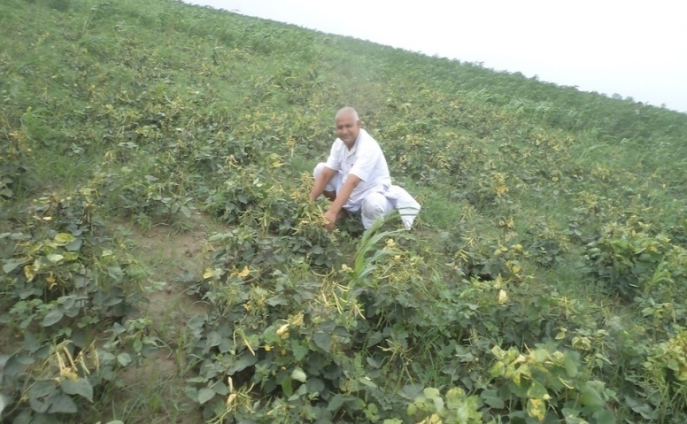

**Success Story - 04**

.

1. Name and address of the farmer: - **Ranjan Kumar Rajeev**

Vill- Badi Maliya Block- Gogri Distt- Khagaria

1. Contact No.: - 9525393711
2. Age: - 40 Years
3. Holding size (in acre/ha): - 8 acre
4. Educational qualification: - Graduation
5. Experience in farming: - 3 Years
6. **Brief description of the farm/enterprise: -.**

Sri Ranjan Kr. Rajeev is a small farmer having 8 acres of land. He is hard working as well as innovative. He diversified his farming practices by cultivating flowers and horticulture crops and earning good amount of money by selling his produce. He grows most of seasonal vegetables such as tomato, bitter gourd, cucumber, cauliflower, capsicum etc. and seasonal flowers such as rose, marigold, oyster, gladiolus, clawer, mallike etc.to cater to the need of local market.

Besides this he also grows tissue cultured banana and sunflower in the diversified farming system.

1. **Economics of the farm: -**

|  |  |  |  |  |
| --- | --- | --- | --- | --- |
| **Crop/**  **Livestock/**  **Fish/**  **Enterprise** | **Area (acre)/No.** | **Cost of production * (Rs. per unit)** | **Return (Rs. per unit)** | **Net income (Rs. per unit)** |
| Flouriculture | 4.0 | 50,000.00 | 1,25,000.00 | 75,000.00 |
| Vegetables | 2.0 | 18,000.00 | 78,000.00 | 60,000.00 |
| Banana | 2.5 | 25,000.00 | 65,000.00 | 40,000.00 |
| Sunflower | 2.0 | 14,000.00 | 30,000.00 | 16,000.00 |
| Dairy | 1 Cow | 20,000.00 | 30,000.00 | 10,000.00 |

* Includes cost of input, labour and other including marketing and transport of the products.

1. **Income level before adopting such farming:**

|  |  |  |  |  |
| --- | --- | --- | --- | --- |
| **Crop/**  **Livestock/**  **Fish/**  **Enterprise** | **Area (acre)/No.** | **Cost of production (Rs. per unit)** | **Return (Rs. per unit)** | **Net income (Rs. per unit)** |
| Paddy | 4.0 | 08,000.00 | 18,000.00 | 10,000.00 |
| Maize | 4.0 | 15,000.00 | 35,000.00 | 20,000.00 |
| Vegetables | 1.0 | 40,000.00 | 80,000.00 | 40,000.00 |
| Banana | 2.0 | 20,000.00 | 60,000.00 | 40,000.00 |

1. 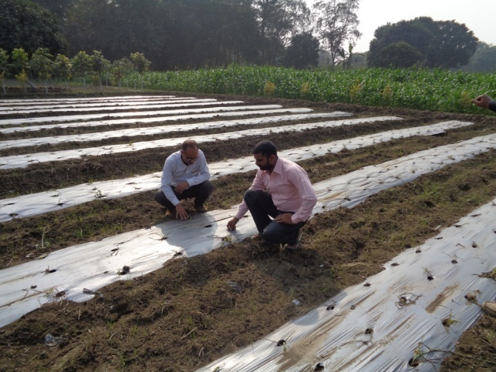**Suitable action photographs:**

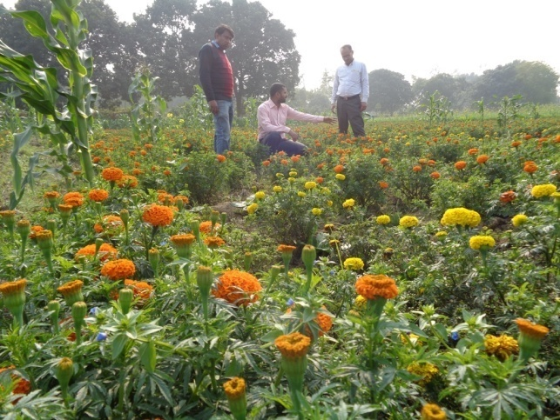

**Success stories 05**

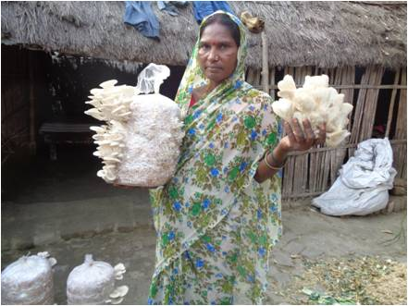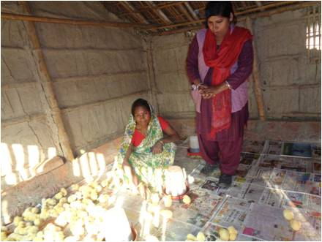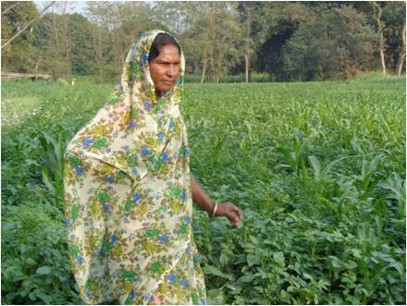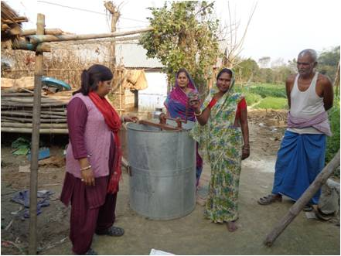 **Smt Sanju Devi** of village Telonchh of Choutham block, Khagaria has 1 acre of land. She used to cultivate vegetables from her land and earn Rs 40000.00 annually on average from the activity. Two years back she came in contact with KVK, Khagaria and got trained on bee keeping. She also learnt the technique of mushroom cultivation from the KVK. Under the guidance of KVK she started integrated practice of mushroom cultivation, poultry farming, vegetable cultivation and bee keeping. Now she is earning more than 1.2 lakh annually from these components which includes net profit of Rs 45000.00 from poultry, Rs 50000.00 from vegetable cultivation and Rs 25000.00 from honey production and in this way she is able to support her family substantially. With her own capability, enthusiasm and KVK’s intervention now she has become one of the progressive farmers in integrated farming within a short period of time. She has been a source of inspiration for local youth in and around and has encouraged around 30 women of the village to undertake honey production activity.

**Success Story 06**

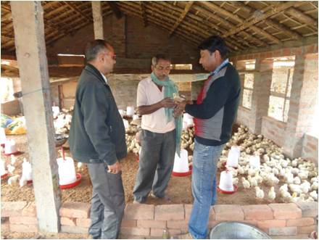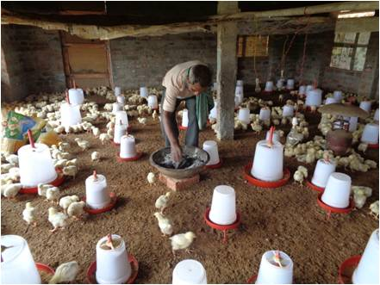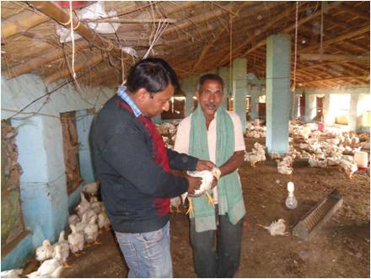 **Sri Dayanand Singh** of village Parbatta of Parbatta block, Khagaria has 1 acre of land. Three years back he started poultry farming with 500 chicks and got income of Rs 50000.00 approx. Later on he came in contact with KVK, Khagaria and got properly trained on the aspect. Under the guidance of KVK he has built a brick walled poultry house with thatched roof for rearing 2000 chicks of hybrid race Vencobb under the guidance of KVK scientist. He is now producing 28500 kg of chicken meat from 10 batches of farming annually and earning Rs 2.4 lakh to 3.0 lakh from the activity. He has also provided full time employment to two persons at his poultry farm. He is using the poultry litter as manure in his vegetable garden and earning Rs 60000.00 to 70000.00 by selling the vegetable produced. By learning from Mr Dayanand Singh the adjoining farmers have adopted the practice and reaping good benefits. In this way Mr Dayanand Singh is acting as an example for the farmers to emulate by getting good benefits from poultry farming and using the organic byproduct of the farming for vegetable production.

**3.8. Give details of innovative methodology or innovative technology of Transfer of Technology developed and used during the year**

|  |  |  |  |
| --- | --- | --- | --- |
| **Sl. No.** | **Name/ Title of the technology** | **Name/ Details of the Innovator(s)** | **Brief details of the Innovative Technology** |
| 01. | Organic cultivation | PrabhooNandan, Amani, Khagaria. | Use of Cow urine, cow dung, yam bean seed extract and waste decomposure for the control of insect pest and disease |

**3.9. a. Give details of indigenous technology practiced by the farmers in the KVK operational area which can be considered for technology development (in detail with suitable photographs)**

|  |  |  |  |
| --- | --- | --- | --- |
| **Sl. No.** | **Crop / Enterprise** | **ITK Practiced** | **Purpose of ITK** |
|  |  |  |  |

**b. Give details of organic farming practiced by the farmer**

|  |  |  |  |  |  |
| --- | --- | --- | --- | --- | --- |
| **Sl. No.** | **Crop / Enterprise** | **Area (ha)/ No. covered** | **Production** | **No. of farmers involved** | **Market available (Y/N)** |
| 01. | Vegetables | 5.00 | 150 q | 05 | Yes |

**3.10. Indicate the specific training need analysis tools/methodology followed by KVKs**

|  |  |  |
| --- | --- | --- |
| **Sl. No.** | **Brief details of the tool/ methodology followed** | **Purpose for which the tool was followed** |
| 01. | Use of ADV, VC, FIG, and Exposure visite | To enhancement and fully skilled of Rural youth for entrepreneurship development |

**3.11. Details of equipment available in Soil and Water Testing Laboratory**

|  |  |  |
| --- | --- | --- |
| **Sl. No** | **Name of the Equipment** | **Qty.** |
| 1 | Mini Kit (STFR Kit) | 02 |

**3.11.b. Details of samples analyzed so far :**

|  |  |  |  |  |  |
| --- | --- | --- | --- | --- | --- |
| **Number of soil samples analyzed** | | | **No. of Farmers** | **No. of Villages** | **Amount realized**  **(in Rs.)** |
| Through mini soil testing kit/labs | Through soil testing laboratory | Total |  |  |  |
| 853 | 0 | 853 | 853 | 25 | 56745.00 |

**3.11.c. Details on World Soil Day**

|  |  |  |  |  |  |  |
| --- | --- | --- | --- | --- | --- | --- |
| **Sl.**  **No.** | **Activity** | **No. of Participants** | **No. of VIPs** | **Name (s) of VIP(s)** | **Number of Soil Health Cards distributed** | **No. of farmers benefitted** |
| 1. | Awareness cum training programme. Distribution of soil health cards | 155 | 01 | Smt. Kumari Sweta Bharti, Chairman, Zila Parishad, Khagaria | 55 | 155 |
|  |  |  |  |  |  |  |

**3.12. Activities of rain water harvesting structure and micro irrigation system**

|  |  |  |  |  |
| --- | --- | --- | --- | --- |
| **No of training programme** | **No of demonstrations** | **No of plant material produced** | **Visit by the farmers** | **Visit by the officials** |
|  |  |  |  |  |

**3.13. Technology week celebration**

|  |  |  |  |
| --- | --- | --- | --- |
| **Type of activities** | **No. of activities** | **Number of participants** | **Related crop/livestock technology** |
|  |  |  |  |

**3.14. RAWE/ FET programme - is KVK involved (Y)**

|  |  |
| --- | --- |
| **No of student trained** | **No of days stayed** |
| 17 | 140 |

**3.15. List of VIP visitors (Minister/ MP/MLA/DM/ VC/Zila Sabhadipati/Other Head of Organization/Foreigners)**

|  |  |  |
| --- | --- | --- |
| **Date** | **Name of the person** | **Purpose of visit** |
| 30.01.2019 | Sri Ashok Kumar  Assitant Director Horticulture, Khagaria | To participate in Micro Irrigation Training programme |
| 22.02.2019 | Dr. Prem Kumar  Hon’ble Minister of Agriculture, Govt of Bihar | Laid foundation stone of gowdown and threshing floor of the KVK |
| 24.02.2019 | Sri Dinkar Prasad Singh  District Agriculture Officer cum PD ATMA, Khagaria | To participate in Rabi Sammelan cum PK-Kisan Samman Nidhi Yojna launching programme. Makes frequent visit for joint execution of different programmes |
| 22.10.2019 | Smt. Sita Devi Nagar Sabhapati, Khagaria | To participate in Fertilizer Application Awareness Programme |
| 22.10.2019 | Sri Manohar Yadav, Ex Nagar Sabhapati, Khagaria | To participate in Fertilizer Application Awareness |
| 20.11.2019 | Inaugurated by Hon’ble Chief Minister of Bihar. | To inauguration of CRA Programme in KVK, Farm and Farmers fields. |
| 05.12.2019 | Smt. Poonam Yadav, M.L.A. Khagaria and  Smt. Kumari Sweta Bharti, Chairman, Zila Parishad, Khagaria | To participate in FMD & AI & Live telecast of National Animal Disease Control Programme and Artificial insemination programme and Swachhata he Sewa |

**IMPACT**

**Impact of KVK activities (Not to be restricted for reporting period).**

|  |  |  |  |  |
| --- | --- | --- | --- | --- |
| **Name of specific technology/skill transferred** | **No. of participants** | **% of adoption** | **Change in income (Rs.)** | |
| **Before (Rs./Unit)** | **After (Rs./Unit)** |
| Cultivation technique of Soybean | 10120 | 60 | 12856.00/ha | 35000.00/ha |
| Introduction of improved variety of lentil HUL - 57 | 1800 | 40 | 15950.00/ha | 24750.00/ha |
| Honey production technique | 435 | 35 | - | 3500.00/box |
| Introduction of improved variety of wheat HD – 2967 | 9500 | 60 | 12320.00/ha | 20900.00/ha |
| Mushroom production | 200 | 35 | - | 450.00/kg spawn |

NB: Should be based on actual study, questionnaire/group discussion etc. with ex-participants

4.2. Cases of large scale adoption

|  |  |
| --- | --- |
| **Horizontal spread of technologies** | |
| **Technology** | **Horizontal spread** |
| Adoption of Soybean in Kharif season in upland area | In the year 2015, kharif maize was cultivated in 17,242 ha area while paddy in 20,699 ha area in Khagaria district.  In the year 2019, soybean replaced kharif maize in 18 percent area while upland paddy in 12 percent area bringing total area under soybean cultivation to approx. 5100 ha. |
| Adoption of improved variety of wheat HD-2967 | * Through the results of the OFT and further FLD activities more than 90% of the wheat cultivated area in adopted villages Rani Sakarpura, Chaidha Banni and Ranko has been brought under cultivation of HD – 2967 variety of wheat which has led to the improved productivity (28.00 q/ha) compared to that of (23.5 q/ha) local varieties. Line department has adopted HD-2967 variety due to activities of the KVK.   In the year 2018-19, approx. 35% of the total wheat cultivated area (29664 ha) was covered by the variety HD-2967 while similar percentage was covered by local variety |
| Mushroom production | More than 80 rural youth of Khagaria district have adopted the enterprise as their income generating activity. |
| Honey production | 13 batches consisting of more than 350 rural women and men were trained on honey bee keeping and honey production technique. Majority of them were provided with 10 honey bee boxes under sponsorship of Dabur and NHM to initiate honey production activity. Due to KVKs effort honey production in Khagaria district has increased to approx. 180 q in 2018 compared to 140 q in the year 2014. |

Give information in the same format as in case studies

4.3. Details of impact analysis of KVK activities carried out during the reporting period

|  |  |  |  |
| --- | --- | --- | --- |
| **Sl. No.** | **Brief details of technology** | **Impact of the technology in subjective terms** | **Impact of the technology in objective terms** |
|  |  |  |  |

**4.4. Details of innovations recorded by the KVK**

|  |  |
| --- | --- |
| Thematic area | Poultry farming |
| Name of the Innovation | Low cost semi-intensive backyard poultry farming |
| Details of Innovator | Sri Satendra Kumar, SMS, Veterinary Science |
| Back ground of innovation | Low productivity of backyard poultry farms in terms of flesh and egg production |
| Technology details | **Area per 200 bird**  Housing area – 300 ft2,.Open enclosed area – 5000 ft2, Azolla pit – 5 nos (8x4 ft each)  **Feeding practices**  **Feeding materials -**  (i) Home made concentrate (maize, wheat, soybean, vit. mineral mix.) (ii) Azolla (iii) Green fodder (iv) Insects  **Feeding rate per day -** (i) Home made feed – 25 gm (ii) Azolla – 25 gm (iii) Green fodder & natural insects – 50 to 75 gm |
| Practical utility of innovation | * Low investment and high return * Easy to maintain and low labour requirement * Birds forage whole day in open area enclosed by nylon netting * Low mortality and high meat quality * Meat and egg produced more of in organic way and get high market price |

**4.5. Details of entrepreneurship development**

|  |  |
| --- | --- |
| 1. **Entrepreneurship development** | |
| Name of the enterprise | Papaya cultivation |
| Name & complete address of the entrepreneur | Bijay Kumar, Village – Malia, Block - Gogri |
| Intervention of KVK with quantitative data support | Provided Training and Technical guidance |
| Time line of the entrepreneurship development | 4 Years |
| Technical Components of the Enterprise | Improved quality of seed, timely fertilization with nutrients and fertilizers, proper management of insect and diseases proper irrigation |
| Status of entrepreneur before and after the enterprise | **Before the enterprise –**  Earning Rs. 50000.00 annually through vegetable cultivation  **After the enterprise** –  Earning gross income of Rs. 5.50 lakh annually through papaya cultivation |
| Present working condition of enterprise in terms of raw materials availability, labour availability, consumer preference, marketing the product etc. ( Economic viability of the enterprise): | Papaya is being cultivated mostly in kitchen gardens consisting of mostly unidentified and local varieties. Though papaya is very remunerative fruit crop compared to mango, banana and others. Area day by day under papaya cultivation increasing.    **Impact Analysis**   |  |  |  | | --- | --- | --- | | **Impact factor** | **Before Adoption** | **After Adoption** | | Farmer Practice | Papaya cultivation was not done on commercial scale. | High yield production per year | | Yield of Product | 500 q/acre | | Fixed Cost | Nil | | Recurring Cost per acre | 1.5 Lakh | | Gross Income per acre | 5.50 Lakh | | Net Profit per acre | 4.00 Lakh | | B:C Ratio | 3.6 | | Marketing | Retail | | Dissemination of knowledge in the locality | Yes | | Knowledge gain based on 1- 5 scale* | 5 | | Feeling of economic security based on 1- 5 scale* | 5 | | Ability to understand and solve problems based on 1- 5 scale* | 5 | | Self image in community based on 1- 5 scale* | 5 | | Self confidence based on 1- 5 scale* | 5 | | * 1- 5 scale indicates 1 = lowest and 5 = highest | | | |
| Horizontal spread of enterprise | More than 100 farmers have visited the farm of Mr. Bijay Kumar to have exposure of the papaya farm and interactions regarding management practices involved. A number of them have also contacted with the KVK scientists and got technical knowledge about papaya farming. More than 46 farmers have started papaya cultivation in Khagaria district. It has been estimated that potential income obtained from papaya cultivation is three times more than that of banana cultivation and 5 to 10 times more than that of mango cultivation. Hence, papaya cultivation can play a great role in enhancing farmer’s income. Even 5 % of the cultivated upland area of Khagaria district is converted into papaya farm it will give a boost to the rural economy of the district by over 500 million rupees. |

**4.6. Any other initiative taken by the KVK**

**(i) Low cost semi-intensive backyard poultry farming**

Advantages

* + Low investment and high return
  + Birds forage whole day in open enclosed area
  + Low mortality and high meat quality
  + Meat and egg produced more of in an organic way and get high market price
  + Easy to maintain and low labour requirement
  + 45 farmers of Khagaria district have adopted the model within 6 months

(ii) **Breed improvement of local goat variety of goat**

In one of the adopted villages Budhwa Parri and its adjoining villages Sirohi goat is being utilized for breed improvement of the local breed. Almost 500 goat kids have been produced which has shown excellent growth and good economic return to farmers.

(iii) **Cultivation of Papaya**

Papaya is being cultivated mostly in kitchen gardens involving mostly unidentified and local varieties. Though papaya is very remunerative fruit crop compared to mango, banana and others, Under the circumstances KVK, Khagaria took the initiative of establishing commercial cultivation of papaya with the three farmers.

**Sl. No. Name of the farmer and address Area of cultivation (ha)**

1. Sri Bijay Kumar, Maliya, Gogri **0.80**
2. **Sri Rajeev Ranjan, Badi Maliya, Gogri 0.40**
3. **Sri Dhiraj Kumar, Garh Mohini, Gogri 0.25**
4. **Sri Arbind Kumar 0.10**

(iv) **Orchard Management of litchi**

**In Farreh village, Gogri 300 acre of orchard under litchi cultivation is being managed under the guidance of**

**KVK, Khagaria.**

|  |  |
| --- | --- |
| **Farmers practices/production diminishing factors** | **Interventions made** |
| Improper and irregular use of fertilizers | Application of Compost, Urea, SSP and MOP in proper doses at proper time. |
| No spray of micronutrients | Foliar spray of zinc sulfate and borax at proper interval in proper doses. |
| Most farmers practice irrigation before flowering | The practice was stopped. |
| No use of medicines to check fruit dropping | Farmers were made to apply planofix @ 2 ml/5 lit. of water |
| Problem of fruit cracking | Farmers were made to apply borax @ 4gm/lit. of water as foliar spray |
| To control attack of fruit borer farmers were applying improper insecticides as advised by input dealers | Azadiractin 1500 ppm was made to apply @ 4-5 ml/lit. of water before maturing of fruit |

**5.0 LINKAGES**

**5.1 Functional linkage with different organizations**

|  |  |
| --- | --- |
| **Name of organization** | **Nature of linkage** |
| ATMA | Participation in different govt programmes such as Kharif and Rabi Mahotsav, Krishi Yantrikaran mela and others, farmers scientist interaction, short term research on technical refinement and validation, demonstration on onion, demonstration on maize, sending farmers in exposure visits and Kisan Mela at BAU, Sabour |
| DAO | Conducting training programmes, workshops, field surveys |
| DAHO | Participation in technology week, conducted training programmes |
| Regional Research Centre of IARI, Pusa | Conducting varietal trial on timely shown, late shown, rainfed wheat and short duration paddy varieties |
| Regional centre for research and seed production on maize (ICAR), Begusarai | Conducted collaborative programmes on demonstration on maize |
| Jeevika | Training Honey bee keeping and honey production, Installation of exhibition stall during awareness progamme on Pradhanmantri Phasal Beema Yojna |
| Nehru Yuva Kendra | Trainings |
| Navakanksha Foundation | Training and field visit |
| National Bee Board | Training programmes for rural women on Honey bee keeping and honey production |
| Bihar Mahila Samakhya Society | Training on women empowerment |
| NABARD | Kisan club formation, Training and other programmes |
| KRIBHCO | Training and Technology week celebration, Krishi Yatrikaran Mela, Workshops |
| Sudha Dairy, Barouni | Training and field visit |
| IFFCO | Training and demonstration |
| District Industries Center, Khagaria | Training |
| RSETI, Khagaria | Training |
| Sabarmati Plantation Farmers Society, Khagaria | Training |

**5.2. List of special programmes undertaken during 2019 by the KVK, which have been financed by ATMA/ Central Govt/ State Govt./NABARD/NHM/NFDB/Other Agencies (information of previous years should not be provided)**

**a) Programmes for infrastructure development**

|  |  |  |  |  |
| --- | --- | --- | --- | --- |
| **Name of the programme/ scheme** | **Purpose of programme** | **Date/ Month of initiation** | **Funding agency** | **Amount (Rs.)** |
| CRA | Sustainable and Livelihood Security | 20.11.2019 | BISA | 3,00000.00 |
| Poshan Vatika (ICDS) |  |  | ICDS | 9,16,090.00 |
| Quality Seed Grower | Skill Development Training Programme | 15.02.2020 | BSDM | 5,89016.00 |
| Mushroom Grower | Skill Development Training Programme | 15.02.2020 | ASCI | 1,80,000.00 |
| Bio-Tech Kisan Hub | Bee Keeping G-9 Banana, Mushroom inputs & training | 06.02.2020 | Biotech Kisan Hub | 24,00000.00 |
| Gramin Kisan Mausam Seva | FAP villages & forcasting of climates | 2016 | GKMS | 1101000.00 |
| BGREI | Survey | 2017 |  | 17000.00 |
| Plantation Drive Programme | Plantation | 17.09.2019 |  | 10000.00 |
| RPL Training Programme | Training of Extension Functionaries | March-2020 |  | 3041100.00 |
| NR Equipment |  | 2018-19 |  | 350000.00 |
| SCSP Capital |  | 2018-19 |  | 46900.00 |
| ATMA | Strengthening of training room | 2018-19 | ATMA | 100000.00 |
| NADCP & FMD | Livetelecast of AI Programme | Sep. 2019 |  | 15000.00 |
| Fertilizer Awareness Programme |  | 20.09.2019 |  | 50000.00 |
| CSISA |  | 2018-19 |  | 59800.00 |
| IFS |  | 15.02.2020 |  | 750000.00 |
| Model Nursery |  | - |  | 750000.00 |
| RAWE |  | 2018-19 |  | 25000.00 |
| NADEP Pit |  | 2018-19 |  | 7000.00 |
| Kisan Choupal |  | 2018-19 |  |  |

(b) Programme for other activities (Training, FLD,OFT, Mela, Exhibition etc.)

|  |  |  |  |  |
| --- | --- | --- | --- | --- |
| **Name of the programme/ scheme** | **Purpose of programme** | **Date/ Month of initiation** | **Funding agency** | **Amount (Rs.)** |
| ATMA | FAW | September | ATMA | - |
| IFFCO | INM and IPM | October | IFFCO | - |
| IFFCO | Plantations | October | IFFCO | 10000.00 |
| ADH, Khagaria | G-9 Banan cultivation | October | ADH, Khagaria | - |
| ADH, Khagaria | Drip irrigation awareness programme | November | ADH, Khagaria | - |

PERFORMANCE OF INFRASTRUCTURE IN KVK

|  |  |  |  |  |  |  |  |  |  |
| --- | --- | --- | --- | --- | --- | --- | --- | --- | --- |
| **Sl. No.** | **Name of demo Unit** | **Year of estt.** | **Area(Sq.mt)** | **Details of production** | | | **Amount (Rs.)** | | **Remarks** |
| **Variety/breed** | **Produce** | **Qty.** | **Cost of inputs** | **Gross income** |
| 1. |  |  |  |  |  |  |  |  |  |
| 2. |  |  |  |  |  |  |  |  |  |
| 3. |  |  |  |  |  |  |  |  |  |
| 4. |  |  |  |  |  |  |  |  |  |
| 5. |  |  |  |  |  |  |  |  |  |
| 6. |  |  |  |  |  |  |  |  |  |
| 7. |  |  |  |  |  |  |  |  |  |
|  | Total |  |  |  |  |  |  |  |  |

6.1. Performance of demonstration units (other than instructional farm)

**6.2. Performance of Instructional Farm (Crops)**

|  |  |  |  |  |  |  |  |  |  |
| --- | --- | --- | --- | --- | --- | --- | --- | --- | --- |
| **Name**  **Of the crop** | **Date of sowing** | **Date of harvest** | **Area (ha)** | **Details of production** | | | **Amount (Rs.)** | | **Remarks** |
| **Variety** | **Type of Produce** | **Qty.(q)** | **Cost of inputs** | **Gross income** |
| Lentil | 01-03 Nov, 2017 | 28-30 March, 2018 | 2.00 | HUL-57 | C/S | 14.00 | Seed was sent to DSF, BAU, Sabour for processing and marketing | | |
| Wheat | 11-21 Nov, 2017 | 20-26 April, 2018 | 6.00 | HD 2967 | F/S | 150.00 | Seed was sent to DSF, BAU, Sabour for processing and marketing | | |
| Cowpea | 28.02.2018 | 28 May to 10 June, 18 | 0.40 | Kashi Kanchan | F/S | 1.80 | Seed was sent to DSF, BAU, Sabour for processing and marketing | | |
| Lentil | 25-28 Octo, 18 | 24-27 March, 19 | 2.00 | HUL-57 | F/S | 21.50 | Stored in godown | | |
| Wheat | 14-22 Nov, 18 | 24-30 April, 19 | 6.00 | HD- 2967 | F/S | 197.00 | Stored in godown | | |

**Performance of Production Units (bio-agents / bio pesticides/ bio fertilizers etc.,)**

|  |  |  |  |  |  |
| --- | --- | --- | --- | --- | --- |
| **Sl.**  **No.** | **Name of the Product** | **Qty. (Kg)** | **Amount (Rs.)** | | **Remarks** |
| **Cost of inputs** | **Gross income** |
| 1. | Vermy compost | 50 ton. | 75000.00 | 300000.00 | Production by Mdhukar Yadav as a entrepreneurship |
|  |  |  |  |  |  |

Performance of instructional farm (livestock and fisheries production)

|  |  |  |  |  |  |  |  |
| --- | --- | --- | --- | --- | --- | --- | --- |
| **Sl.**  **No** | **Name**  **of the animal / bird / aquatics** | **Details of production** | | | **Amount (Rs.)** | | **Remarks** |
| **Breed** | **Type of Produce** | **Qty.** | **Cost of inputs** | **Gross income** |
| 1. |  |  |  |  |  |  |  |
| 2. |  |  |  |  |  |  |  |

Utilization of hostel facilities

Accommodation available (No. of beds) :- 25

|  |  |  |  |
| --- | --- | --- | --- |
| **Months** | **No. of trainees stayed** | **Trainee days**  **(days stayed)** | **Reason for short fall (if any)** |
| January, 2019 | 20 | 20 |  |
| Feb to March, 2019 | 20 | 20 |  |
| August to December, 2019 | 17 | 140 |  |
| Total : | 57 | 180 |  |

(For whole of the year)

Utilization of staff quarters

Whether staff quarters has been completed: Yes

No. of staff quarters: 06

Date of completion:

Occupancy details:

|  |  |  |  |  |  |  |  |
| --- | --- | --- | --- | --- | --- | --- | --- |
| Months | Q I | QII | | Q III | QIV | Q V | QVI |
| Occupied since January, 2015 | Occupied | | Occupied | Occupied | Occupied | Occupied | Occupied |

**FINANCIAL PERFORMANCE**

7.1. Details of KVK Bank accounts

|  |  |  |  |
| --- | --- | --- | --- |
| **Bank account** | **Name of the bank** | **Location** | **Account Number** |
| Current Account | P.N.B, Khagaria | Rajendra Chowk, Khagaria | 4931002100001609 |
| Current Account | P.N.B, Khagaria | Rajendra Chowk, Khagaria | 4931002100001618 |

**Utilization of funds under CFLD on Oilseed (Rs. In Lakhs)**

|  |  |  |  |  |  |  |  |
| --- | --- | --- | --- | --- | --- | --- | --- |
| **Item** | **Released by ICAR** | | | **Expenditure** | | | **Unspent balance as on -** |
| **Kharif** | **Rabi** | **Summer** | **Kharif** | **Rabi** | **Summer** |
| **Soybean** | **1,50,000.00** | **-** | **-** | **1,49,870.00** | **-** | **-** | **130.00** |
| **Sunflower** | **-** | **-** | **60,000.00** | **-** | **-** | **-** | **60,000.00** |

**7.3. Utilization of funds under CFLD on Pulses (Rs. In Lakhs)**

|  |  |  |  |  |  |  |  |
| --- | --- | --- | --- | --- | --- | --- | --- |
| **Item** | **Released by ICAR** | | | **Expenditure** | | | **Unspent balance as on 1st April 2013** |
| **Kharif** | **Rabi** | **summer** | **Kharif** | **Rabi** | **Summer** |
| **Lentil** | **-** | **1,80,000.00** |  |  | **163148.00** | **-** | **16852.00** |
| Green gram | - |  | 1,80,000.00 | - | - | - | 1,80,000.00 |

**7.4. Utilization of KVK funds during the year 2019 (Not audited)**

|  |  |  |  |  |
| --- | --- | --- | --- | --- |
| **Sl. No.** | **Heads** | **Sanctioned** | **Released** | **Expenditure** |
| A. Salary | | | | |
| 1 | Pay & Allowances | 80,60,000.00 | 37,22,812.00 | 54,99,457.00 |
|  | **Total** | **80,60,000.00** | **37,22,812.00** | **54,99,457.00** |
| B. | **General (Recurring)** | | |  |
| 3 | **Contigency** | | 6,50,328.00 |  |
| a | Stationary , Telephone, Postage & Office | 3,00,000.00 | 2,78,800.00 |
| b | Training of Farmers | 2,70,000.00 | 2,14,600.00 |
| c | Training Material |
| d | Training of Extension Functionaries |
| e | Training of Rural Youth |
| f | FLD | 70,000.00 | 57,314.00 |
| g | OFT | 95,000.00 | 72,600.00 |
| h | Maintenance of Building | 25,000.00 | 24,113.00 |
| i | Extention Activities | 25,000.00 | 25,000.00 |
|  |  |  |  |  |
| **TOTAL (A)** | | **9,10,000.00** |  | **6,72,427.00** |
| **B. Non-Recurring Contingencies** | | | | |
| 1 | Works | 0.00 | 0.00 | 0.00 |
| 2 | Vehicle | 0.00 | 0.00 | 0.00 |
| 3 | Equipments & Furniture | 0.00 | 0.00 | 0.00 |
| 4 | Library | 0.00 | 0.00 | 0.00 |
| TOTAL (B) | |  |  |  |
| C. REVOLVING FUND | | 10,49,498.29 |  |  |
| GRAND TOTAL (A+B+C) – **72,98,652.29** | | **5499457.00** | **749697.00** | **1049498.29** |

**7.5 Status of revolving fund (Rs. in lakh) for last three years**

|  |  |  |  |  |
| --- | --- | --- | --- | --- |
| Year | Opening balance as on 1st April | Income during the year | Expenditure during the year | Net balance in hand as on 1st April of each year (Kind + cash) |
| 2015-16 | 552082.60 | 287523.00 | 291834.98 | 547770.62 |
| 2016-17 | 547770.62 | 57630.00 | 279372.93 | 326027.69 |
| 2017-18 | 326027.69 | 892565.97 | 259425.55 | 959168.11 |
| 218-19 | 930223.11 | 604623.00 | 314126.82 | 1220719.29 |
| 2019-20 | 757796.29 | 823071.00 | 1037483.00 | **543384.29 In kind (600000)** |

7.6 (i) Number of SHGs formed by KVKs

(ii) Association of KVKs with SHGs formed by other organizations indicating the area of SHG activities

(iii) Details of marketing channels created for the SHGs

7.7 Joint activity carried out with line departments and ATMA

|  |  |  |  |  |  |
| --- | --- | --- | --- | --- | --- |
| **Nameof activity** | **Number of activity** | **Season** | **With line department** | **With ATMA** | **With both** |
| Kharif Mahostav | 07 | Kharif |  |  | √ |
| Rabi Mahostav | 07 | Rabi |  |  | √ |
| Yantrikaran Mela | 03 | Rabi |  |  | √ |
| Farmers Scientist interaction | 02 | Rabi & Kharif |  | √ |  |
| Live Telecast of PM-Kisan Samman Nidhi Yojna | 01 | Rabi | √ |  |  |
| World Soil Day | 01 | Rabi | √ |  |  |
| Kisan Choupal | 17 | Rabi & Kharif | √ |  |  |

**8. Other information**

**8.1. Prevalent diseases in Crops**

|  |  |  |  |  |  |
| --- | --- | --- | --- | --- | --- |
| **Name of the disease** | **Crop** | **Date of outbreak** | **Area affected (in ha)** | **% Commodity loss** | **Preventive measures taken for area (in ha)** |
|  |  |  |  |  |  |

**8.2. Prevalent diseases in Livestock/Fishery**

|  |  |  |  |  |  |
| --- | --- | --- | --- | --- | --- |
| **Name of the disease** | **Species affected** | **Date of outbreak** | **Number of death/ Morbidity rate (%)** | **Number of animals vaccinated** | **Preventive measures taken in pond (in ha)** |
|  |  |  |  |  |  |
|  |  |  |  |  |  |

9.1. Nehru Yuva Kendra (NYK) Training

|  |  |  |  |  |  |
| --- | --- | --- | --- | --- | --- |
| **Title of the training programme** | **Period** | | **No. of the participant** | | **Amount of Fund Received (Rs)** |
|  | **From** | **To** | **M** | **F** |  |
|  |  |  |  |  |  |

9.2. PPV & FR Sensitization training Programme

|  |  |  |  |  |
| --- | --- | --- | --- | --- |
| **Date of organizing the programme** | **Resource Person** | **No. of participants** | **Registration (crop wise)** | |
| **Name of crop** | **No. of registration** |
|  |  |  |  |  |

**9.3. mKisan Portal (National Farmers’ Portal/ SMS Portal)**

|  |  |  |
| --- | --- | --- |
| **Type of message** | **No. of Message** | **No. of farmers covered** |
| Crop | 16 | 106576 |
| Livestock | 02 | 20595 |
| Fishery | 02 | 1794 |
| Weather | 118 | 5120 |
| Marketing | - | - |
| Awareness | 03 | 1524 |
| Training information | 04 | 1134 |
| Other | 25 | 1575 |
| **Total** |  | **133,198** |

**9.4. KVK Portal and Mobile App**

|  |  |  |
| --- | --- | --- |
| Sl. No. | Particulars | Description |
| 1. | No. of visitors visited the portal |  |
| 2. | No. of farmers registered in the portal | 7298 |
| 3. | Mobile Apps developed by KVK |  |
| 4. | Name of the App |  |
| 5. | Language of the App |  |
| 6. | Meant for crop/ livestock/ fishery/ others |  |
| 7. | No. of times downloaded |  |

**9.5. a. Observation of Swacha Bharat Programme**

|  |  |
| --- | --- |
| **Date of Observation** | **Activities undertaken** |
|
| 25-01-19 | Cleanliness drive of office premises |
| 29-01-19 | Cleanliness campaign and gosthi in adopted village Budhwa Parri |
| 24-03-19 | Cleanliness campaign and gosthi in adopted village Telonchh |
| 02.10.2019 | Cleanliness drive of office premises and in adopted village |
| 30.10.2019 | Cleanliness drive of office premises and in adopted village and also Awareness programme in sawchata abhiyan |

|  |  |  |
| --- | --- | --- |
| **Activities** | **(in Numbers)** | **Expenditure (till 31str March 2019** |
| Organized awareness programme among with farmers and distributed cloth bag, cleaning activities in KVK campus, farm and other public places. | 22 | 24000.00 |

b. Details of Swachhta activities with expenditure

**9.6. Observation of National Science day**

|  |  |
| --- | --- |
| **Date of Observation** | **Activities undertaken** |
|
| 28-02-19 | Gosti organised on the application of science and technology for sustaining mankind with environment friendly approach |

**9.7. Programme with Seema SurakshaBal (BSF)**

|  |  |  |
| --- | --- | --- |
| **Title of Programme** | **Date** | **No. of participants** |
|  |  |  |

**9.8. Agriculture Knowledge in rural school:**

|  |  |  |  |
| --- | --- | --- | --- |
| **Name and address of school** | **Date of visit to school** | **Areas covered** | **Teaching aids used** |
| High School Mehsouri | 04.12.2019 | 03 | Bulletins, and news letters |
| Rako, Sansarpur and Hardas chouk | 07.09.2019-11.09.2019 | 05 | Bulletins, folders and news letters |

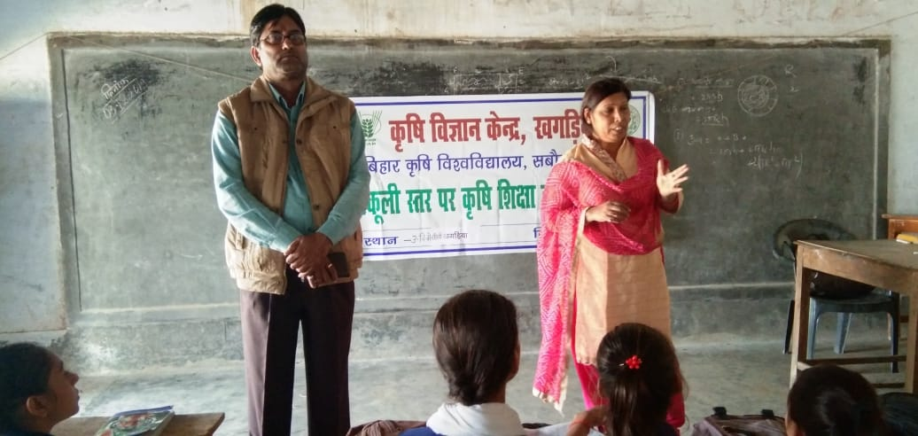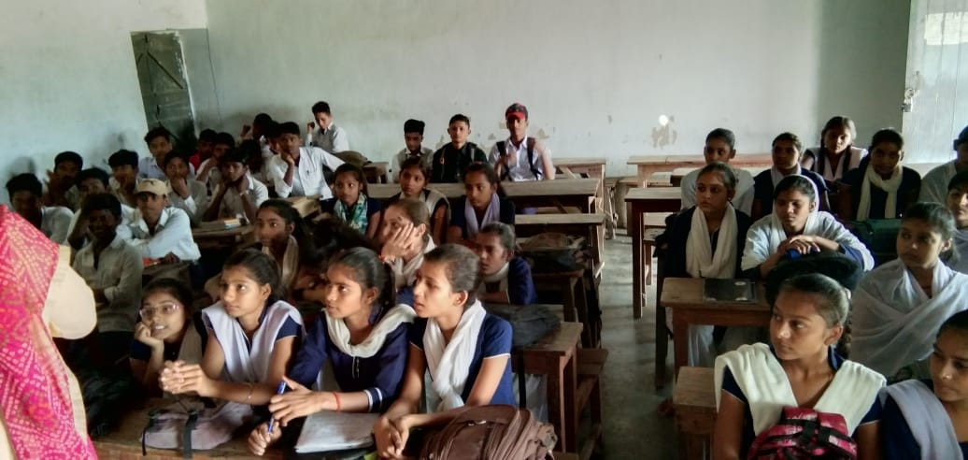

**9.9. Details of ‘Pre-Rabi Campaign’ Programme**

|  |  |  |  |  |  |  |  |  |  |  |  |  |
| --- | --- | --- | --- | --- | --- | --- | --- | --- | --- | --- | --- | --- |
| Date of programme | No. of Union Ministers attended the programme | No. of  Hon’ble MPs (Loksabha/ Rajyasabha) participated | No. of State Govt. Ministers | Participants (No.) | | | | | | | Coverage by Door Darshan (Yes/No) | Coverage by other channels (Number) |
| MLAs Attended the programme | Chairman ZilaPanchayat | Distt. Collector/ DM | Bank Officials | Farmers | Govt. Officials, PRI members etc. | Total |
| 24.02.2019 | 0 | 00 | 0 | 0 | 0 | 0 | 0 | 375 | 05 | 380 | No. | 03 |

9.10. Details of Swachhta Hi Sewa programme organized

|  |  |  |  |  |  |
| --- | --- | --- | --- | --- | --- |
| **S.No.** | **Activity** | **No. of villages Involved** | **No. of Participants** | **No. of VIPs** | **Name (s) of VIP(s)** |
| 1. | Sewa Divas  02.10.2019 | 01 | 45 | 02 | Smt.Sweta Bharti, Jila Parisad, Khagaria |
| 2. | Samagra Swatch Divas, 10.10.2019 | 01 | 38 | 01 | Smt.Sweta Bharti, Jila Parisad, Khagaria |
| 3. | Sarwatra  Swachha 29th 12.10.2019 | 01 | 54 | 03 | Smt.Sweta Bharti, Jila Parisad, Khagaria |

9.11. Details of Mahila Kisan Divas programme organized

|  |  |  |  |  |  |
| --- | --- | --- | --- | --- | --- |
| Sl.  No. | Activity | No. of villages Involved | No. of Participants | No. of VIPs | Name (s) of VIP(s) |
| 1 | Painting  Debate on Role of women in agriculture | 05 | 100 | 01 | Smt. Manorama Kumari, Manager, Livelihood, Jeevika, Khagaria |

**9.12. No. of Progressive/Innovative/Lead farmer identified (category wise)**

|  |  |  |  |
| --- | --- | --- | --- |
| **Sl.**  **No.** | **Name of Farmer** | **Address of the farmer with contact no.** | **Innovation/ Leading in enterprise** |
| 1 | Sri Bijay Kumar | Maliya, Gogri  09821265019 | Papaya cultivation |
| 2 | Sri Prabhoo Nandan | Amni, Khagaria | Organic Cultivation in vegetables |
| 2 | Sri Ranjay Paswan | Village-Parri, Panchayat - Bhikhari Ghat, Block-Alouli, District-Khagaria | Low cost semi-intensive backyard poultry farming |
| 3 | Sri Ramprawesh | Amni, Khagaria | Organic Cultivation |
| 4 | Md Jaffirul Hods Javed | Village – Bela Simri, Khagaria, Bihar  9430240936 | Nursery raising of Indian Major Carps and Black Carp as well as enhancing income of members of fishermen cooperative through introduction of black carp (Mylopharyngodon piceus) seeds in culture system |
| 5 | Sri Sanjeev Kumar | Rako- 970956114 | Poultry farming,Dairy, Fiseries and Mushroom cultivation |
| 6 | Sri Rajeshwre yadav | Rako- 9570416366 | Crop residue management through Happy seeder |
| 7 | Sri Anil kumar | Rani Sakarpura- 8298213200 | Mushroom Spawn Production Lab |
| 8 | Sri Sanjeev Kumar Singh | Mehsodhi, Khagaria  9308079528 | Enhancing income through diversified farming |
| 9 | Sri Sudarshan Prasad Singh | Adabari, Khagaria  9135395928 | Interculture of vegetables |
| 10 | Sri Chavendra | Chaida Banni-7631316667 | Mushroom production and Sudha milk collection centre |
| 11 | Sri Anil Kumar | Gouchari- 9430262040 | Machination in Farm |

9.13. **Revenue generation**

| Sl.No. | Name of Head | Income(Rs.) | Sponsoring agency |
| --- | --- | --- | --- |
| 1. | Seed production | 511723.00 | KVK, Khagaria |
| 2. | RAWE | 57000.00 | BAC, Sabour |
| 3. | Infrastructure development | 200000.00 | ATMA, Khagaria |

9.14. **Resource Generation:**

|  |  |  |  |  |  |
| --- | --- | --- | --- | --- | --- |
| **Sl.No.** | **Name of the programme** | **Purpose of the programme** | **Sources of fund** | **Amount**  **(Rs. lakhs)** | **Infrastructure created** |
| 1 | Bio - Tech – Kisan Hub | Entrepreneurship | BAU, Sabour | 24.00 | -- |
| 2 | ICDS | Nutri Garden | BAU, Sabour | 27.00 | -- |
| 3 | CRAP | Entrepreneurship Bee Keeping, Mushroom | Govt. of Bihar | 24.00 |  |
| 4 | BSDM | Quality seed grower | Govt. of Bihar | 5.5 |  |
| 5 | ASCI | Mushroom grower | RKVY | 1.80 |  |

9.15. **Performance of Automatic Weather Station in KVK**

|  |  |  |
| --- | --- | --- |
| Date of establishment | Source of funding i.e. IMD/ICAR/Others (pl. specify) | Present status of functioning |
|  |  |  |
|  |  |  |

**9.16. Contingent crop planning**

|  |  |  |  |  |  |
| --- | --- | --- | --- | --- | --- |
| Name of the state | Name of district/KVK | Thematic area | Number of programmes organized | Number of Farmers contacted | A brief about contingent plan executed by the KVK |
| Bihar | Khagaria | Kharif crop | 02 | 185 | Kharif crop other than paddy |

**10. Report on Cereal Systems Initiative for South Asia (CSISA)**

**Year:**

**Introduction / General Information:**

|  |  |  |  |  |  |  |
| --- | --- | --- | --- | --- | --- | --- |
|  | Title | Objective | Treatment details | Date of sowing | Replication | Result with photographs |
| Experiment 1 |  |  |  |  |  |  |
| Experiment 2 |  |  |  |  |  |  |
| Experiment 3 |  |  |  |  |  |  |
| … |  |  |  |  |  |  |
| .. |  |  |  |  |  |  |
| Others (If any) |  |  |  |  |  |  |

**11. Details of TSP**

**Achievements of physical output under TSP during 2019**

|  |  |
| --- | --- |
| Programmes | Physical achievements |
| Asset creation (Number; Sprayer, ridge maker, pump set, weeder etc.) |  |
| On-farm trials (Number) |  |
| Frontline demonstrations (Number) |  |
| Farmers training (in lakh) |  |
| Extension personnel training (in lakh) |  |
| Participants in extension activities (in lakh) |  |
| Seed production (in tonnes) |  |
| Planting material production (in lakh) |  |
| Livestock strains and fingerlings production (in lakh) |  |
| Soil, water, plant, manures samples testing (in lakh) |  |
| Provision of mobile agro – advisory to farmers (in lakh) |  |
| No. of other programmes (Swachha Bharat Abhiyaan, Agriculture knowledge in rural school, Planting material distribution, Vaccination camp etc.) |  |

**Fund received under TSP in 2019-20 (Rs. In lakh):**

**Achievements of physical outcome under TSP during 2019-20**

|  |  |  |  |
| --- | --- | --- | --- |
| Sl. No. | Description | Unit | Achievements |
|
| 1 | Change in family income | % |  |
| 2 | Change in family consumption level | % |  |
| 3 | Change in availability of agricultural implements/ tools etc. | No. per household |  |

**Location and Beneficiary Details during 2019-20**

|  |  |  |  |  |  |  |
| --- | --- | --- | --- | --- | --- | --- |
| District | Sub-district | No. of Village covered | Name of village(s)  covered | ST population benefitted  (No.) | | |
| M | F | T |
|  |  |  |  |  |  |  |

**12. Progress report of NICRA KVK (Technology Demonstration component) during the period**

**(Applicable for KVKs identified under NICRA)**

Natural Resource Management

|  |  |  |  |  |  |  |  |  |  |  |  |  |  |  |
| --- | --- | --- | --- | --- | --- | --- | --- | --- | --- | --- | --- | --- | --- | --- |
| Name of intervention undertaken | Numbers under taken | No of units | Area (ha) | No of farmers covered / benefitted | | | | | | | | | | Remarks |
|  |  |  |  | SC | | ST | | | Other | | Total | | |  |
|  |  |  |  | M | F | | M | F | M | F | M | F | T |  |
|  |  |  |  |  |  | |  |  |  |  |  |  |  |  |

Crop Management

|  |  |  |  |  |  |  |  |  |  |  |  |  |
| --- | --- | --- | --- | --- | --- | --- | --- | --- | --- | --- | --- | --- |
| Name of intervention undertaken | Area (ha) | No of farmers covered / benefitted | | | | | | | | | | Remarks |
|  |  | SC | | ST | | | Other | | Total | | |  |
|  |  | M | F | | M | F | M | F | M | F | T |  |
|  |  |  |  | |  |  |  |  |  |  |  |  |

Livestock and fisheries

|  |  |  |  |  |  |  |  |  |  |  |  |  |  |  |
| --- | --- | --- | --- | --- | --- | --- | --- | --- | --- | --- | --- | --- | --- | --- |
| Name of intervention undertaken | Number of animals covered | No of units | Area (ha) | No of farmers covered / benefitted | | | | | | | | | | Remarks |
|  |  |  |  | SC | | ST | | | Other | | Total | | |  |
|  |  |  |  | M | F | | M | F | M | F | M | F | T |  |
|  |  |  |  |  |  | |  |  |  |  |  |  |  |  |

Institutional interventions

|  |  |  |  |  |  |  |  |  |  |  |  |  |  |
| --- | --- | --- | --- | --- | --- | --- | --- | --- | --- | --- | --- | --- | --- |
| Name of intervention undertaken | No of units | Area (ha) | No of farmers covered / benefitted | | | | | | | | | | Remarks |
|  |  |  | SC | | ST | | | Other | | Total | | |  |
|  |  |  | M | F | | M | F | M | F | M | F | T |  |
|  |  |  |  |  | |  |  |  |  |  |  |  |  |

Capacity building

|  |  |  |  |  |  |  |  |  |  |  |  |
| --- | --- | --- | --- | --- | --- | --- | --- | --- | --- | --- | --- |
| Thematic area | No of Courses | No of beneficiaries | | | | | | | | | |
|  |  | SC | ST | | | Other | | | Total | | |
|  |  | M | F | M | F | | M | F | M | F | T |
|  |  |  |  |  |  | |  |  |  |  |  |

Extension activities

|  |  |  |  |  |  |  |  |  |  |  |  |
| --- | --- | --- | --- | --- | --- | --- | --- | --- | --- | --- | --- |
| Thematic area | No of activities | No of beneficiaries | | | | | | | | | |
|  |  | SC | ST | | | Other | | | Total | | |
|  |  | M | F | M | F | | M | F | M | F | T |
|  |  |  |  |  |  | |  |  |  |  |  |

Detailed report should be provided in the circulated Performa

13. **Awards/Recognition received by the KVK**

|  |  |  |  |  |  |
| --- | --- | --- | --- | --- | --- |
| Sl. No. | Name of the Award | Year | Conferring Authority | Amount | Purpose |
|  |  |  |  |  |  |
|  |  |  |  |  |  |
|  |  |  |  |  |  |

Award received by Farmers from the KVK district

|  |  |  |  |  |  |  |
| --- | --- | --- | --- | --- | --- | --- |
| Sl. No. | Name of the Award | Name of the Farmer | Year | Conferring Authority | Amount | Purpose |
|  |  |  |  |  |  |  |
|  |  |  |  |  |  |  |
|  |  |  |  |  |  |  |

14. Any significant achievement of the KVK with facts and figures as well as quality photograph

(i) CRA Programme : (a) Management of Crop Residues

(b) Minimise the cost of Cultivation

(c) To Conserve the Moisture

(d) Minimise the risk due to climate change.

(e) Increase the production and productivity.

(ii) BIO Tech Kishan Hub : (a) Development entrepreneurship in bee keeping in adopted village.

(b) Development entrepreneurship in Mushroom Cultivation in adopted village.

(c) Scientific Cultivation of Banana G-9 and increase the income in adopted village.

(iii) ICDS : (a) To developed the Nutri-Garden in selected Anganwadi centre of Khagaria District.

(b) To provide the seasonal vegetables for the growing children's of Anganwadi centres.

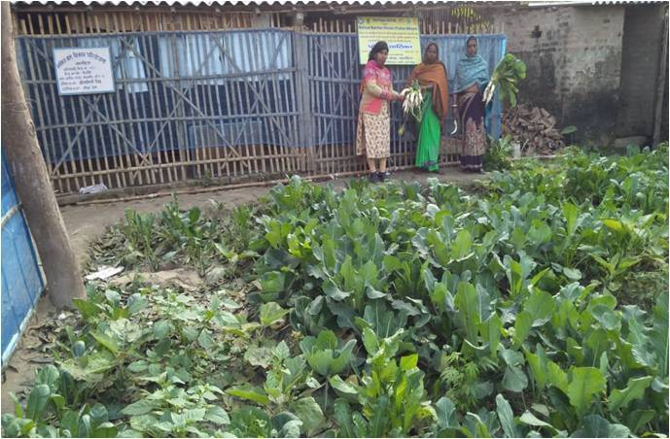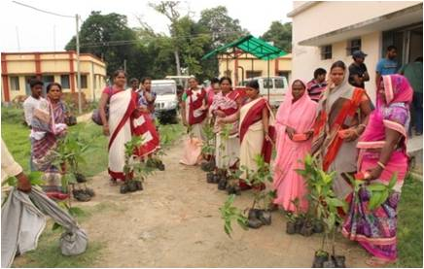

15. Number of commodity based organizations/ farmers’ cooperative society/ FPO formed/ associated with during last one year (Details of the group/society may be indicated)

|  |  |  |  |  |  |  |  |  |
| --- | --- | --- | --- | --- | --- | --- | --- | --- |
| Sl. No. | Name of the organization/ Society | Trust Deed No.& date | Date of Trust Registration  Address | Proposed Activity | Commodity Identified | No. of Members | Financial position  (Rupees in lakh) | Success indicator |
|  |  |  |  |  |  |  |  |  |

Integrated Farming System (IFS)

Details of KVK Demo. Unit

|  |  |  |  |  |  |  |  |
| --- | --- | --- | --- | --- | --- | --- | --- |
| Sl.  No. | Module details (Component-wise) | Area under IFS (ha) | Production (Commodity-wise) | Cost of production in Rs. (Component-wise) | Value realized in Rs. (Commodity-wise) | No. of farmer adopted practicing IFS | % Change in adoption during the year |
|  |  |  |  |  |  |  |  |

Technologies for Doubling Farmers' Income

|  |  |  |  |  |  |
| --- | --- | --- | --- | --- | --- |
| Sl. No. | Name of the Technology | Brief Details of Technology (3- 5 bullet points) | Net Return to the farmer (Rs.) per ha per year due to adoption of the technology | No. of farmers adopted the technology in the district | WhatsApp Image 2020-02-21 at 14.24.28.jpegOne high resolution ‘Photo’ in ‘jpg’ format for each technology |
| 1 | Happy seeder | Crop residue management  Timely Sowing  Saving of initial cost | - | 35 |  |
| 2 | Zero tillage | Crop residue management  Timely Sowing  Saving of initial cost |  | 70 | WhatsApp Image 2020-02-21 at 14.25.18.jpeg |

Report on Digital Farming Initiatives in Agriculture/ Digital Ag. Extension Service

|  |  |  |  |  |  |
| --- | --- | --- | --- | --- | --- |
|  | Database prepared/ covered for | | KVK level Committee | | Various activity conducted for farmers |
| Phase | Total no. of villages | Total no. of farmers | Date of formation | Name of members |
| I (up-to 15.03.2020) |  |  |  |  |  |
| II (up-to 24.04.2020) |  |  |  |
| Total |  |  |  |

**Information on Visit of Ministers to KVKs, if any**

|  |  |  |  |
| --- | --- | --- | --- |
| Date of Visit | Name of Hon’ble Minister | Name of Minister | Salient points in his/her observation (2-3 bulleted points) |
| 22.07.19 | Dr Prem Kumar, Hon’ble Minister of Agriculture, Govt of Bihar |  | 1.Laid foundation stone of gowdown and threshing floor of the KVK  2. Addressed gathering of over 500 farmers and political representatives of Khagaria district.  3. Thanked KVK and line department officials for the initiatives made for farmers’ upliftment. |

**a) Information on ASCI Skill Development Training Programme (2018-19)**

|  |  |  |  |  |  |  |  |
| --- | --- | --- | --- | --- | --- | --- | --- |
| Year | Name of the Job role | Name of the certified Trainer of KVK for the Job role | Date of start of training | Date of completion of training | No. of participants | Whether uploaded to SDMS Portal (Y/N) | Fund utilized for the training (Rs.) |
| 2018-19 | Mushroom Grower | Dr. Anita Kumari  Dr. Satendra Kumar | 29.12.2018 | 28.01.2019 | 20 | Yes | 165200.00 |
| 2018-19 | Quality Seed Grower | Sri Jitendra KumarSri Pawan Kumar | 20.02.2019 | 20.03.2019 | 20 | Yes | 165200.00 |

**(n) BSDM Training Programme (2018-19)**

|  |  |  |  |  |  |  |  |
| --- | --- | --- | --- | --- | --- | --- | --- |
| Year | Name of the Job role | Name of the certified Trainer of KVK for the Job role | Date of start of training | Date of completion of training | No. of participants | Whether uploaded to SDMS Portal (Y/N) | Fund utilized for the training (Rs.) |
| 2018-19 | Mushroom Grower | Dr. Anita Kumari  Dr. Satendra Kumar | 3/15/2019 | 20.06.2019 | 30 | Y | 267592.00 |

**Information on NARI Project (if applicable)**

|  |  |  |  |  |  |  |
| --- | --- | --- | --- | --- | --- | --- |
| Name of Nodal Officer | No. of OFT on specified aspects | Title(s) of OFT | No. of FLD on specified aspects | No. of capacity development programme on specified aspects | Total no. of farm women/ girls involved in the project | Details of Issues related to gender mainstreaming addressed through the project |
|  |  |  |  |  |  |  |

Information on Krishi Kalyan Abhiyan Phase- I/ Phase-II/ Phase-III, if applicable

**Krishi Kalyan Abhiyan- I and II**

Training

|  |  |  |  |  |  |  |  |  |  |  |  |
| --- | --- | --- | --- | --- | --- | --- | --- | --- | --- | --- | --- |
| Name of programme | No. of programmes | No. of farmers benefitted | | | | | | | | | No. of officials attended the programme |
| SC | | ST | | Others | | Total | | |
| M | F | M | F | M | F | M | F | T |
| KKA-I |  |  |  |  |  |  |  |  |  |  |  |
| KKA-II |  |  |  |  |  |  |  |  |  |  |  |

Distribution of seed/ planting materials/ input/ others

| Name of programme | No. of Programme | Total quantity distributed | | | | No. of farmers benefited | | | | | | | | | | No. of other officials (except KVK)  attended the programme |
| --- | --- | --- | --- | --- | --- | --- | --- | --- | --- | --- | --- | --- | --- | --- | --- | --- |
| Seed (q) | Planting material (lakh) | Input (kg) | Other (kg/ No.) | SC | | ST | | Others | | Total | | |  | |
| M | F | M | F | M | F | M | F | T |
| KKA-I |  |  |  |  |  |  |  |  |  |  |  |  |  |  |  | |
| KKA-II |  |  |  |  |  |  |  |  |  |  |  |  |  |  |  | |

Livestock and Fishery related activities

| Name of programme | No. of Programme | Activities performed | | | | No. of farmers benefited | | | | | | | | | No. of other officials (except KVK)  attended the programme |
| --- | --- | --- | --- | --- | --- | --- | --- | --- | --- | --- | --- | --- | --- | --- | --- |
| No. of animals vaccinated | No. of animals dewormed | Feed/ nutrient supplements provided (kg) | Any other (Distribution of animals/ birds/ fingerlings)  [No.] | SC | | ST | | Others | | Total | | |
| M | F | M | F | M | F | M | F | T |
| KKA-I |  |  |  |  |  |  |  |  |  |  |  |  |  |  |  |
| KKA-II |  |  |  |  |  |  |  |  |  |  |  |  |  |  |  |

**Other activities**

| Name of programme | Activities | No. of farmers benefited | | | | | | | | | No. of other officials (except KVK)  attended the programme |
| --- | --- | --- | --- | --- | --- | --- | --- | --- | --- | --- | --- |
| SC | | ST | | Others | | Total | | |
| M | F | M | F | M | F | M | F | T |
| KKA-I | Soil Health Card Distributed |  |  |  |  |  |  |  |  |  |  |
| NADEP  Pit established |  |  |  |  |  |  |  |  |  |  |
| Farm implements distributed |  |  |  |  |  |  |  |  |  |  |
| Others, if any |  |  |  |  |  |  |  |  |  |  |
| KKA-II | Soil Health Card Distributed |  |  |  |  |  |  |  |  |  |  |
| NADEP  Pit established |  |  |  |  |  |  |  |  |  |  |
| Farm implements distributed |  |  |  |  |  |  |  |  |  |  |
| Others, if any |  |  |  |  |  |  |  |  |  |  |

Krishi Kalyan Abhiyan- III

|  |  |  |  |  |  |  |  |  |  |  |  |
| --- | --- | --- | --- | --- | --- | --- | --- | --- | --- | --- | --- |
| No. of villages covered | No. of animal inseminated | No. of farmers benefitted | | | | | | | | | Any other, if any  (pl. specify) |
| SC | | ST | | Others | | Total | | |
| M | F | M | F | M | F | M | F | T |  |
|  |  |  |  |  |  |  |  |  |  |  |  |

Any other programme organized by KVK, not covered above

|  |  |  |  |  |  |
| --- | --- | --- | --- | --- | --- |
| Sl.  No. | Name of the programme | Date of the programme | Venue | Purpose | No. of participants |
|  |  |  |  |  |  |

Good quality action photographs of overall achievements of KVK during the year (best 10)

**(e) Gramin Krishi Mausam Sewa, Khagaria**

|  |  |  |  |
| --- | --- | --- | --- |
| Name of Institution/ KVK | District | No. of Blocks for which Agromet Advisory is Prepared |  |
| Krishi Vigyan Kendra | Khagaria | 07 |  |

1. No. of Farmers Awareness Programs organised during 2019-20 = 31
2. No of advisory bulletin published/prepared during 2018-2019=112 (Prepared), 105 (Published)
3. No of farmers receiving agromet advisory bulletin through social

Media/Personal contact/Newspaper-

* Whatsapp (Since 03/01/19)= 1155
* Facebook (Since 04/04/19)=2692
* Personal Contact=73 (in KVK)+ 1426 (in FAP)=(Total=1499)
* Newspaper (Since 08/04/19)=Hindustan, Dainik Jagaran, Dainik Bhaskar and Prabhat khabar

1. Field Visit=31
2. Feedbacks from Farmers=160
3. Leaflet related to GKMS Prepared for Awareness and importance ofGKMS
4. Poster Prepared related to GKMS Importance/Information for using different Farmers Awareness Program and Different Mela.
5. Meeting with District Agricultural Officer, all AC, KS, ATM and BTM of Khagaria District in DAO office for awareness to GKMS dated on 05/01/19
6. Meeting with All news reporter of Khagaria district for publishing Agro-advisory bulletins in newspaper dated on 08/04/19
7. Participated in training/workshop related to GKMS=4
8. Other activities with KVK for giving information and importation related to GKMS=16
9. Now a days working on Agromet DSS and getting training of Agromet DSS by skype group video call through PNO and IMD Experts**.**
10. **New Biotech Kisan Hub KVK, Khagaria**

|  |  |  |  |  |  |
| --- | --- | --- | --- | --- | --- |
| **S. N.** | **Activity** | **Area/No. of Farmers** | **Survey of village & Farmers** | **Training** | **Demonstration conduct time** |
| 1. | Field demonstration of tissue culture Bananá | 10 acres. | Gauchhari, Maheshkhunt | February | After training |
| 2. | Bee Keeping | 15 Farmers  (3 Village) | Selection of farmers & village under process | February | After training |
| 3. | Mushroom Cultivation | 25 Farmers  (5 Village) | Bela Simri  Rani Sakerpura Banni  Ashurar and Vaisa | January | After training |

**Kisan Choupal**

|  |  |  |  |  |  |  |  |
| --- | --- | --- | --- | --- | --- | --- | --- |
| Sl. No | Date | Name of the Village | No. of Participants | | | | Grand Total |
| Others | | SC/ST | |
| M | F | M | F |
|  | 12.12.2018 | Bachouta, Khagaria | 25 | 05 | 03 | 02 | 35 |
|  | 19.12.2018 | Kaithi, Khagaria | 22 | 04 | 06 | 04 | 36 |
|  | 02.02.2019 | Nowad, Beldour | 22 | - | 05 | - | 27 |
|  | 09.02.2019 | Ladoura, Alouli | 20 | - | 07 | - | 27 |
|  | 16.02.2019 | Lavtoli, Alouli | - | - | 11 | 45 | 56 |
|  | 27.04.2019 | Devka, Choutham | 13 | 05 | 06 | 02 | 26 |
|  | 04.05.2019 | Rahimpur (Uttari) | 24 | - | 02 | - | 26 |
|  | 11.05.2019 | Sansarpur | 04 | - | 21 | - | 25 |
|  | 01.06.2019 | Bhadas | 35 | 10 | 10 | 03 | 58 |
|  | 08.06.2019 | Amni(Mansi) | 24 | 20 | 03 | 03 | 50 |
|  | 15.06.2019 | Mathurapur (Khagaria) | 14 | 02 | 43 | 05 | 64 |
|  | 30.06.2019 | Rako (Khagaria) | 30 | 17 | 06 | 03 | 56 |
|  | 06.07.2019 | Sanshi, Alouli | 43 | 11 | 01 | - | 55 |
|  | 13.07.2019 | Mahaddipur | 58 | - | 02 | - | 60 |
|  | 20.07.2019 | Bajrangtola | 12 | 23 | 01 | 04 | 40 |
|  | 03.08.2019 | Pir Nagar (Beldour) | 25 | - | 03 | - | 28 |
|  | 10.08.2019 | Hardiya Choutham | 47 | - | 05 | - | 52 |
|  | 17.08.2019 | SaharKundi (Chouthm) | 50 | -- | 04 | -- | 54 |
|  | 24.08.2018 | Kashimpur (Khagaria) | 32 | 19 | 01 | -- | 52 |
|  | 31.08.2019 | Khagaria (Mansi) | 39 | - | 02 | - | 41 |
|  | 07.09.2019 | Rako, Khagaria | 21 | 12 | 03 | 02 | 38 |
|  | 14.09.2019 | Baisa, Parbatta | 07 | 38 | 01 | 03 | 49 |
|  | 12.10.2019 | Ranisakarpura | 24 | 04 | 09 | 02 | 49 |
|  | 19.10.2019 | Kashimpur | 52 | - | - | - | 52 |
|  | 26.10.2019 | Ashurar | 49 | - | - | - | 49 |
|  | 16.11.2019 | Bachhauta | 48 | - | 01 | - | 49 |
|  | 23.11.2019 | KVK, Campus | 16 | 04 | - | - | 20 |
|  | 07.12.2019 | Khatha, Gogri | 32 | -- | -- | -- | 32 |
|  | 14.12.2019 | Bela Naiwad | 21 | 0 | 30 | 0 | 51 |
|  | 28.12.2019 | Bachhouata | 27 | 05 | -- | -- | 32 |
| **TOTAL** | | | **836** | **179** | **186** | **78** | **1289** |

**Video Conferencing:**

|  |  |  |  |
| --- | --- | --- | --- |
| **Sl. No** | **Date** | **Topic** | **No. of farmers Participate** |
| 1 | 08.11.2019 | Scientific Cultivation of Lentil | 25 |
| 2 | 15.11.2019 | Disease Management in Maize | 25 |
| 3 | 22.11.2019 | Scientific Cultivation of Rabi Maize | 25 |
| 4 | 29.11.2019 | Mushroom Cultivation Technique | 25 |
| 5 | 06.12.2019 | Management of FAW in Maize | 30 |
| 6 | 13.12.2019 | Weed Management in Maize | 26 |
| 7 | 20.12.2019 | Backyard Poultry Farming | 38 |
| **TOTAL** | | | **194** |

**K. Celebration of Important Days/Events**

|  |  |  |  |  |  |
| --- | --- | --- | --- | --- | --- |
|  | **Date** | **Name of Event** | **Place** | **No. of Participants** | |
|  | **Farmers** | **Others** |
|  | 12.01.2019  To  13.01.2019 | Krishi Yantrikaran Mela | DAO, Office Khagaria | 178 | 22 |
|  | 25.01.2019  To  25.01.2019 | Krishi Yantrikaran Mela | DAO, Office Khagaria | 188 | 12 |
|  | 24.02.2019 | Live telecast of Hon’ble Kisan Samman Nidhi Yojna | KVK Campus | 325 | 50 |
|  | 24.02.2019 | Rabi Sammelan | KVK Campus | 325 | 50 |
|  | 21.06.2019 | International Yoga Day | KVK, Campus | 16 | 02 |
|  | 11.09.2019 | FMD & AI & Live telecast of National Animal Disease Control Programme and Artificial insemination programme and Swachhata he Sewa | KVK, Khagaria | 123 | 12 |
|  | 17.09.2019 | Wrihad Wriksharopan Abhiyan | KVK, Khagaria | 225 | 14 |
|  | 02.10.2019 | Rabi Abhiyan | Alouli | 57 | 13 |
|  | 22.10.2019 | Rabi Abhiyan | Gogri | 45 | 07 |
|  | 30.10.2019  and  31.10.2019 | Vigilance Awareness Week | KVK, Khagaria | 52 | 03 |
|  | 26.08.2019 | Constitution Day | KVK, Khagaria | 17 | 02 |
|  | 26.09.2019 | 21 | 03 |
|  | 26.10.2019 | 19 | 05 |
|  | 26.11.2019 | 35 | 04 |
|  | 26.12.2019 | 21 | 03 |
|  | 16-22.08.2019 | Parthenium Awareness Week | KVK, Khagaria | 55 | 05 |
|  | 23.12.2019 | Kisan Diwas | KVK, Khagaria | 39 | 04 |
|  | 14.08.2019 | Har Parisar Hara Parisar | KVK, Khagaria | 65 | 03 |
|  | 07.09.2019 | National Nutritional Week | KVK, Khagaria | 225 | 04 |
|  |  |  | KVK, Khagaria |  |  |
|  | 02.10.2019 | Swaschhata hee Sewa | KVK, Khagaria | 85 | 02 |
|  | 22.10.2019 | “Fertilizer Application Awareness Programme” Khad Ka Sahi Upyog | KVK, Khagaria | 75 | 11 |
|  | 11.09.2019 | Live telecast of Hon'ble PM speech about launch of National Animal Disease Control Program (NADCP) | KVK, Khagaria | 85 | 06 |
|  | 25.12.2019 | Jai Kisan avam Jai Vigyan Divas | Sanhouli | 35 | 04 |
| **TOTAL** | | | | **2311** | **241** |

**THE END**